Report 2: Special Sensor
Name: Rafael Garcia
Robot Name: Change Collector
Course: EEL 5666 – Intelligent Machine Design Laboratory
Instructors: Dr. Antonio Arroyo
Dr. Eric M. Schwartz
TAs: Adam Barnett
Kevin Claycomb
07/05/07

Abstract
This report outlines the progress made on the robot: Change Collector. The main focus of the report will be on the special sensor, namely the CMUCam2+ and how it is applied to this robot.

Executive Summary
The goal of this project is to construct a change collecting robot. This robot will roam across the floor in search of coins and once it finds one, it will pick it up, sort it, and add its monetary value to a dollar amount of coins collected so far. The most important sensor needed to achieve these goals is the coin detection sensor, or the CMUCam.

Circuits and Interface
The interface used by the CMU camera is serial +5V/0V ASCII. To interface with a PC, a separate RS-232 logic shifting circuit is required. Transmissions are all terminated with a special character and the transmission rate is adjustable.

Software
The key aspects of the software portion of the camera include knowing the right protocol used in transmissions and writing interrupts or polling routines for the serial transmissions. Some parsing and ASCII to integer conversion are needed but aside from that, the CMU camera does everything else on its own.

Sensor Resolution and Viewable Area
The camera has an adjustable resolution with tradeoffs to both settings. On maximum resolution, a more precise image is created but response times are slower since more data is processed and the viewable area actually decreases. The low resolution mode has quicker response times but some precision may be lost.

Discrepancy in Viewable Area and Internal Coordinates
The image created by the camera is not exactly square and neither is the internal coordinates used for color tracking. This creates a noticeable distortion on the image and must be accounted for when using bounding box area to determine the coin denomination.

Issues
Some additional issues include: lighting, power consumption, data rate transfers, and reliability. Some possible solutions are outlined in this section of the report.

Circuits and Interface

The CMU camera uses a serial, ASCII based interface at TTL logic levels. When interfacing with a desktop, I created a separate RS-232 logic shifting circuit using a MAX232CPE chip. For the Maveric board on my robot, no extra circuitry is needed and I use the USART0 system. The camera returns ‘ACK’ when it acknowledges a command sent to it or a ‘NCK’ when there is an error. Each transmission to or from the camera is terminated with a carriage return (‘\r’ in C notation). The baud rates are adjustable but I was able to use the default 115.2K baud setting.

Software
The bulk of the software written for the camera is shown below:

#ifndef __CMUcam_H_
#define __CMUcam_H_

char recbuf[500]; // Receive buffer, must reset count = 0 before
// overflow
char sendbuf[32]; // Buffer used for sending commands

void init_UART0() {
// Enable receive interrupt, enable receiver, enable transmitter
UCSR0B = (1 << 7) | (1 << 4) | (1 << 3);

// Set baud rate to 115.2k
UBRR0L = 8;
}

void sCam(char send[32]){
int i = 0;
for(; send[i] != '\0'; i++) {
// Send character
UDR0 = send[i];
// Wait for transmission
while ((UCSR0A & (1 << 6)) == 0) {}
// clear transmit flag
UCSR0A = (1 << 6);
}
}

int count;
ISR (SIG_UART0_RECV) {
recbuf[count++] = (char) UDR0;
}

#endif /* _CMUcam_H_ */

This init_UART0()function performs basic initializations. According to the AtMega128 manual, doubling the transmission speed by enabling the U2Xn bit in the USART control and status register A reduces the error from 3.5% to 2.1%. I was having major problems when I did this and it turns out that the error tolerance when the U2Xn bit is set is much lower. I was only able to read data from the camera when this bit was not set, despite the higher error rate.
The sCam() function uses simple polling techniques to transmit data for three reasons: it is simple, it is not a time critical operation, and it generally does not take more than a couple hundred clock cycles to transmit a couple dozen characters. The interrupt service routine on the other hand must be very fast to handle the transmission speed. The danger here is buffer overflow so it must be emptied periodically. When I attempted to add size checks to the buffer in the routine, it would increase the execution time and data could no longer be received in time.

The rest of the software needed to interface with the camera consists of simple parsing methods to store and convert ASCII numbers into ‘int’ types for calculations. The atoi() function in the <stdlib.h> library is an invaluable tool for this operation.

Sensor Resolution and Viewable Area

The viewable area can be adjusted by varying the distance from the lens to the target image. A greater viewing area can be achieved by increasing this distance but with greater area comes lower resolution and lower image quality.

Initially the CMUCam2+ was mounted on the robot platform that is 4.5cm high. The camera lens extends below this height as shown in the figure below. The result was a very small viewable area. To remedy this, I added a 5cm stand on top of the robot platform to mount the camera at a greater distance and thus increase the viewable area (see figure 2). This dramatically increased the viewable area and several coins could now be seen at once.

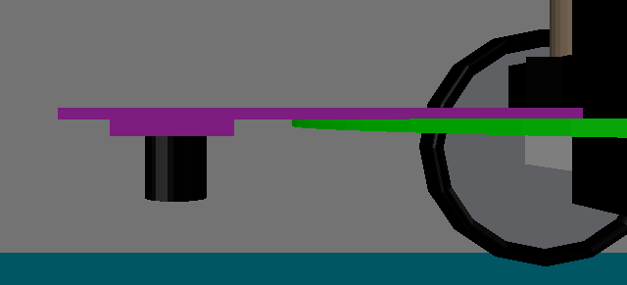
Figure 1: Original camera mounting

CMUCam2+ board
Robot Platform
Camera Lens
4.5cm
3cm

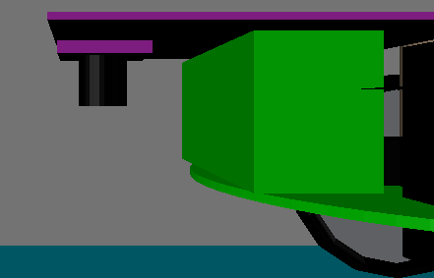
CMUCam2+ board
Figure 2: Camera mount with 5cm wooden stand

Camera Lens

5cm

8cm

Robot Platform

The CMUCam2+ has a setting to toggle between a high resolution and a low resolution mode. The tradeoff between these two modes is better image quality and quicker response time. Another important but subtle difference is viewable area. Since my robot will use a mechanical gripper to pick up coins, the camera must be able to reliably track the center of a coin. A smaller viewable area would be more precise at tracking the center but it could also miss coins just outside the viewable area. The figures below show the same images taken from the camera in high resolution and low resolution modes.

Width measurements
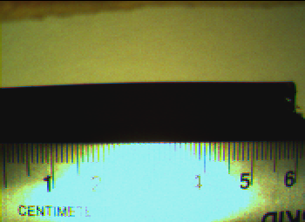
350 pixels
Figure 3: High Resolution Width Measurement

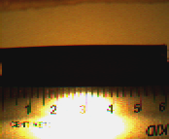
255 pixels 174 pixels

143 pixels

Figure 4: Low Resolution Width Measurement

Height measurements
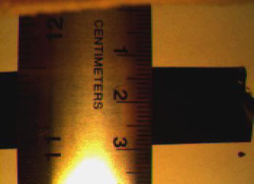
350 pixels
Figure 5: High Resolution Height Measurement

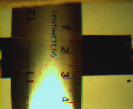
255 pixels
174 pixels

143 pixels

Figure 6: Low Resolution Height Measurement

From the width measurement pictures you can see that the horizontal viewable distance in both cases is about 6cm. In the height measurements however, the high resolution image is about 4cm but the low resolution one is about 4.5cm. The pixel sizes and aspect ratios confirm this discrepancy. The high resolution images have about a 1.37 aspect ratio and a 1.22 aspect ratio for the low resolution images. From these results, the choice is clear: the low resolution setting provides a larger viewable area and a quicker response time due to a reduced amount of information needed to be processed. There is however a drop in precision but I have yet to test whether that drop is significant when it comes to tracking the center of a coin.

Discrepancy in Viewable Area and Internal Coordinates
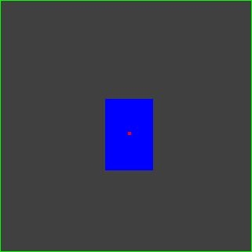

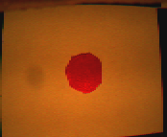

Figure 8: Center and bounding box in color tracking mode
Figure 7: Red circle used for color tracking in previous figure

Figure 7 above shows the center (red) and bounding box (blue) for the color tracking mode on the camera when a red circle is placed in the center. One of the important things to note is that this image is perfectly square, the red circle is roughly circle, but the bounding box is clearly rectangular. This is a direct result from the fact that the camera reports coordinates in its own rectangular coordinate space. The end result is a distorted bounding box. This is important because when measuring the area of a coin to determine its denomination, one must remember to account for this distortion.

Using the red circle shown in figure 8, I connected the camera to the Maveric IIB board and had it use color tracking and return the coordinates of the circle as I moved it around the entire viewable area. Based on the maximum and minimum values returned, it seems the camera’s coordinate space looks something like figure 9:
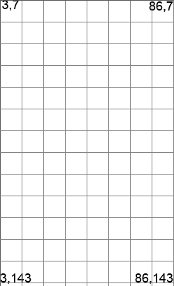
The first number represents horizontal displacement and the second is vertical displacement. When comparing the shape of figure 9 with that of figure 8, you can see why the distortion occurs. The viewable area is a rectangle with more width than height and the coordinate space is also a rectangular but this one has more height than width. Figures 10 and 11 readily show the distortion effects on primitive shapes.

Figure 9: Approximate CMUcam2+ coordinate space

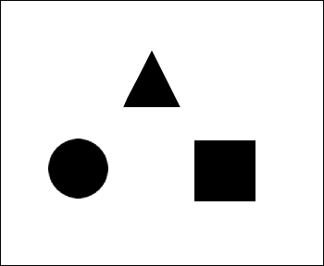
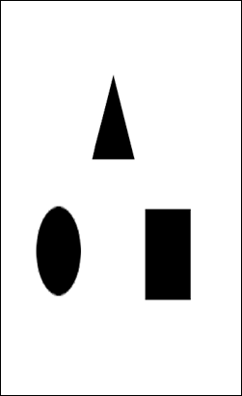

Figure 10: Original image (as seen from camera)
Figure 11: Image seen by color tracker

Issues
Lighting
The test case used for this report included a 60-watt incandescent lamp that would evenly light up the poster board used by the camera. In most environments, the lighting is too poor to reliably track color and an external light source is required. I attached some high intensity LEDs (1900mcd x2) but these lights are very directional and do not ‘flood’ the light as incandescent bulbs do. Later I will use the small light bulbs used in flashlights to see if these work better.

Power Consumption
Even without all the servos mounted and no lighting added I am running into power problems every other day. The main reason behind this seems to be the volatile nature of the NiMH batteries and their steep voltage drops just before dieing. The key has been to always keep a set of fresh batteries on hand and switch them out just before long periods of testing. I purchased larger capacity battery packs just in case I need to use more batteries with all the added lights and servos.

Data Rate
As mentioned in the software section of the report, the data rate used by the camera was initially a very big problem. A fast data rate is desired to reduce the amount of wasted time waiting for the camera but this meant that interrupt service routines must do their job quickly. The solution that finally worked was creating a separate buffer for storing data instead of using the interrupt routine to print the data to the screen. The problem with this method is buffer overflows and checking for array bound did not seem to work. If this becomes a bigger problem I may need to lower the baud rate but for now it seems to work at the default (and fastest) rate of 115.2K.

Reliability
The reliability of the camera to track colored objects is surprisingly good. I was able to track a red circle in figure 7 with a failure rate better than 1 in 10. This of course is under ideal conditions, meaning a well lit area and a very red circle. Coins however do not have such a solid color and most areas are not as well lit as my test condition. A possible solution to this problem is better lightning as mentioned and precise calibration (maybe even a form of self-calibration for given lighting environments).

