Machine Intelligence Laboratory
University of Florida

Research Experience for Undergraduates

Summer 2000

Scott Nortman
Project Title: Pneuman

Abstract

Pneuman is an autonomous anthropomorphic mobile agent developed at the University of Florida’s Machine Intelligence Laboratory (MIL). The projects main objective is to provide a robust platform for robotics research. This is made possible by integrating high performance embedded microprocessors with numerous sensors and actuators. The electrical and mechanical subsystems of Pneuman are modular to allow for future expansion. The platform integrates these sensors and actuators while provided a human-like appearance, thereby enhancing machine-human interaction. This platform and its various subsystems were designed and developed at the MIL. The development of this platform was made possible by a grant from the Department of Electrical and Computer Engineering at the University of Florida and from the National Science Foundation.

Physical Platform

The physical platform consists of the mechanical structure, control electronics / sensors, and actuators. The platform’s structure resembles a human; it has a head, two arms each with a gripper, and a waist, all on a mobile base. Figure 1 shows the initial concept design.
Figure 1

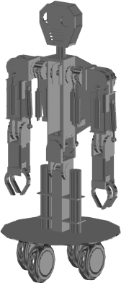

Two mechanical engineering students redesigned this initial structure. Many improvements were made. The improvements include a lower center of gravity, lighter materials, and lower number of actuators needed to control the degrees of freedom (DOF). The new design is shown in Figure 2.

Figure 2
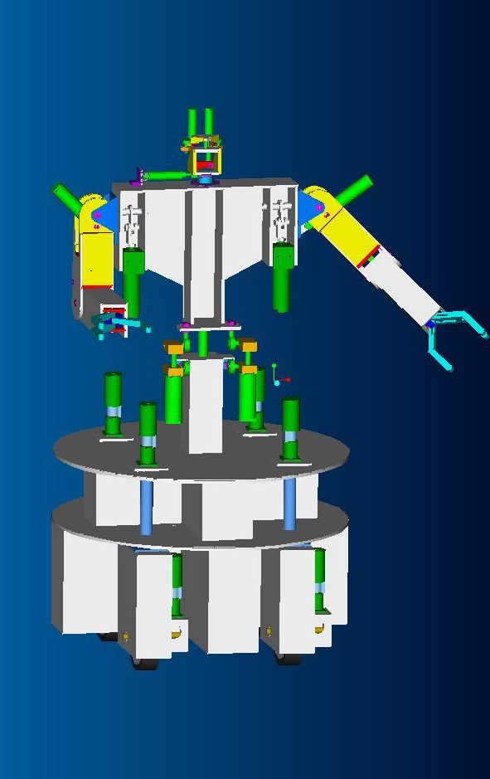

There are 20 DOF. The DOF allow Pneuman to pan and tilt the head, abduct and adduct the arms, bend each elbow, and abduct and adduct the waist, open and close each gripper, and operate the drive system. The combination of these movements allows Pneuman to interact with its environment in a human-like manner.
Pneuman uses two different types of actuators. Thirteen pneumatic cylinders actuate twelve DOF and brushed DC motors actuate eight. Double acting pneumatic cylinders offer an increased life span and yield a higher force-to-weight ratio over other forms of electromechanical actuation. The pneumatic cylinders on Pneuman are operated in a closed-loop feedback system thereby allowing proportional control. There is a linear displacement transducer mounted on each cylinder, and the output of each sensor is input to an analog-to-digital converter. The control computer then generates the appropriate valve command signals. A single 5-way valve and two 2-way valves control each cylinder as shown in Figure 3.

Figure 3
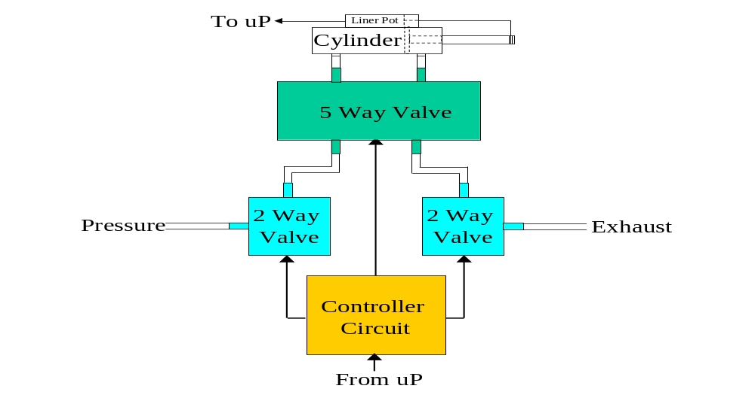
Figure 3. Cylinder Control Structure
The 5-way valve determines the direction of travel. One of the 2-way valves controls the pressure inlet, and the other controls the cylinder exhaust. Both 2-way valves are simultaneously pulse width modulated to allow the piston to move in small increments and stop anywhere along their travel range.

Each cylinder requires the above configuration. Therefore, a “valve control module” (VCM) was developed. A 3D rendering of the VCM is shown in Figure 4.

Figure 4

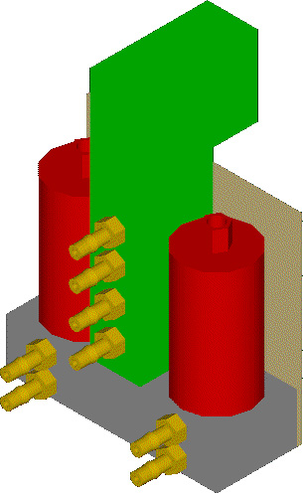
Figure 4. Valve Module

Each VCM contains the driver circuitry and the valves attached to an aluminum valve block. The schematic for the driver circuit is shown in Figure 5.

Figure 5
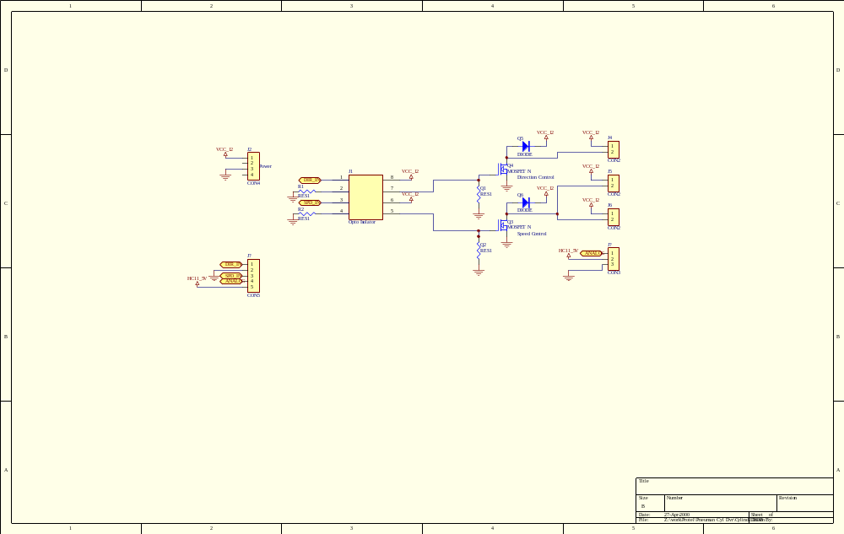

The printed circuit board is shown in Figure 6.

Figure 6
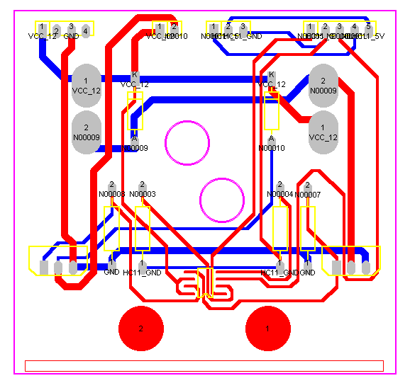

The overall control architecture is shown in Figure 7.
Figure 7
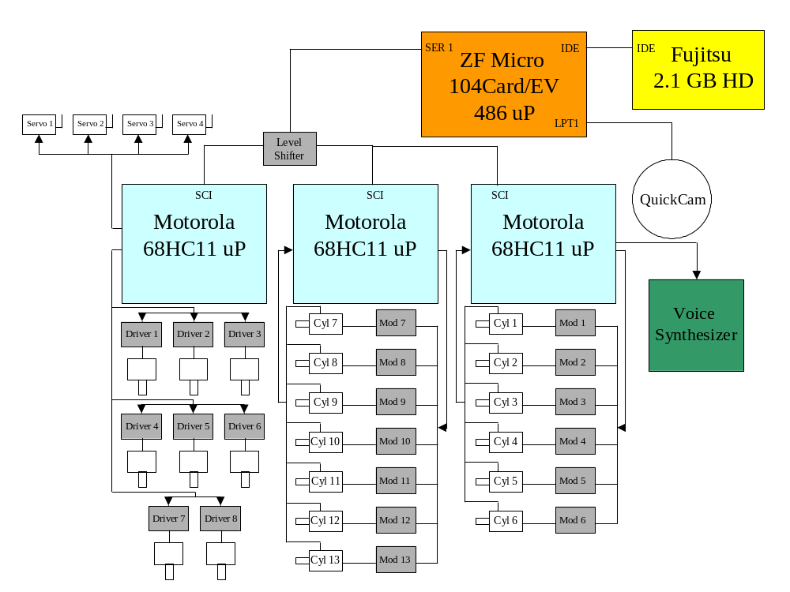

The main control computer is a ZF Microsystems pc/104 card with a 486 processor. It has the standard features of a desktop computer including two RS-232 ports, a parallel port, an IDE controller, a video output port, and 16 megabytes of RAM. The entire package is contained within a PC/104 form factor, making this is an ideal processor for the given application. Additionally, there is a Fujitsu 2.1 gigabyte hard drive attached to the IDE bus. An RS-232 port is connected to the 68HC11 micro-controllers and is used to send the control signals.
The embedded 486 processor operates on the Red Hat© Linux 5.2 operating system, which provides a robust multitasking environment for process control. Three Motorola© 68HC11 micro controllers operate on Mekatronix© TJ Pro circuit boards, each with 32k of non-volatile SRAM. Each microcontroller is contained in an individual module, which brings out the connections of port E for analog to digital conversion, port A for pulse width modulation (PWM), and two memory mapped input/output ports. Each module shares a common SCI receive line from the RS-232 to TTL conversion circuit. The transmit line of each processor passes through a tri-state buffer, and remains connected to a high impedance line until the correct command signal is received. The processor then transmits the received command back to the 486 for error checking, disconnects the transmit line from the SCI bus to avoid a data collision, and performs the requested task. Each module is capable of generating eight PWM signals, eight direction signals, and the A/D conversion of eight analog inputs. Furthermore, if additional hardware is added to the robot, another module can be designed that conforms to the SCI bus configuration and will control the new hardware. The device drivers are needed to convert the TTL level signals from the micro controllers to useable power signals. See Figure 8 for a schematic of the TJ Pro module.
Figure 8
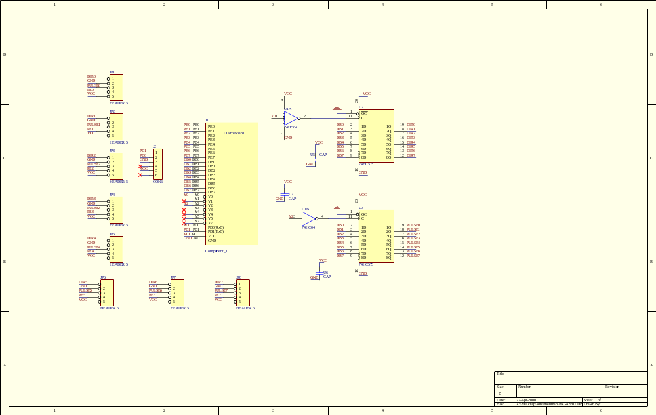

Figure 9 shows the module PC board layout.
Figure 9

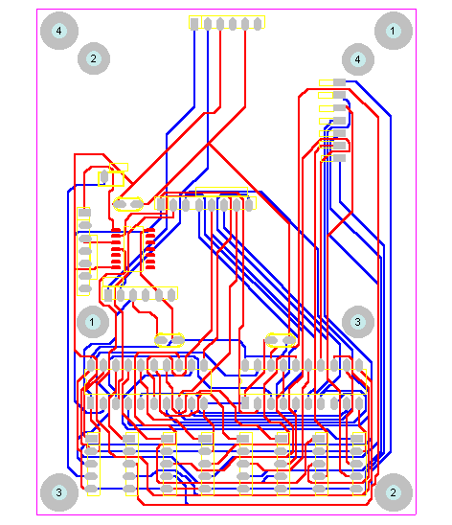

Software

The software subsystem is comprised of two main components, the code for the low-level control system and the code for the embedded 486 computer. The code for the low-level control is being designed using the Image Craft C Compiler for execution on the 68HC11. Figure 10 illustrates the program flow of the 68HC11.
Figure 10
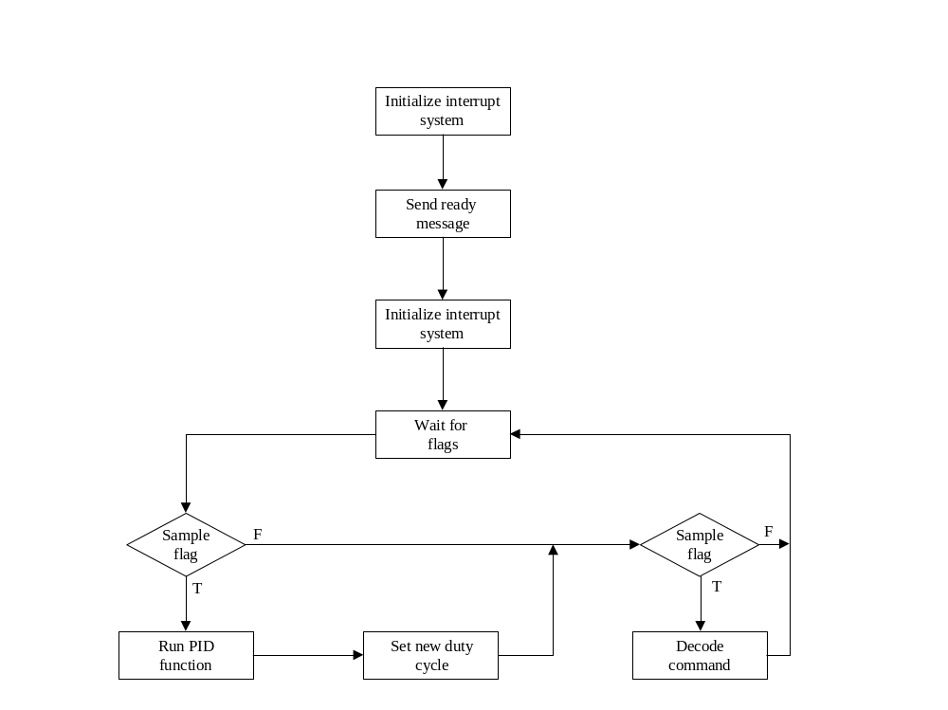
The code enables the 68HC11 to generate a variety of PWM signals using only three or four timers. The timer interrupts are multiplexed and used to control up to six pins, however, up to ten pins can be accommodated. Linear displacement transducers are used in a feedback loop to determine the position and speed of the pistons. Adjustments are made to the duty cycle of the PWM signals based on the feedback from the transducers. The code contains all the routines necessary to control the sub-systems of the platform. The next figure shows the interrupt operation of the 68HC11s.

Figure 11
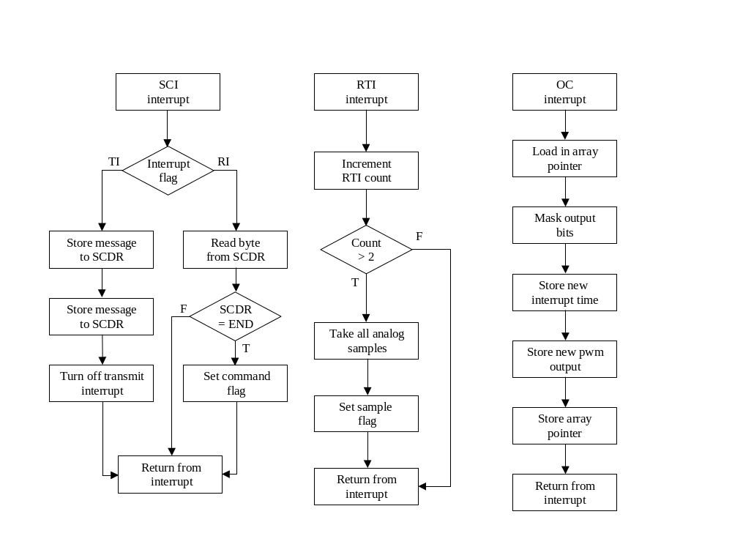
The embedded 486 computer gives a specific address to each 68HC11 based upon its primary function. Commands sent to every microcontroller contain a specific target address indicating which system to actuate. The microcontroller located at that address will respond to the command while the others remain idle. This design allows other systems to be added on to the platform by assigning them a new control addresses. When the 68HC11s are powered up, the software initializes all systems into a wait state until control commands are received from the high-level processing system. A string set, terminating with a carriage return, instructs the low-level code to perform a desired operation.
The code on the embedded 486 computer is being developed in the C programming language for the Linux 5.2 operating system. The code consists of six modules, all of which are individual processes. See Figure 12. The main executable is a process manager that initializes memory space for the other processes and executes the requested modules. Figure 13 shows the flow of the software control manager.
The communication module is necessary for control of the serial port sends command strings to the 68HC11s. It repeatedly checks a send queue to determine if there are any commands waiting to be distributed. All returned strings are stored in a receive queue for processing. The image processing module requests frames from the color camera and processes the data according to a predetermined algorithm. The results from the processes are then sent to the other modules via a shared memory space. The movement control module keeps precise records of the current states of all the actuators. This data is used to determine what control is necessary to move to a desired position. The data analysis module will contain the primary functions for all of the data processing. This module enables autonomous control of the entire system. All the other modules contain the data input and output functions, providing the data analysis module with all the necessary parameters.

Figure 12
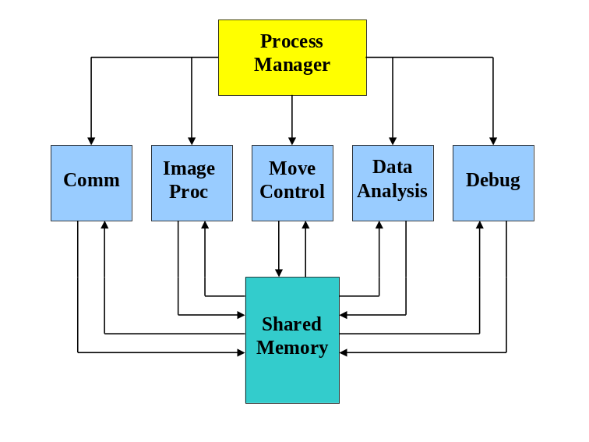

Figure 13
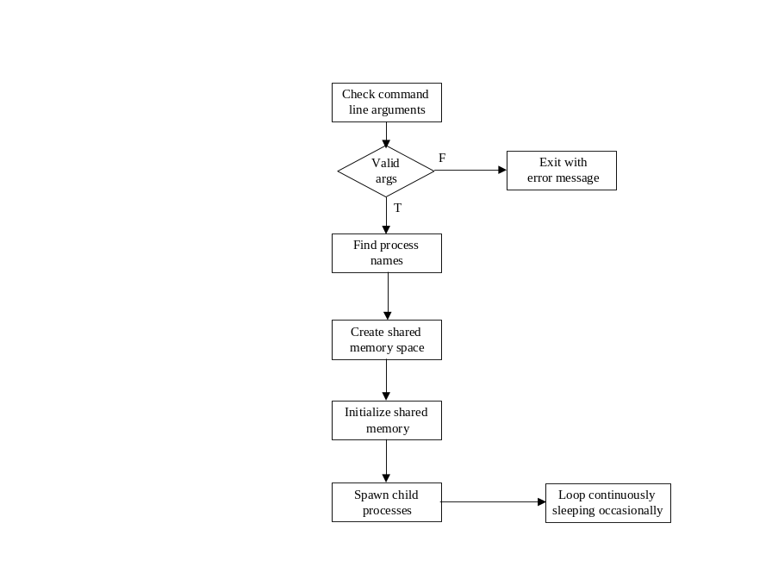

A debug module is included in the design, enabling human intervention into the control of the platform. The debug module provides a screen image of all the data gathered by the system and allows an override of any control parameters. See Figure 14 for the program structure.
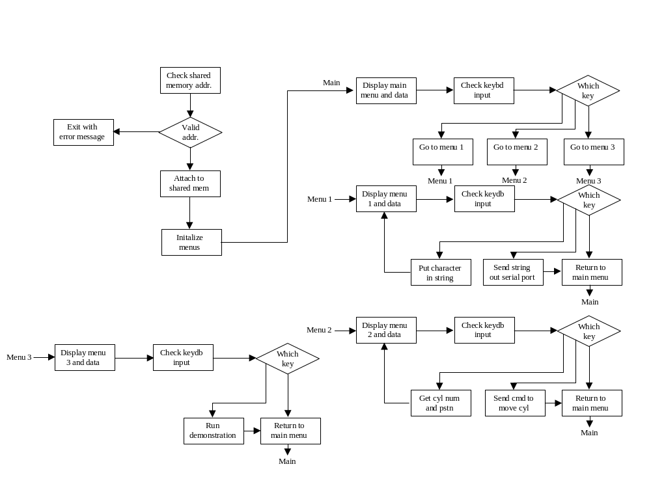Figure 14
Conclusion

The Research Experience for Undergraduates was an excellent opportunity to get a hands-on view of robotics research. This has allowed me to develop a project in an academic environment while having the freedom to explore my own ideas. Pneuman is a robust platform that can be used for a wide verity of research. Future applications for Pneuman may include robotic assistance to help individuals with everyday tasks. Additionally, Pneuman’s human-like appearance is an effective way to increase human-machine interaction. This makes Pneuman well suited for entertainment purposes as well. Although Pneuman was not completely finished during the summer REU program, it will continue to be an ongoing research project at the MIL.

Appendix A: Software

Demoday.c

/*----------------------------------------------------*
*Program : demoday.c *
*Version : HC11-1.0 *
*Programmer : Scott Kanowitz *
*Contractor : Machine Intelligence Laboratory *
* University of Florida *
*Project : Pneuman *
*Date : May 2000 *
*----------------------------------------------------*
* Description : A program to run on the HC11 to *
* control 8 cylinders via a PID *
* controller and communicate with *
* the host machine via serial line *
*----------------------------------------------------*/

//#include <multvlve.h>
#include <hc11.h>
#include <mil.h>
#include <analog.h>
#include <pwmvals.h>

/* Set up interrupt vectors (also at end) */
extern void _start(void); /* entry point in crt??.s */

#pragma interrupt_handler TOC2_isr
#pragma interrupt_handler TOC3_isr
#pragma interrupt_handler TOC4_isr
#pragma interrupt_handler TOC5_isr
#pragma interrupt_handler SCI_isr
#pragma interrupt_handler RTI_isr

#define DUMMY_ENTRY (void (*)(void))0xFFFF /*used as blank space in inpt vectors*/
#define COMMAND_LENGTH 7 //(start char) + (5 char command(ie C1150)) + (end char)
#define START_CHAR 0x24 //corresponds to $
#define END_CHAR 0x23 //corresponds to #

#define P 0
#define I 1
#define D 2

#define TOLERANCE 4

#define DIR_PORT *(unsigned char *)(0x4000)
/*--------------------------------------------------*
*Global variables *
* *
*--------------------------------------------------*/
//char cylinderNumber = 0;

char Message = 0;
char CommandPos = 0;
char handleCommandFlag = 0;
char Command[2* COMMAND_LENGTH];

char handleSampleFlag = 0;

int cyl1_pstn = 0;
int cyl2_pstn = 0;
int cyl3_pstn = 0;
int cyl4_pstn = 0;
int cyl5_pstn = 0;
int cyl6_pstn = 0;
int cyl7_pstn = 0;
int cyl8_pstn = 0;

int cyl1_des = 100;
int cyl2_des = 100;
int cyl3_des = 100;
int cyl4_des = 100;
int cyl5_des = 100;
int cyl6_des = 100;
int cyl7_des = 100;
int cyl8_des = 100;

int error1[3] = {0, 0, 0};
int error2[3] = {0, 0, 0};
int error3[3] = {0, 0, 0};
int error4[3] = {0, 0, 0};
int error5[3] = {0, 0, 0};
int error6[3] = {0, 0, 0};
int error7[3] = {0, 0, 0};
int error8[3] = {0, 0, 0};

int K1[3] = {10, 0, 0};
int K2[3] = {10, 0, 0};
int K3[3] = {10, 0, 0};
int K4[3] = {10, 0, 0};
int K5[3] = {10, 0, 0};
int K6[3] = {10, 0, 0};
int K7[3] = {10, 0, 0};
int K8[3] = {10, 0, 0};

int motor1 =0;
int motor2 =0;
int motor3 =0;
int motor4 =0;
int motor5 =0;
int motor6 =0;
int motor7 =0;
int motor8 =0;

char calc_1ot =0;
int calc_1vl =0;
char calc_2ot =0;
int calc_2vl =0;
char calc_3ot =0;
int calc_3vl =0;

char new_motor_num = 0;
int new_motor_spd = 0;
int comp_motor_spd = 0;
char first_motor = 0;
char same_motor = 0;

char *oc5_reg = 0;
char oc5_1ot = 0;
int oc5_1vl = 0;
char oc5_2ot = 0;
int oc5_2vl = 0;
char oc5_3ot = 0;
int oc5_3vl = 0;

char *oc4_reg = 0;
char oc4_1ot = 0;
int oc4_1vl = 0;
char oc4_2ot = 0;
int oc4_2vl = 0;
char oc4_3ot = 0;
int oc4_3vl = 0;

char *oc3_reg = 0;
char oc3_1ot = 0;
int oc3_1vl = 0;
char oc3_2ot = 0;
int oc3_2vl = 0;
char oc3_3ot = 0;
int oc3_3vl = 0;

char *oc2_reg = 0;
char oc2_1ot = 0;
int oc2_1vl = 0;
char oc2_2ot = 0;
int oc2_2vl = 0;
char oc2_3ot = 0;
int oc2_3vl = 0;

int x_preserve = 0;

char mot_spd = 0;

int pwm_port = 0x5000;

int wave_period = 0xEA60;

char RTIcount =0;

/************************************************************

INITIALIZATION FUNCTIONS

*************************************************************/

/* Set SCI for 9600, 8-n-1, TE, RE, and rx interrupt enabled, tx disabled */
void init_SCI(){
BAUD |= 0X30;
SCCR1 = 0X00;
SCCR2 |= 0X2C;
SCCR2 &= 0X7f;
}

/* Set up oc2-5 to interrupt and dissconnect from pins*/
void init_pulse()
{
INTR_OFF();
CLEAR_BIT(TCTL1, 0xFF); //Disconnect all OCs from pins
TOC2 = 3000;
TOC3 = TOC2+3000; //offset all the initial interrupt times
TOC4 = TOC3+3000;
TOC5 = TOC4+3000;
SET_BIT(TMSK1, 0x78); //enable oc2-5
CLEAR_BIT(PACTL, 0x04); //Enable oc5
INTR_ON(); //turn on interrupts
}

/* Initialize RTI to interrupt every 32.768ms */
void init_RTI() {
PACTL |= 0X03;
TMSK2 |= 0X40;
}

/************************************************************

MULTVLVE function to set up duty_cycles

*************************************************************/

void multvlve(int new_duty, char mot_num)
{
new_motor_spd = new_duty;
new_motor_num = mot_num;

asm("stx _x_preserve\n"
"ldab _new_motor_num\n"
"cmpb #$01\n"
"bne is_motor_2\n"
"ldx _new_motor_spd\n"
"stx _motor1\n"
"ldx _motor2\n"
"stx _comp_motor_spd\n"
"ldab #$01\n"
"stab _first_motor\n"
"jmp calc_motor_times\n"
"is_motor_2:\n"
"cmpb #$02\n"
"bne is_motor_3\n"
"ldx _new_motor_spd\n"
"stx _motor2\n"
"ldx _motor1\n"
"stx _comp_motor_spd\n"
"clr _first_motor\n"
"jmp calc_motor_times");
asm("is_motor_3:\n"
"cmpb #$03\n"
"bne is_motor_4\n"
"ldx _new_motor_spd\n"
"stx _motor3\n"
"ldx _motor4\n"
"stx _comp_motor_spd\n"
"ldab #$01\n"
"stab _first_motor\n"
"jmp calc_motor_times\n"
"is_motor_4:\n"
"cmpb #$04\n"
"bne is_motor_5\n"
"ldx _new_motor_spd\n"
"stx _motor4\n"
"ldx _motor3\n"
"stx _comp_motor_spd\n"
"clr _first_motor\n"
"jmp calc_motor_times");
asm("is_motor_5:\n"
"cmpb #$05\n"
"bne is_motor_6\n"
"ldx _new_motor_spd\n"
"stx _motor5\n"
"ldx _motor6\n"
"stx _comp_motor_spd\n"
"ldab #$01\n"
"stab _first_motor\n"
"jmp calc_motor_times\n"
"is_motor_6:\n"
"cmpb #$06\n"
"bne is_motor_7\n"
"ldx _new_motor_spd\n"
"stx _motor6\n"
"ldx _motor5\n"
"stx _comp_motor_spd\n"
"clr _first_motor\n"
"jmp calc_motor_times");
asm("is_motor_7:\n"
"cmpb #$07\n"
"bne is_motor_8\n"
"ldx _new_motor_spd\n"
"stx _motor7\n"
"ldx _motor8\n"
"stx _comp_motor_spd\n"
"ldab #$01\n"
"stab _first_motor\n"
"jmp calc_motor_times\n"
"is_motor_8:\n"
"cmpb #$08\n"
"bne end_routine\n"
"ldx _new_motor_spd\n"
"stx _motor8\n"
"ldx _motor7\n"
"stx _comp_motor_spd\n"
"clr _first_motor\n"
"bra calc_motor_times\n");
asm("end_routine:\n"
"jmp multvlve_done\n"
"calc_motor_times:\n"
"clr _same_motor\n"
"ldx _new_motor_spd\n"
"cpx _comp_motor_spd\n"
"bne calc_motor_nequ\n"
"ldaa #$01\n"
"staa _same_motor\n"
"calc_motor_nequ:\n"
"cpx _wave_period\n"
"bne calc_mot_con1\n"
"jmp clc_mot_40\n"
"calc_mot_con1:\n"
"cpx #$0000\n"
"bne calc_mot_con2\n"
"jmp clc_mot_00");
asm("calc_mot_con2:\n"
"ldaa _same_motor\n"
"bne calc_motor_same\n"
"cpx _comp_motor_spd\n"
"bls clc_mot_les\n"
"jmp clc_mot_gt\n"
"clc_mot_les:\n"
"stx _calc_1vl\n"
"ldd _comp_motor_spd\n"
"subd _new_motor_spd\n"
"std _calc_2vl\n"
"ldd _wave_period\n"
"cpd _comp_motor_spd\n"
"beq clc_mot_lesc\n"
"subd _calc_2vl\n"
"subd _calc_1vl\n"
"std _calc_3vl\n"
"ldaa #0b00000011\n"
"staa _calc_1ot\n"
"ldaa #0b00000010\n"
"staa _calc_2ot\n"
"ldaa #0b00000000\n"
"staa _calc_3ot\n"
"jmp calc_mot_fin");
asm("clc_mot_lesc:\n"
"subd _new_motor_spd\n"
"subd #1000\n"
"std _calc_3vl\n"
"ldd #1000\n"
"std _calc_2vl\n"
"ldaa _first_motor\n"
"bne is_mot_lessc\n"
"ldaa #0b00000011\n"
"staa _calc_1ot\n"
"ldaa #0b00000001\n"
"staa _calc_3ot\n"
"staa _calc_2ot\n"
"jmp calc_mot_fin\n"
"is_mot_lessc:\n"
"ldaa #0b00000011\n"
"staa _calc_1ot\n"
"ldaa #0b00000010\n"
"staa _calc_3ot\n"
"staa _calc_2ot\n"
"jmp calc_mot_fin");
asm("calc_motor_same:\n"
"ldd _new_motor_spd\n"
"std _calc_1vl\n"
"ldd #1000\n"
"std _calc_2vl\n"
"ldd _wave_period\n"
"subd _calc_2vl\n"
"subd _calc_1vl\n"
"std _calc_3vl\n"
"ldaa #0b00000011\n"
"staa _calc_1ot\n"
"ldaa #$00000000\n"
"staa _calc_3ot\n"
"staa _calc_2ot\n"
"jmp calc_mot_fin");
asm("clc_mot_gt:\n"
"ldd _comp_motor_spd\n"
"cpd #$00\n"
"beq clc_mot_gtr0\n"
"std _calc_1vl\n"
"ldd _new_motor_spd\n"
"subd _comp_motor_spd\n"
"std _calc_2vl\n"
"ldd _wave_period\n"
"subd _calc_2vl\n"
"subd _calc_1vl\n"
"std _calc_3vl\n"
"ldaa _first_motor\n"
"bne is_mot_gtrc\n"
"ldaa #0b00000011\n"
"staa _calc_1ot\n"
"ldaa #0b00000010\n"
"staa _calc_2ot\n"
"ldaa #0b00000000\n"
"staa _calc_3ot\n"
"jmp calc_mot_fin")
asm("is_mot_gtrc:\n"
"ldaa #0b00000011\n"
"staa _calc_1ot\n"
"ldaa #0b00000001\n"
"staa _calc_2ot\n"
"ldaa #0b00000000\n"
"staa _calc_3ot\n"
"jmp calc_mot_fin\n"
"clc_mot_gtr0:\n"
"ldd _new_motor_spd\n"
"std _calc_1vl\n"
"ldd #1000\n"
"std _calc_2vl\n"
"ldd _wave_period\n"
"subd _calc_2vl\n"
"subd _calc_1vl\n"
"std _calc_3vl\n"
"ldaa _first_motor\n"
"bne is_mot_gtrcc\n"
"ldaa #0b00000010\n"
"staa _calc_1ot\n"
"ldaa #0b00000000\n"
"staa _calc_3ot\n"
"staa _calc_2ot\n"
"jmp calc_mot_fin");
asm("is_mot_gtrcc:\n"
"ldaa #0b00000001\n"
"staa _calc_1ot\n"
"ldaa #0b00000000\n"
"staa _calc_3ot\n"
"staa _calc_2ot\n"
"jmp calc_mot_fin\n"
"clc_mot_00:\n"
"ldaa _same_motor\n"
"bne both_zero\n"
"ldd _comp_motor_spd\n"
"cpd _wave_period\n"
"beq clc_mot_0040\n"
"std _calc_1vl\n"
"ldd #1000\n"
"std _calc_2vl\n"
"ldd _wave_period\n"
"subd _calc_2vl\n"
"subd _calc_1vl\n"
"std _calc_3vl\n"
"ldaa _first_motor\n"
"bne is_mot_00\n"
"ldaa #0b00000001\n"
"staa _calc_1ot\n"
"ldaa #0b00000000\n"
"staa _calc_3ot\n"
"staa _calc_2ot\n"
"jmp calc_mot_fin");
asm("is_mot_00:\n"
"ldaa #0b00000010\n"
"staa _calc_1ot\n"
"ldaa #0b00000000\n"
"staa _calc_3ot\n"
"staa _calc_2ot\n"
"jmp calc_mot_fin\n"
"both_zero:\n"
"ldaa #0b00000000\n"
"staa _calc_1ot\n"
"staa _calc_2ot\n"
"staa _calc_3ot\n"
"ldd #1000\n"
"std _calc_1vl\n"
"ldd #1000\n"
"std _calc_2vl\n"
"ldd _wave_period\n"
"subd _calc_2vl\n"
"subd _calc_1vl\n"
"std _calc_3vl\n"
"jmp calc_mot_fin\n"
"clc_mot_0040:\n"
"ldd #1000\n"
"std _calc_1vl\n"
"std _calc_2vl\n"
"ldd _wave_period\n"
"subd _calc_1vl\n"
"subd _calc_2vl\n"
"std _calc_3vl\n"
"ldaa #0b00000010\n"
"ldab _first_motor\n"
"bne is_mot_0040\n"
"ldaa #0b00000001");
asm("is_mot_0040:\n"
"staa _calc_1ot\n"
"staa _calc_2ot\n"
"staa _calc_3ot\n"
"jmp calc_mot_fin\n"
"clc_mot_40:\n"
"ldaa _same_motor\n"
"bne both_40000\n"
"ldd _comp_motor_spd\n"
"cpd #$0000\n"
"bne clc_mot_40c\n"
"ldd #1000\n"
"clc_mot_40c:\n"
"std _calc_1vl\n"
"ldd #1000\n"
"std _calc_2vl\n"
"ldd _wave_period\n"
"subd _calc_2vl\n"
"subd _calc_1vl\n"
"std _calc_3vl\n"
"ldaa _first_motor\n"
"bne is_mot_40\n"
"ldaa #0b00000011\n"
"ldx _comp_motor_spd\n"
"cpx #$0000\n"
"bne clc_mot_40cc\n"
"ldaa #0b00000010\n"
"clc_mot_40cc:\n"
"staa _calc_1ot\n"
"ldaa #0b00000010\n"
"staa _calc_3ot\n"
"staa _calc_2ot\n"
"jmp calc_mot_fin");
asm("is_mot_40:\n"
"ldaa #0b00000011\n"
"ldx _comp_motor_spd\n"
"cpx #$0000\n"
"bne is_mot_40c\n"
"ldaa #0b00000001\n"
"is_mot_40c:\n"
"staa _calc_1ot\n"
"ldaa #0b00000001\n"
"staa _calc_3ot\n"
"staa _calc_2ot\n"
"jmp calc_mot_fin\n"
"both_40000:\n"
"ldd #1000\n"
"std _calc_1vl\n"
"ldd #1000\n"
"std _calc_2vl\n"
"ldd _wave_period\n"
"subd _calc_2vl\n"
"subd _calc_1vl\n"
"std _calc_3vl\n"
"ldaa #0b00000011\n"
"staa _calc_1ot\n"
"staa _calc_2ot\n"
"staa _calc_3ot\n"
"jmp calc_mot_fin");
asm("calc_mot_fin:\n"
"ldy #_oc2_1ot\n"
"ldaa _new_motor_num\n"
"cmpa #$01\n"
"beq jmp_calc_motor_done\n"
"cmpa #$02\n"
"beq jmp_calc_motor_done\n"
"cmpa #$03\n"
"beq calc_motor_34\n"
"cmpa #$04\n"
"beq calc_motor_34\n"
"cmpa #$05\n"
"beq calc_motor_56\n"
"cmpa #$06\n"
"beq calc_motor_56\n"
"bra calc_motor_78\n"
"jmp_calc_motor_done:\n"
"jmp calc_motor_done");
asm("calc_motor_78:\n"
"ldaa _calc_1ot\n"
"lsla\n"
"lsla\n"
"lsla\n"
"lsla\n"
"lsla\n"
"lsla\n"
"staa _calc_1ot\n"
"ldaa _calc_2ot\n"
"lsla\n"
"lsla\n"
"lsla\n"
"lsla\n"
"lsla\n"
"lsla\n"
"staa _calc_2ot\n"
"ldaa _calc_3ot\n"
"lsla\n"
"lsla\n"
"lsla\n"
"lsla\n"
"lsla\n"
"lsla\n"
"staa _calc_3ot\n"
"ldy #_oc5_1ot\n"
"jmp calc_motor_done");
asm("calc_motor_56:\n"
"ldaa _calc_1ot\n"
"lsla\n"
"lsla\n"
"lsla\n"
"lsla\n"
"staa _calc_1ot\n"
"ldaa _calc_2ot\n"
"lsla\n"
"lsla\n"
"lsla\n"
"lsla\n"
"staa _calc_2ot\n"
"ldaa _calc_3ot\n"
"lsla\n"
"lsla\n"
"lsla\n"
"lsla\n"
"staa _calc_3ot\n"
"ldy #_oc4_1ot\n"
"jmp calc_motor_done");
asm("calc_motor_34:\n"
"ldaa _calc_1ot\n"
"lsla\n"
"lsla\n"
"staa _calc_1ot\n"
"ldaa _calc_2ot\n"
"lsla\n"
"lsla\n"
"staa _calc_2ot\n"
"ldaa _calc_3ot\n"
"lsla\n"
"lsla\n"
"staa _calc_3ot\n"
"ldy #_oc3_1ot\n"
"calc_motor_done:\n"
"ldx #_calc_1ot\n"
"ldaa 0,x\n"
"staa 0,y\n"
"inx\n"
"iny\n"
"ldd 0,x\n"
"std 0,y\n"
"inx\n"
"inx\n"
"iny\n"
"iny\n"
"ldaa 0,x\n"
"staa 0,y\n"
"inx\n"
"iny\n"
"ldd 0,x\n"
"std 0,y\n"
"inx\n"
"inx\n"
"iny\n"
"iny\n"
"ldaa 0,x\n"
"staa 0,y\n"
"inx\n"
"iny\n"
"ldd 0,x\n"
"std 0,y\n"
"multvlve_done:\n"
"ldx _x_preserve");

}

/********************************************************/
/*pid_controller() */
/*function contains all the pid routines to update */
/*the duty cycles */
/* */
/********************************************************/

void pid_controller(void){

int proportion = 0;
int integral = 0;
int derivative = 0;
int new_duty = 0;

//Run pid for cylinder 1

//shift error values
error1[2] = error1[1];
error1[1] = error1[0];
error1[0] = cyl1_des - cyl1_pstn;

//range for tolerance
if (error1[0] < TOLERANCE & error1[0] > 0 - TOLERANCE){
error1[0] = 0;
multvlve(0, 0x01);
}
else { //run pid

//calc gains
proportion = K1[P] * error1[0];
//integral = K1[I];
//derivative = K1[D] * (error1[0] - error1[1]);

//calc new raw value
new_duty = proportion + integral + derivative;

if (error1[0] < 0) {
DIR_PORT &= 0xFE;
}
else {
DIR_PORT |= 0x01;
}

//take absolute value of new_duty
if (new_duty < 0){
asm("ldd %new_duty\n"
"subd #1\n"
"coma\n"
"comb\n"
"std %new_duty\n");
}
//range new_duty to max value
if (new_duty > 236){
new_duty = 236;
}

new_duty = pwm_vals[new_duty];

multvlve(new_duty, 0x01);

}

//Run pid for cylinder 2

//shift error values
error2[2] = error2[1];
error2[1] = error2[0];
error2[0] = cyl2_des - cyl2_pstn;

//range for tolerance
if (error2[0] < TOLERANCE & error2[0] > 0 - TOLERANCE){
error2[0] = 0;
multvlve(0, 0x02);
}
else { //run pid

//calc gains
proportion = K2[P] * error2[0];
//integral = K2[I];
//derivative = K2[D] * (error2[0] - error2[1]);

//calc new raw value
new_duty = proportion + integral + derivative;

if (error2[0] < 0) {
DIR_PORT &= 0xFD;
}
else {
DIR_PORT |= 0x02;
}

//take absolute value of new_duty
if (new_duty < 0){
asm("ldd %new_duty\n"
"subd #1\n"
"coma\n"
"comb\n"
"std %new_duty\n");
}
//range new_duty to max value
if (new_duty > 236){
new_duty = 236;
}

new_duty = pwm_vals[new_duty];

multvlve(new_duty, 0x02);

}

//Run pid for cylinder 3

//shift error values
error3[2] = error3[1];
error3[1] = error3[0];
error3[0] = cyl3_des - cyl3_pstn;

//range for tolerance
if (error3[0] < TOLERANCE & error3[0] > 0 - TOLERANCE){
error3[0] = 0;
multvlve(0, 0x03);
}
else { //run pid

//calc gains
proportion = K3[P] * error3[0];
//integral = K3[I];
//derivative = K3[D] * (error3[0] - error3[1]);

//calc new raw value
new_duty = proportion + integral + derivative;

if (error3[0] < 0) {
DIR_PORT &= 0xFB;
}
else {
DIR_PORT |= 0x04;
}

//take absolute value of new_duty
if (new_duty < 0){
asm("ldd %new_duty\n"
"subd #1\n"
"coma\n"
"comb\n"
"std %new_duty\n");
}
//range new_duty to max value
if (new_duty > 236){
new_duty = 236;
}

new_duty = pwm_vals[new_duty];

multvlve(new_duty, 0x03);

}

//Run pid for cylinder 4

//shift error values
error4[2] = error4[1];
error4[1] = error4[0];
error4[0] = cyl4_des - cyl4_pstn;

//range for tolerance
if (error4[0] < TOLERANCE & error4[0] > 0 - TOLERANCE){
error4[0] = 0;
multvlve(0, 0x04);
}
else { //run pid

//calc gains
proportion = K4[P] * error4[0];
//integral = K4[I];
//derivative = K4[D] * (error4[0] - error4[1]);

//calc new raw value
new_duty = proportion + integral + derivative;

if (error4[0] < 0) {
DIR_PORT &= 0xF7;
}
else {
DIR_PORT |= 0x08;
}

//take absolute value of new_duty
if (new_duty < 0){
asm("ldd %new_duty\n"
"subd #1\n"
"coma\n"
"comb\n"
"std %new_duty\n");
}
//range new_duty to max value
if (new_duty > 236){
new_duty = 236;
}

new_duty = pwm_vals[new_duty];

multvlve(new_duty, 0x04);

}

//Run pid for cylinder 5

//shift error values
error5[2] = error5[1];
error5[1] = error5[0];
error5[0] = cyl5_des - cyl5_pstn;

//range for tolerance
if (error5[0] < TOLERANCE & error5[0] > 0 - TOLERANCE){
error5[0] = 0;
multvlve(0, 0x05);
}
else { //run pid

//calc gains
proportion = K5[P] * error5[0];
//integral = K5[I];
//derivative = K5[D] * (error5[0] - error5[1]);

//calc new raw value
new_duty = proportion + integral + derivative;

if (error5[0] < 0) {
DIR_PORT &= 0xEF;
}
else {
DIR_PORT |= 0x10;
}

//take absolute value of new_duty
if (new_duty < 0){
asm("ldd %new_duty\n"
"subd #1\n"
"coma\n"
"comb\n"
"std %new_duty\n");
}
//range new_duty to max value
if (new_duty > 236){
new_duty = 236;
}

new_duty = pwm_vals[new_duty];

multvlve(new_duty, 0x05);

}

//Run pid for cylinder 6

//shift error values
error6[2] = error6[1];
error6[1] = error6[0];
error6[0] = cyl6_des - cyl6_pstn;

//range for tolerance
if (error6[0] < TOLERANCE & error6[0] > 0 - TOLERANCE){
error6[0] = 0;
multvlve(0, 0x06);
}
else { //run pid

//calc gains
proportion = K6[P] * error6[0];
//integral = K6[I];
//derivative = K6[D] * (error6[0] - error6[1]);

//calc new raw value
new_duty = proportion + integral + derivative;

if (error2\6[0] < 0) {
DIR_PORT &= 0xDF;
}
else {
DIR_PORT |= 0x20;
}

//take absolute value of new_duty
if (new_duty < 0){
asm("ldd %new_duty\n"
"subd #1\n"
"coma\n"
"comb\n"
"std %new_duty\n");
}
//range new_duty to max value
if (new_duty > 236){
new_duty = 236;
}

new_duty = pwm_vals[new_duty];

multvlve(new_duty, 0x06);

}

//Run pid for cylinder 7

//shift error values
error7[2] = error7[1];
error7[1] = error7[0];
error7[0] = cyl7_des - cyl7_pstn;

//range for tolerance
if (error7[0] < TOLERANCE & error7[0] > 0 - TOLERANCE){
error7[0] = 0;
multvlve(0, 0x07);
}
else { //run pid

//calc gains
proportion = K7[P] * error7[0];
//integral = K7[I];
//derivative = K7[D] * (error7[0] - error7[1]);

//calc new raw value
new_duty = proportion + integral + derivative;

if (error7[0] < 0) {
DIR_PORT &= 0xBF;
}
else {
DIR_PORT |= 0x40;
}

//take absolute value of new_duty
if (new_duty < 0){
asm("ldd %new_duty\n"
"subd #1\n"
"coma\n"
"comb\n"
"std %new_duty\n");
}
//range new_duty to max value
if (new_duty > 236){
new_duty = 236;
}

new_duty = pwm_vals[new_duty];

multvlve(new_duty, 0x07);

}

//Run pid for cylinder 8

//shift error values
error8[2] = error8[1];
error8[1] = error8[0];
error8[0] = cyl8_des - cyl8_pstn;

//range for tolerance
if (error8[0] < TOLERANCE & error8[0] > 0 - TOLERANCE){
error8[0] = 0;
multvlve(0, 0x08);
}
else { //run pid

//calc gains
proportion = K8[P] * error8[0];
//integral = K8[I];
//derivative = K8[D] * (error8[0] - error8[1]);

//calc new raw value
new_duty = proportion + integral + derivative;

if (error8[0] < 0) {
DIR_PORT &= 0x7F;
}
else {
DIR_PORT |= 0x80;
}

//take absolute value of new_duty
if (new_duty < 0){
asm("ldd %new_duty\n"
"subd #1\n"
"coma\n"
"comb\n"
"std %new_duty\n");
}
//range new_duty to max value
if (new_duty > 236){
new_duty = 236;
}

new_duty = pwm_vals[new_duty];

multvlve(new_duty, 0x08);

}

handleSampleFlag = 0;
}

/********************************************************/
/*decode_command() */
/*function to decode the commands recieved on the */
/*serial port */
/* */
/********************************************************/

void decode_command(void){

int counter = 0;
char cylinderNumber = 0;
char cylinderDes = 0;

//search through command string to find start char
//in case of bogus data
while(counter < COMMAND_LENGTH && Command[counter] != START_CHAR)
{counter++;
}

if (counter == COMMAND_LENGTH){//bogus data so return
handleCommandFlag = 0;
return;
}

switch (Command[counter + 1]){
case 'C': //cylinder position value
cylinderNumber = Command[counter + 2] & 0x0F;
Command[counter + 3] &= 0x0F;
Command[counter + 4] &= 0x0F;
Command[counter + 5] &= 0x0F;
cylinderDes = Command[counter + 3] * 100 + Command[counter + 4] * 10 + Command[counter + 5];
//store new command into global variables
asm("ldab %cylinderNumber\n"
"subb #1\n"
"lslb\n"
"ldaa %cylinderDes\n"
"stx _x_preserve\n"
"ldx #_cyl1_des\n"
"abx\n"
"inx\n"
"staa 0,x\n"
"ldx _x_preserve");

break ;

//put next command case here

}//ends switch statement

handleCommandFlag = 0;
}

/********************************************************/
/*send_message(byte) */
/*function to send a byte out the serial port */
/* */
/* */
/********************************************************/

void send_message(char byte)
{
Message = byte;
SCCR2 |= 0x80;
}

/********************************************************/
/*ISRs */
/* */
/* */
/* */
/********************************************************/

/* Captures incoming messages of CommandLength bytes */
/* Sends one byte messages then disables TIE */
/* SCI isr */
void SCI_isr() {
if(SCSR & 0X20) {
Command[CommandPos] = SCDR;
send_message(SCDR); // Include to echo characters
if (++CommandPos == COMMAND_LENGTH) {
CommandPos = 0;
}
if (SCDR == END_CHAR) {
handleCommandFlag = 1;
}
}
else if(SCSR & 0X80) {
SCDR = Message;
SCCR2 &= 0X7F;
}

}

/*TOC5_isr- controls motors 7 and 8*/
void TOC5_isr()
{
TFLG1 = 0x08; //clear interrupt flag
asm("ldy _oc5_reg\n"
"ldaa _mot_spd\n"
"anda #$3f\n"
"oraa 0,y\n"
"staa _mot_spd\n"
"ldx _pwm_port\n"
"staa 0,x\n"
"iny\n"
"ldx #$101E\n"
"ldd 0,y\n"
"addd 0,x\n"
"std 0,x\n"
"cpy #_oc5_3vl\n"
"bne oc5_rti\n"
"ldy #_oc5_reg\n"
"oc5_rti:\n"
"iny\n"
"iny\n"
"sty _oc5_reg");
}

/*TOC4_isr - controls motors 5 and 6*/
void TOC4_isr()
{
TFLG1 = 0X10; //clear interrupt flag
asm("ldy _oc4_reg\n"
"ldaa _mot_spd\n"
"anda #$cf\n"
"oraa 0,y\n"
"staa _mot_spd\n"
"ldx _pwm_port\n"
"staa 0,x\n"
"iny\n"
"ldx #$101C\n"
"ldd 0,y\n"
"addd 0,x\n"
"std 0,x\n"
"cpy #_oc4_3vl\n"
"bne oc4_rti\n"
"ldy #_oc4_reg\n"
"oc4_rti:\n"
"iny\n"
"iny\n"
"sty _oc4_reg");
}

/*TOC3_isr - controls motors 3 and 4*/
void TOC3_isr()
{
TFLG1 = 0x20; //clear interrupt flag
asm("ldy _oc3_reg\n"
"ldaa _mot_spd\n"
"anda #$f3\n"
"oraa 0,y\n"
"staa _mot_spd\n"
"ldx _pwm_port\n"
"staa 0,x\n"
"iny\n"
"ldx #$101A\n"
"ldd 0,y\n"
"addd 0,x\n"
"std 0,x\n"
"cpy #_oc3_3vl\n"
"bne oc3_rti\n"
"ldy #_oc3_reg\n"
"oc3_rti:\n"
"iny\n"
"iny\n"
"sty _oc3_reg");
}

/*TOC2_isr - controls motors 1 and 2*/
void TOC2_isr()
{
TFLG1 = 0x40; //clear interrupt flag

asm("ldy _oc2_reg\n"
"ldaa _mot_spd\n"
"anda #$fc\n"
"oraa 0,y\n"
"staa _mot_spd\n"
"ldx _pwm_port\n"
"staa 0,x\n"
"iny\n"
"ldx #$1018\n"
"ldd 0,y\n"
"addd 0,x\n"
"std 0,x\n"
"cpy #_oc2_3vl\n"
"bne oc2_rti\n"
"ldy #_oc2_reg\n"
"oc2_rti:\n"
"iny\n"
"iny\n"
"sty _oc2_reg");
}

/*RTI_isr - samples analog values on every third interrupt*/
/*sets a flag to call PID controller*/
void RTI_isr()
{
TFLG2 = 0x40; //clear flag
if (RTIcount < 2)
{
RTIcount++;
return;
}

RTIcount = 0;

//run sample of all 8 cylinders
ADCTL = 0x90 //CCF=1 SCAN=0 MULT=1 CD-CA=0000
//wait for complete samples
asm("ldaa #21\n"
"loop:\n"
"deca\n"
"bne loop");

//now load in the analog values
//assembly routines to change char to int

//cyl1_pstn = ADR1;
asm("ldaa $1031\n"
"staa _cyl1_pstn + 1\n");

//cyl2_pstn = ADR2;
asm("ldaa $1032\n"
"staa _cyl2_pstn + 1\n");

//cyl3_pstn = ADR3;
asm("ldaa $1033\n"
"staa _cyl3_pstn + 1\n");

//cyl4_pstn = ADR4;
asm("ldaa $1034\n"
"staa _cyl4_pstn + 1\n");

ADCTL = 0x94 //CCF=1 SCAN=0 MULT=1 CD-CA=0100
//wait for complete samples
asm("ldaa #21\n"
"loop2:\n"
"deca\n"
"bne loop2");

//cyl5_pstn = ADR1;
asm("ldaa $1031\n"
"staa _cyl5_pstn + 1\n");

//cyl6_pstn = ADR2;
asm("ldaa $1032\n"
"staa _cyl6_pstn + 1\n");

//cyl7_pstn = ADR3;
asm("ldaa $1033\n"
"staa _cyl7_pstn + 1\n");

//cyl8_pstn = ADR4;
asm("ldaa $1034\n"
"staa _cyl8_pstn + 1\n");

//finished with sampling

handleSampleFlag = 1; //set flag to run pid routine

}

/********************************************************/
/*Begin main function */
/* */
/* */
/* */
/********************************************************/

void main(void)
{

int count = 1700;
/*this must be here to initalize the pointers and
leave them in the correct momory space*/

oc2_reg = &oc2_1ot;
oc3_reg = &oc3_1ot;
oc4_reg = &oc4_1ot;
oc5_reg = &oc5_1ot;

init_analog();
init_SCI();
init_pulse(); //set up interrupts for oc2-5
init_RTI();

//printf("\n\n starting\n");
//multvlve(20000, 0x01);

while(1){ //main loop
if(handleSampleFlag){
pid_controller();
}//ends if

if(handleCommandFlag){
decode_command();
}//ends if

}//ends main while
}

/************************************************************

Initialize interrupt vectors

*************************************************************/

#pragma abs_address:0xffd6
void (*interrupt_vectors[])(void) =
{
SCI_isr, /* SCI */
DUMMY_ENTRY, /* SPI */
DUMMY_ENTRY, /* PAIE */
DUMMY_ENTRY, /* PAO */
DUMMY_ENTRY, /* TOF */
TOC5_isr, /* TOC5 */
TOC4_isr, /* TOC4 */
TOC3_isr, /* TOC3 */
TOC2_isr, /* TOC2 */
DUMMY_ENTRY, /* TOC1 */
DUMMY_ENTRY, /* TIC3 */
DUMMY_ENTRY, /* TIC2 */
DUMMY_ENTRY, /* TIC1 */
RTI_isr, /* RTI */
DUMMY_ENTRY, /* IRQ */
DUMMY_ENTRY, /* XIRQ */
DUMMY_ENTRY, /* SWI */
DUMMY_ENTRY, /* ILLOP */
DUMMY_ENTRY, /* COP */
DUMMY_ENTRY, /* CLM */
_start /* RESET */
};
#pragma end_abs_address

Pwmvals.h
/*----------------------------------------------------*
*Program : pwmvals.h *
*Version : HC11-1.0 *
*Programmer : Scott Kanowitz *
*Contractor : Machine Intelligence Laboratory *
* University of Florida *
*Project : Pneuman *
*Date : 3/25/2000 *
*----------------------------------------------------*
* Description : Header file containing all the *
* possible duty cycles for demoday.c *
*----------------------------------------------------*/

int pwm_vals[] = {0,
0x4268,
0x42CC,
0x4330,
0x4394,
0x43F8,
0x445C,
0x44C0,
0x4524,
0x4588,
0x45EC,
0x4650,
0x46B4,
0x4718,
0x477C,
0x47E0,
0x4844,
0x48A8,
0x490C,
0x4970,
0x49D4,
0x4A38,
0x4A9C,
0x4B00,
0x4B64,
0x4BC8,
0x4C2C,
0x4C90,
0x4CF4,
0x4D58,
0x4DBC,
0x4E20,
0x4E84,
0x4EE8,
0x4F4C,
0x4FB0,
0x5014,
0x5078,
0x50DC,
0x5140,
0x51A4,
0x5208,
0x526C,
0x52D0,
0x5334,
0x5398,
0x53FC,
0x5460,
0x54C4,
0x5528,
0x558C,
0x55F0,
0x5654,
0x56B8,
0x571C,
0x5780,
0x57E4,
0x5848,
0x58AC,
0x5910,
0x5974,
0x59D8,
0x5A3C,
0x5AA0,
0x5B04,
0x5B68,
0x5BCC,
0x5C30,
0x5C94,
0x5CF8,
0x5D5C,
0x5DC0,
0x5E24,
0x5E88,
0x5EEC,
0x5F50,
0x5FB4,
0x6018,
0x607C,
0x60E0,
0x6144,
0x61A8,
0x620C,
0x6270,
0x62D4,
0x6338,
0x639C,
0x6400,
0x6464,
0x64C8,
0x652C,
0x6590,
0x65F4,
0x6658,
0x66BC,
0x6720,
0x6784,
0x67E8,
0x684C,
0x68B0,
0x6914,
0x6978,
0x69DC,
0x6A40,
0x6AA4,
0x6B08,
0x6B6C,
0x6BD0,
0x6C34,
0x6C98,
0x6CFC,
0x6D60,
0x6DC4,
0x6E28,
0x6E8C,
0x6EF0,
0x6F54,
0x6FB8,
0x701C,
0x7080,
0x70E4,
0x7148,
0x71AC,
0x7210,
0x7274,
0x72D8,
0x733C,
0x73A0,
0x7404,
0x7468,
0x74CC,
0x7530,
0x7594,
0x75F8,
0x765C,
0x76C0,
0x7724,
0x7788,
0x77EC,
0x7850,
0x78B4,
0x7918,
0x797C,
0x79E0,
0x7A44,
0x7AA8,
0x7B0C,
0x7B70,
0x7BD4,
0x7C38,
0x7C9C,
0x7D00,
0x7D64,
0x7DC8,
0x7E2C,
0x7E90,
0x7EF4,
0x7F58,
0x7FBC,
0x8020,
0x8084,
0x80E8,
0x814C,
0x81B0,
0x8214,
0x8278,
0x82DC,
0x8340,
0x83A4,
0x8408,
0x846C,
0x84D0,
0x8534,
0x8598,
0x85FC,
0x8660,
0x86C4,
0x8728,
0x878C,
0x87F0,
0x8854,
0x88B8,
0x891C,
0x8980,
0x89E4,
0x8A48,
0x8AAC,
0x8B10,
0x8B74,
0x8BD8,
0x8C3C,
0x8CA0,
0x8D04,
0x8D68,
0x8DCC,
0x8E30,
0x8E94,
0x8EF8,
0x8F5C,
0x8FC0,
0x9024,
0x9088,
0x90EC,
0x9150,
0x91B4,
0x9218,
0x927C,
0x92E0,
0x9344,
0x93A8,
0x940C,
0x9470,
0x94D4,
0x9538,
0x959C,
0x9600,
0x9664,
0x96C8,
0x972C,
0x9790,
0x97F4,
0x9858,
0x98BC,
0x9920,
0x9984,
0x99E8,
0x9A4C,
0x9AB0,
0x9B14,
0x9B78,
0x9BDC,
0x9C40,
0x9CA4,
0x9D08,
0x9D6C,
0x9DD0,
0x9E34};

Spwnproc.c

/*----------------------------------------------------*
*Program : spwnproc.c *
*Version : PC/104-1.0 *
*Programmer : Scott Kanowitz *
*Contractor : Machine Intelligence Laboratory *
* University of Florida *
*Project : Pneuman *
*Date : 3/29/2000 *
*----------------------------------------------------*
* Description : A program to allow user management *
* of processes. Command line options *
* allow user to specify which processes*
* to spawn. Initalizes shared memory *
* and forks off new processes *
*----------------------------------------------------*/

#include "spwnprocLib.h"
#include "user.h"

/*********************Global Variables*********************/
struct shrd_mem *shmem; /*pointer to shared memory*/
int shmid; /*shared memory id*/

/***********************Main Routine***********************/
int main(int argc, char **argv){

int proc_counter = 0; /*counter for the number of processes to spawn*/
char *spawnable_procs[argc]; /*pointer to the process names to spawn*/
int i=0; /*loop variables*/
int j=0;

/*begin command line error checking*/
if(argc < 2 || argc > NUM_OF_PROCS + 1){
printf("parameters incorect\n");
exit(1);
}/*end if*/

/*read command line args and fill spawnable_procs array*/
proc_counter = 0;
for(i=0; i < (argc - 1); i++){
for(j=0; j < NUM_OF_PROCS; j++){
if(strcmp(argv[i+1], CMD_ARRAY[j]) == 0){
spawnable_procs[proc_counter] = PROCESS_ARRAY[j];
proc_counter ++;
}/*end if*/
}/*end for2*/
}/*end for1*/

/*create and attach shared memory*/
shmid = shmget(IPC_PRIVATE, sizeof *shmem, 0666);
shmem = (struct shrd_mem *) shmat(shmid,0,0);

/*clear out all of shared memory*/
shared_mem_clear();

/*spawn all procs*/
spawn_procs(proc_counter, spawnable_procs);

//run until killed
for(;;)
sleep(10);
}

Spwnproclib.c

/*----------------------------------------------------*
*Program : spwnprocLib.c *
*Version : PC/104-1.0 *
*Programmer : Scott Kanowitz *
*Contractor : Machine Intelligence Laboratory *
* University of Florida *
*Project : Pneuman *
*Date : 3/29/2000 *
*----------------------------------------------------*
* Description : Contains library routines used by *
* spwnproc.c *
*----------------------------------------------------*/

#include "spwnprocLib.h"
#include "user.h"

/**********************************************************
*spawn_procs *
* *
*library routine to spawn the processes given in the *
*spawnable_procs array. Uses fork and ececl to do the *
*process creation. Child process id's are stored in *
*the proc_id array in shared memory. *
**********************************************************/
int spawn_procs(int proc_counter, char *spawnable_procs[]){

extern struct shrd_mem *shmem;
int i = 0;
int cpid;
char ashmem[10]; //string to convert shared mem address to string
extern int shmid;

sprintf(ashmem, "%d", shmid);
// printf("SPWMPROCLIB: shared mem id = %s", ashmem);

for(i = 0; i < proc_counter; i++){
cpid = fork();

if (!(cpid)){
execl(spawnable_procs[i], spawnable_procs[i], ashmem, 0);
}

shmem->proc_ids[i] = cpid; /*store child process id's in shared mem*/
}/*end for*/

return 0;
}

/**********************************************************
*shared_mem_clear *
* *
*Library routine to clear (set equal to 0) *
*out all of the shared memory table locations *
**********************************************************/

void shared_mem_clear(void){
extern struct shrd_mem *shmem;

shmem-> despstn_cyl1 = 0; /*desired position of cylinder 1*/
shmem-> despstn_cyl2 = 0; /*desired position of cylinder 2*/
shmem-> despstn_cyl3 = 0; /*desired position of cylinder 3*/
shmem-> despstn_cyl4 = 0; /*desired position of cylinder 4*/
shmem-> despstn_cyl5 = 0; /*desired position of cylinder 5*/
shmem-> despstn_cyl6 = 0; /*desired position of cylinder 6*/
shmem-> despstn_cyl7 = 0; /*desired position of cylinder 7/
shmem-> despstn_cyl8 = 0; /*desired position of cylinder 8*/
shmem-> despstn_cyl9 = 0; /*desired position of cylinder 9*/
shmem-> despstn_cyl10 = 0; /*desired position of cylinder 10*/
shmem-> despstn_cyl11 = 0; /*desired position of cylinder 11*/
shmem-> despstn_cyl12 = 0; /*desired position of cylinder 12*/
shmem-> despstn_cyl13 = 0; /*desired position of cylinder 13*/

shmem-> pstn_cyl1 = 0; /*current position of cylinder 1*/
shmem-> pstn_cyl2 = 0; /*current position of cylinder 2*/
shmem-> pstn_cyl3 = 0; /*current position of cylinder 3*/
shmem-> pstn_cyl4 = 0; /*current position of cylinder 4*/
shmem-> pstn_cyl5 = 0; /*current position of cylinder 5*/
shmem-> pstn_cyl6 = 0; /*current position of cylinder 6*/
shmem-> pstn_cyl7 = 0; /*current position of cylinder 7*/
shmem-> pstn_cyl8 = 0; /*current position of cylinder 8*/
shmem-> pstn_cyl9 = 0; /*current position of cylinder 9*/
shmem-> pstn_cyl10 = 0; /*current position of cylinder 10*/
shmem-> pstn_cyl11 = 0; /*current position of cylinder 11*/
shmem-> pstn_cyl12 = 0; /*current position of cylinder 12*/
shmem-> pstn_cyl13 = 0; /*current position of cylinder 13*/

}

Spwnproclib.h

/*----------------------------------------------------*
*Program : spwnprocLib.h *
*Version : PC/104-1.0 *
*Programmer : Scott Kanowitz *
*Contractor : Machine Intelligence Laboratory *
* University of Florida *
*Project : Pneuman *
*Date : 3/29/2000 *
*----------------------------------------------------*
* Description : Header file for spwnporocLib.c *
*----------------------------------------------------*/

#include <stdio.h>
#include <stdlib.h>
#include <unistd.h>
#include <signal.h>
#include <string.h>
#include <sys/types.h>
#include <sys/ipc.h>
#include <sys/shm.h>

#define DEBUG /*this is used to set the debug messages*/

int spawn_procs ( int proc_counter, char *spawnable_procs[] );

User.h

/*----------------------------------------------------*
*Program : user.h *
*Version : PC/104-1.0 *
*Programmer : Scott Kanowitz *
*Contractor : Machine Intelligence Laboratory *
* University of Florida *
*Project : Pneuman *
*Date : 3/29/2000 *
*----------------------------------------------------*
* Description : Contains all the user changeable *
* attributes. Contains the process *
* table *
*----------------------------------------------------*/

#define NUM_OF_PROCS 2

/*the commandline arguments referring to the processes definitions numbered according to the */
static const char CMD_ARRAY[NUM_OF_PROCS][2] = {"m\0", "b\0"};
/* m = menu
b = process2*/

static const char PROCESS_ARRAY[NUM_OF_PROCS][10] = {"menu\0", "process2\0"}; /*process names are limited to 10 characters*/

/*the shared memory table */
struct shrd_mem {
int proc_ids[NUM_OF_PROCS];

int despstn_cyl1; /*desired position of cylinder 1*/
int despstn_cyl2; /*desired position of cylinder 2*/
int despstn_cyl3; /*desired position of cylinder 3*/
int despstn_cyl4; /*desired position of cylinder 4*/
int despstn_cyl5; /*desired position of cylinder 5*/
int despstn_cyl6; /*desired position of cylinder 6*/
int despstn_cyl7; /*desired position of cylinder 7*/
int despstn_cyl8; /*desired position of cylinder 8*/
int despstn_cyl9; /*desired position of cylinder 9*/
int despstn_cyl10; /*desired position of cylinder 10*/
int despstn_cyl11; /*desired position of cylinder 11*/
int despstn_cyl12; /*desired position of cylinder 12*/
int despstn_cyl13; /*desired position of cylinder 13*/

int pstn_cyl1; /*current position of cylinder 1*/
int pstn_cyl2; /*current position of cylinder 2*/
int pstn_cyl3; /*current position of cylinder 3*/
int pstn_cyl4; /*current position of cylinder 4*/
int pstn_cyl5; /*current position of cylinder 5*/
int pstn_cyl6; /*current position of cylinder 6*/
int pstn_cyl7; /*current position of cylinder 7*/
int pstn_cyl8; /*current position of cylinder 8*/
int pstn_cyl9; /*current position of cylinder 9*/
int pstn_cyl10; /*current position of cylinder 10*/
int pstn_cyl11; /*current position of cylinder 11*/
int pstn_cyl12; /*current position of cylinder 12*/
int pstn_cyl13; /*current position of cylinder 13*/
};
Menu.c

/*------------------------------------------------------------------------*
* Program : menu.c *
* Version : 1.0 *
* Programmer : Scott Kanowitz *
*------------------------------------------------------------------------*
* Date : 04/4/00 *
*------------------------------------------------------------------------*
* Description : This program will display the current state of the *
* system and allow users to change variables via menus *
*------------------------------------------------------------------------*/

#include "menuLib.h"
#include "user.h"
#include "portOpsLib.h"

struct shrd_mem *shmem; //pointer to shared mem
int fd; //file descriptor for speech module
int ioport; //serial ioport

int main(int argc, char *argv[])
{

int retval;
int menu, new_menu, cylinder_selected, integer_string;
int cylinder_number;
int select;
int curs_pstn = 0;
char in_string[CMD_LENGTH] = {'\0', '\0', '\0', '\0', '\0', '\0', '\0', '\0', '\0', '\0'};
char output_string[CMD_LENGTH] = {'\0', '\0', '\0', '\0', '\0', '\0', '\0', '\0', '\0', '\0'};
char speak_buf[40];

//check if shared memory address was passed
if (argc < 2){
printf("ERROR: menu.c, shared memory address not passed\n");
exit(1);
}

//get shared memory address and attach
shmem = (struct shrd_mem *) shmat(atoi(argv[1]),0,0);

//open IO port at 9600 baud 8N1
ioport = initPort(2, 9600, "8N1");
flushBuf(ioport, 2);

//open port to talk to doubletalk
fd = open("/dev/dtlk", O_RDWR);
if (fd == -1)
{
printf("ERROR: menu.c, can not open double talk\n");
exit(1);
}

//initalize keyboard input
if ( initscr() == NULL)
perror("initscr");
noecho();
cbreak();
keypad( stdscr, TRUE ) ;

//say begining of menu program
retval = write(fd, "pneuman user control and data analysis program", 46 + 1);

menu = MAIN;
new_menu = TRUE;
cylinder_selected = FALSE;

while(1){//begin main while loop

if (menu == MAIN){
printMainData();

if (new_menu){
printMain();
retval = write(fd, ",main menu", 10 + 1);
new_menu = FALSE;
}

//-----------------------------------------------//
//main menu choices //
//-----------------------------------------------//

//read keyboard input for main menu
select = readKeyboard();
switch ( select ){
case ERR:
//do nothing
break;

case '1':
//enter menu 1
menu = MENU1;
new_menu = TRUE;
break;

case '2':
//enter menu 2
menu = MENU2;
new_menu = TRUE;
break;

case'3':
//enter menu3
menu = MENU3;
new_menu = TRUE;
break;

}//ends main menu keyboard input switch
}//ends if menu == main

else if (menu == MENU1){
printMenu1Data();

if (new_menu) {
printMenu1();
retval = write(fd, ",send command string menu", 25 + 1);
new_menu = FALSE;
}

//-----------------------------------------------//
//menu 1 choices //
//-----------------------------------------------//

//read keyboard input for menu 1
select = readKeyboard();
switch (select){
case ERR:
//do nothing
break;

//this should be the escape ESC case
case ESC:
//return to main menu
menu = MAIN;
new_menu = TRUE;
curs_pstn = 0; //clear out buffer
break;

//this should be the return sequence
case CR:
//pressed return so send out string and return to main menu
writeBuf(ioport, in_string, curs_pstn);
menu = MAIN;
new_menu = TRUE;
curs_pstn = 0;
break;

default:
//otherwise input the string

in_string[curs_pstn] = (char)select;
if (++curs_pstn == CMD_LENGTH){
retval = write(fd, "string too long, try again", 26 + 1);
curs_pstn = 0;
}
in_string[curs_pstn] = '\0';

}// ends read keyboard for menu 1

}//ends if menu == menu1

else if (menu == MENU2){
printMenu2Data();

if (new_menu) {
printMenu2();
retval = write(fd, ",set cylinder position menu", 27 + 1);
new_menu = FALSE;
}

select = readKeyboard();

if ( curs_pstn + 1 == 5){//invalid input length
menu = MAIN;
new_menu = TRUE;
select = ERR; //do this so the switch statement is ignored
curs_pstn = 0;
retval = write(fd, "invalid position", 16 + 1);
}

switch (select){
case ERR:
//do nothing
break;

case ESC:
//return to main menu
menu = MAIN;
new_menu = TRUE;
cylinder_selected = FALSE;
cylinder_number = 0;
break;

case '1':
if (cylinder_selected == FALSE){
cylinder_number = select;
cylinder_selected = TRUE;
retval = write(fd, "cylinder selected, now input position", 37 +1);
}
else{
in_string[curs_pstn] = (char) select;
in_string[++curs_pstn] = '\0';
}
break;

case '2':
if (cylinder_selected == FALSE){
cylinder_number = select;
cylinder_selected = TRUE;
retval = write(fd, "cylinder selected, now input position", 37 +1);
}
else{
in_string[curs_pstn] = (char) select;
in_string[++curs_pstn] = '\0';
}
break;

case '3':
if (cylinder_selected == FALSE){
cylinder_number = select;
cylinder_selected = TRUE;
retval = write(fd, "cylinder selected, now input position", 37 +1);
}
else{
in_string[curs_pstn] = (char) select;
in_string[++curs_pstn] = '\0';
}
break;

case '4':
if (cylinder_selected == FALSE){
cylinder_number = select;
cylinder_selected = TRUE;
retval = write(fd, "cylinder selected, now input position", 37 +1);
}
else{
in_string[curs_pstn] = (char) select;
in_string[++curs_pstn] = '\0';
}
break;

case '5':
if (cylinder_selected == FALSE){
cylinder_number = select;
cylinder_selected = TRUE;
retval = write(fd, "cylinder selected, now input position", 37 +1);
}
else{
in_string[curs_pstn] = (char) select;
in_string[++curs_pstn] = '\0';
}
break;

case '6':
if (cylinder_selected == FALSE){
cylinder_number = select;
cylinder_selected = TRUE;
retval = write(fd, "cylinder selected, now input position", 37 +1);
}
else{
in_string[curs_pstn] = (char) select;
in_string[++curs_pstn] = '\0';
}
break;

case '7':
if (cylinder_selected == FALSE){
cylinder_number = select;
cylinder_selected = TRUE;
retval = write(fd, "cylinder selected, now input position", 37 +1);
}
else{
in_string[curs_pstn] = (char) select;
in_string[++curs_pstn] = '\0';
}
break;

case '8':
if (cylinder_selected == FALSE){
cylinder_number = select;
cylinder_selected = TRUE;
retval = write(fd, "cylinder selected, now input position", 37 +1);
}
else{
in_string[curs_pstn] = (char) select;
in_string[++curs_pstn] = '\0';
}
break;

case '9':
if (cylinder_selected == FALSE){
retval = write(fd, "invalid cylinder number", 23 + 1);
menu = MAIN;
new_menu = TRUE;
cylinder_selected = FALSE;
cylinder_number = 0;
break;
}
else{
in_string[curs_pstn] = (char) select;
in_string[++curs_pstn] = '\0';
}
break;

case '0':
if (cylinder_selected == FALSE){//invalid cylinder number
retval = write(fd, "invalid cylinder number", 23 + 1);
menu = MAIN;
new_menu = TRUE;
cylinder_selected = FALSE;
cylinder_number = 0;
break;
}
else{
in_string[curs_pstn] = (char) select;
in_string[++curs_pstn] = '\0';
}
break;

case CR:

integer_string = atoi(in_string);

if ( 0 <= integer_string && integer_string <= 255 && '1'<= cylinder_number && cylinder_number <= '8' ){
//run the rest of the routine

//first store values to memory
if (cylinder_number == '1')
shmem-> despstn_cyl1 = integer_string;
else if (cylinder_number == '2')
shmem-> despstn_cyl2 = integer_string;
else if (cylinder_number == '3')
shmem-> despstn_cyl3 = integer_string;
else if (cylinder_number == '4')
shmem-> despstn_cyl4 = integer_string;
else if (cylinder_number == '5')
shmem-> despstn_cyl5 = integer_string;
else if (cylinder_number == '6')
shmem-> despstn_cyl6 = integer_string;
else if (cylinder_number == '7')
shmem-> despstn_cyl7 = integer_string;
else if (cylinder_number == '8')
shmem-> despstn_cyl8 = integer_string;

//now send out command to HC11
if (integer_string >= 100){//just output cylinder position
sprintf(output_string, "$C%c%s#", (char)cylinder_number, in_string);
}
else if (10 <= integer_string && integer_string < 100){//append a zero to the beginng of the position
sprintf(output_string, "$C%c0%s#", (char)cylinder_number, in_string);
}
else if (integer_string < 10){//append two zeros to the begining of the position
sprintf(output_string, "$C%c00%s#", (char)cylinder_number, in_string);

}
sprintf(speak_buf, "moving cylinder %c, to position %s", (char)cylinder_number, in_string);
retval = write(fd, speak_buf, strlen(speak_buf));

writeBuf( ioport, output_string, OUTPUT_LENGTH);
}//ends if (0<=atoi(in_string ) <= ......

else{//invalid input so do nothing
retval = write(fd, "invalid input", 13 + 1);
}
menu = MAIN;
new_menu = TRUE;
cylinder_selected = FALSE;
cylinder_number = 0;
curs_pstn = 0;
break;

}//ends read keyboard for menu 2

}//ends if menu == menu2
else if (menu == MENU3) {//run presentation
printMenu3Data();

if (new_menu){
printMenu3();
retval = write(fd, "Press return to begin demonstration or escape to return to the main menu", 72 + 1);
new_menu = FALSE;
}

select = readKeyboard();

switch (select){
case ERR:
//do nothing
break;

case ESC:
//return to main menu
menu = MAIN;
new_menu = TRUE;
break;

case CR:
//run presentation
runPresentation();
menu = MAIN;
new_menu = TRUE;
break;

}//ends keyboard input for menu3

}//ends if menu = menu3

}//ends main while loop

}//ends program

Menulib.c

/*----------------------------------------------------*
*Program : menuLib.c *
*Version : PC/104-1.0 *
*Programmer : Scott Kanowitz *
*Contractor : Machine Intelligence Laboratory *
* University of Florida *
*Project : Pneuman *
*Date : 4/5/2000 *
*----------------------------------------------------*
* Description : Contains library routines used by *
* menu.c *
*----------------------------------------------------*/

#include "menuLib.h"
#include "user.h"
#include "portOpsLib.h"

extern struct shrd_mem *shmem;

void printMain(void){
clear();
move(1,0);
printw("%s", "+------------------------------------------------------------------------------+\n");
move(2,0); printw("%s", "+");
move(2,17);
printw("%s", "Pneuman User Control and Data Analysis Program");
move(2,79); printw("%s", "+");
move(3,0); printw("%s", "+");
move(3,35);
printw("%s", "Main Menu");
move(3,79); printw("%s", "+");
move(4,0);
printw("%s", "+------------------------------------------------------------------------------+\n");
move(6,2);
printw("%s", "Command Menus: 1. Send Cmd String 2. Set Cyl Pstn 3. Demonstration");
move(9,2);
printw("%s", "CYL");
move(9,9);
printw("%s", "DES PSTN");
move(9,20);
//printw("%s", "CUR PSTN");
move(10,2); printw("%s", "1 | | |");
move(11,2); printw("%s", "2 | | |");
move(12,2); printw("%s", "3 | | |");
move(13,2); printw("%s", "4 | | |");
move(14,2); printw("%s", "5 | | |");
move(15,2); printw("%s", "6 | | |");
move(16,2); printw("%s", "7 | | |");
move(17,2); printw("%s", "8 | | |");
refresh();
}//end of printMain

void printMainData(void)
{
move(10,9); printw("%d ", shmem-> despstn_cyl1);
move(11,9); printw("%d ", shmem-> despstn_cyl2);
move(12,9); printw("%d ", shmem-> despstn_cyl3);
move(13,9); printw("%d ", shmem-> despstn_cyl4);
move(14,9); printw("%d ", shmem-> despstn_cyl5);
move(15,9); printw("%d ", shmem-> despstn_cyl6);
move(16,9); printw("%d ", shmem-> despstn_cyl7);
move(17,9); printw("%d ", shmem-> despstn_cyl8);
move(22,1);
// printw("%s", "\n");
refresh();
}

void printMenu1(void){
clear();
move(1,0);
printw("%s", "+------------------------------------------------------------------------------+\n");
move(2,0); printw("%s", "+");
move(2,17);
printw("%s", "Pneuman User Control and Data Analysis Program");
move(2,79); printw("%s", "+");
move(3,0); printw("%s", "+");
move(3,29);
printw("%s", "Send Command String");
move(3,79); printw("%s", "+");
move(4,0);
printw("%s", "+------------------------------------------------------------------------------+\n");
move(6,2);
printw("%s", "Input string and press return. Press ESC to return to main menu");
move(9,2);
printw("%s", "CYL");
move(9,9);
printw("%s", "DES PSTN");
move(9,20);
//printw("%s", "CUR PSTN");
move(10,2); printw("%s", "1 | | |");
move(11,2); printw("%s", "2 | | |");
move(12,2); printw("%s", "3 | | |");
move(13,2); printw("%s", "4 | | |");
move(14,2); printw("%s", "5 | | |");
move(15,2); printw("%s", "6 | | |");
move(16,2); printw("%s", "7 | | |");
move(17,2); printw("%s", "8 | | |");
refresh();
}//end of printMenu1

void printMenu1Data(void)
{
move(10,9); printw("%d ", shmem-> despstn_cyl1);
move(11,9); printw("%d ", shmem-> despstn_cyl2);
move(12,9); printw("%d ", shmem-> despstn_cyl3);
move(13,9); printw("%d ", shmem-> despstn_cyl4);
move(14,9); printw("%d ", shmem-> despstn_cyl5);
move(15,9); printw("%d ", shmem-> despstn_cyl6);
move(16,9); printw("%d ", shmem-> despstn_cyl7);
move(17,9); printw("%d ", shmem-> despstn_cyl8);
move(22,1);
// printw("%s", "\n");
refresh();
}//end of print menu 1 data

void printMenu2(void){
clear();
move(1,0);
printw("%s", "+------------------------------------------------------------------------------+\n");
move(2,0); printw("%s", "+");
move(2,17);
printw("%s", "Pneuman User Control and Data Analysis Program");
move(2,79); printw("%s", "+");
move(3,0); printw("%s", "+");
move(3,28);
printw("%s", "Set Cylinder Position");
move(3,79); printw("%s", "+");
move(4,0);
printw("%s", "+------------------------------------------------------------------------------+\n");
move(6,2);
printw("%s", "Select cylinder number then input new position");
move(9,2);
printw("%s", "CYL");
move(9,9);
printw("%s", "DES PSTN");
move(9,20);
//printw("%s", "CUR PSTN");
move(10,2); printw("%s", "1 | | |");
move(11,2); printw("%s", "2 | | |");
move(12,2); printw("%s", "3 | | |");
move(13,2); printw("%s", "4 | | |");
move(14,2); printw("%s", "5 | | |");
move(15,2); printw("%s", "6 | | |");
move(16,2); printw("%s", "7 | | |");
move(17,2); printw("%s", "8 | | |");
refresh();
}//end of printMenu2

void printMenu2Data(void)
{
move(10,9); printw("%d ", shmem-> despstn_cyl1);
move(11,9); printw("%d ", shmem-> despstn_cyl2);
move(12,9); printw("%d ", shmem-> despstn_cyl3);
move(13,9); printw("%d ", shmem-> despstn_cyl4);
move(14,9); printw("%d ", shmem-> despstn_cyl5);
move(15,9); printw("%d ", shmem-> despstn_cyl6);
move(16,9); printw("%d ", shmem-> despstn_cyl7);
move(17,9); printw("%d ", shmem-> despstn_cyl8);
move(22,1);
// printw("%s", "\n");
refresh();
}//end of print menu 2 data

void printMenu3(void){
clear();
move(1,0);
printw("%s", "+------------------------------------------------------------------------------+\n");
move(2,0); printw("%s", "+");
move(2,17);
printw("%s", "Pneuman User Control and Data Analysis Program");
move(2,79); printw("%s", "+");
move(3,0); printw("%s", "+");
move(3,29);
printw("%s", "Self Demonstration");
move(3,79); printw("%s", "+");
move(4,0);
printw("%s", "+------------------------------------------------------------------------------+\n");
move(6,2);
printw("%s", "Press return to begin demonstration or ESC to return to main menu");
move(9,2);
printw("%s", "CYL");
move(9,9);
printw("%s", "DES PSTN");
move(9,20);
//printw("%s", "CUR PSTN");
move(10,2); printw("%s", "1 | | |");
move(11,2); printw("%s", "2 | | |");
move(12,2); printw("%s", "3 | | |");
move(13,2); printw("%s", "4 | | |");
move(14,2); printw("%s", "5 | | |");
move(15,2); printw("%s", "6 | | |");
move(16,2); printw("%s", "7 | | |");
move(17,2); printw("%s", "8 | | |");
refresh();
}//end of printMenu3

void printMenu3Data(void)
{
move(10,9); printw("%d ", shmem-> despstn_cyl1);
move(11,9); printw("%d ", shmem-> despstn_cyl2);
move(12,9); printw("%d ", shmem-> despstn_cyl3);
move(13,9); printw("%d ", shmem-> despstn_cyl4);
move(14,9); printw("%d ", shmem-> despstn_cyl5);
move(15,9); printw("%d ", shmem-> despstn_cyl6);
move(16,9); printw("%d ", shmem-> despstn_cyl7);
move(17,9); printw("%d ", shmem-> despstn_cyl8);
move(22,1);
// printw("%s", "\n");
refresh();
}//end of print menu 3 data

int readKeyboard( void )
{
int nbytes ;

ioctl( 0, FIONREAD, &nbytes ) ;

if ( nbytes == 0 )
return( ERR ) ;
else
return( getch() ) ;

} // end of readKeyboard()... //

void runPresentation(void){
int ret;
char buf[32];
extern int fd;
extern int ioport;
extern struct shrd_mem *shmem;

ret = write(fd, MESS2, strlen(MESS2) +1);
ret = read(fd, buf, 1); //wait until finished talking

sleep(1);

ret = write(fd, MESS3, strlen(MESS3) +1);
ret = read(fd, buf, 1); //wait until finished talking

sleep(1);

ret = write(fd, MESS4, strlen(MESS4) +1);
ret = read(fd, buf, 1); //wait until finished talking

sleep(1);

ret = write(fd, MESS45, strlen(MESS45) +1);
ret = read(fd, buf, 1); //wait until finished talking

sleep(1);

ret = write(fd, MESS5, strlen(MESS5) +1);
ret = read(fd, buf, 1); //wait until finished talking

writeBuf(ioport, "$C1150#", 7);//set cylinder 1 to position 150
shmem-> despstn_cyl1 = 150;
printMenu3Data();

sleep(3);

ret = write(fd, MESS6, strlen(MESS6) +1);
ret = read(fd, buf, 1); //wait until finished talking

writeBuf(ioport, "$C1100#", 7);//set cylinder 1 to position 100
shmem-> despstn_cyl1 = 100;
printMenu3Data();

sleep(3);

ret = write(fd, MESS7, strlen(MESS7) +1);
ret = read(fd, buf, 1); //wait until finished talking

writeBuf(ioport, "$C1220#", 7);//set cylinder 1 to position 220
shmem-> despstn_cyl1 = 220;
printMenu3Data();

sleep(3);

ret = write(fd, MESS8, strlen(MESS8) +1);
ret = read(fd, buf, 1); //wait until finished talking

writeBuf(ioport, "$C1050#", 7);//set cylinder 1 to position 50
shmem-> despstn_cyl1 = 50;
printMenu3Data();

ret = write(fd, MESS9, strlen(MESS9) +1);
sleep(1);//wait 1 second then,
writeBuf(ioport, "$C1200#", 7);//set cylinder 1 to position 200
shmem-> despstn_cyl1 = 200;
printMenu3Data();

sleep(3);

ret = write(fd, MESS10, strlen(MESS10) +1);
ret = read(fd, buf, 1); //wait until finished talking

sleep(2);

ret = write(fd, MESS11, strlen(MESS11) +1);
ret = read(fd, buf, 1); //wait until finished talking

sleep(2);

ret = write(fd, MESS12, strlen(MESS12) +1);
ret = read(fd, buf, 1); //wait until finished talking

}

Menulib.h

/*----------------------------------------------------*
*Program : menuLib.h *
*Version : PC/104-1.0 *
*Programmer : Scott Kanowitz *
*Contractor : Machine Intelligence Laboratory *
* University of Florida *
*Project : Pneuman *
*Date : 4/5/2000 *
*----------------------------------------------------*
* Description : Header file for menuLib.c and menu.c *
*----------------------------------------------------*/

#include <stdio.h>
#include <stdlib.h>
#include <unistd.h>
#include <sys/ioctl.h>
#include <curses.h>
#include <ctype.h>
#include <time.h>

#define MAIN 0
#define MENU1 1
#define MENU2 2
#define MENU3 3

#define CMD_LENGTH 10
#define CR 0x0A
#define ESC 0x1B
#define OUTPUT_LENGTH 7

//presentation strings
#define MESS1 "Press return to begin autonomous control or escape to return to main menu\0010I\r"
#define MESS2 " This is a demonstration of the control abilities of this system\0010I\r"
#define MESS3 "Each cylinder uses a p i d controller to maintain position\0010I\r"
#define MESS4 "there are 255 different positions available along the length of the cylinder\0010I\r"
#define MESS45 "I can set each cylinder position depending on the needs of the system\0010I\r"
#define MESS5 "if I want cylinder 1 at position 150 I can send it there\0010I\r"
#define MESS6 "I can also send it back to position 100\0010I\r"
#define MESS7 "I will set the cylinder to position 220\0010I\r"
#define MESS8 "now I will set the cylinder to position 50 and change the position while it is moving\0010I\r"
#define MESS9 "back to position 200\0010I\r"
#define MESS10 "I can control all 8 cylinders the same way and at the same time\0010I\r"
#define MESS11 "thank you for watching my demonstration\0010I\r"
#define MESS12 "I will now return to the main menu\0010I\r"

//function declarations
void printMain(void);
void printMainData(void);
void printMenu1(void);
void printMenu1Data(void);
void printMenu2(void);
void printMenu2Data(void);
int readKeyboard(void);

C.8 Src Makefile

HOME = /home/pneuman/lincode

SRC = $(HOME)/src

INCLUDE = $(HOME)/include

LIB = $(HOME)/lib

EXE = $(HOME)/bin

CC = gcc

all: libs $(EXE)/spwnproc $(EXE)/menu

libs:
cd $(LIB); make;

$(EXE)/spwnproc: spwnproc.o $(LIB)/spwnprocLib.o
$(CC) -o $(EXE)/spwnproc $(LIB)/spwnprocLib.o spwnproc.o

spwnproc.o: spwnproc.c $(INCLUDE)/spwnprocLib.h $(INCLUDE)/user.h
$(CC) -c -I$(INCLUDE) spwnproc.c

$(EXE)/menu: menu.o $(LIB)/cursPstnLib.o $(LIB)/menuLib.o
$(CC) -o $(EXE)/menu $(LIB)/cursPstnLib.o \
$(LIB)/menuLib.o $(LIB)/portOpsLib.o menu.o -lncurses

menu.o: menu.c $(INCLUDE)/portOpsLib.h $(INCLUDE)/menuLib.h \
$(INCLUDE)/cursPstnLib.h $(INCLUDE)/user.h
$(CC) -c -I$(INCLUDE) menu.c

C.9 Lib Makefile

HOME = /home/pneuman/lincode

INCLUDE = $(HOME)/include

LIB = $(HOME)/lib

EXE = $(HOME)/bin

CC = gcc

all: spwnprocLib.o cursPstnLib.o menuLib.o portOpsLib.o

spwnprocLib.o: spwnprocLib.c $(INCLUDE)/spwnprocLib.h $(INCLUDE)/user.h
$(CC) -c -I$(INCLUDE) spwnprocLib.c

cursPstnLib.o: cursPstnLib.c $(INCLUDE)/cursPstnLib.h
$(CC) -c -I$(INCLUDE) cursPstnLib.c

menuLib.o: menuLib.c $(INCLUDE)/menuLib.h
$(CC) -c -I$(INCLUDE) menuLib.c

portOpsLib.o: portOpsLib.c $(INCLUDE)/portOpsLib.h
$(CC) -c -I$(INCLUDE) portOpsLib.c

Appendix B: Mechanical Drawings

