Superb Ot
Built by Jim Wilson
REU Summer 2005

Introduction and Concept
Superb Ot is, at heart, a robot designed to jump ramps. The original design called for Ot to follow a line between two ramps to measure the distance separating them using sonar, and then use this measurement to judge the speed required to make the jump. Over the course of the design, it was discovered that line following was simply impractical for this application. Instead, Ot would center himself between two walls using sonar exclusively (measuring the distance between the ramps in a break in the wall).
Challenges and Design
The first major challenge presented by this project is simply the speed required to jump over any appreciable gap. First, a common cheap motor simply cannot provide the speed necessary. In addition, any robot traveling 10-15mph will have difficulty keeping itself centered, be it on a line or between two walls.
Perhaps the greatest challenge is the mechanical complexity of creating a robot rugged enough to jump over two ramps and survive to do it again. A robot built from wood would surely collapse. Even an aluminum body would likely come apart at the seams. Also, the impact caused from landing would jar the electronics enough to create a problem. This can be mitigated with a good suspension system, but suspension alone won’t hold the robot together.
Clearly, an RC car provides the perfect platform for this project. In particular, the speed and suspension of the Traxxas Bandit (see Figure 1) is more than sufficient for this application. Furthermore, extensive and brutal testing proved the body could survive any impact before the robot was even begun.
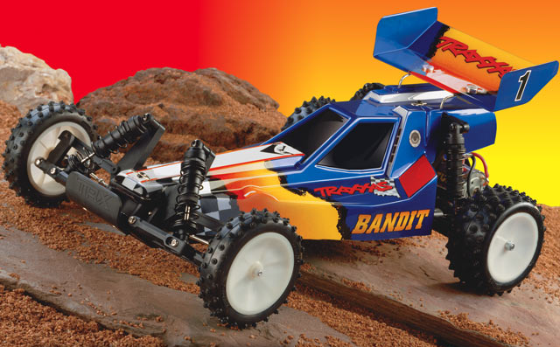
Figure 1: The Traxxas Bandit

The initial concept was for Ot to follow a line up to the ramp. At high speeds, the line tracking photosensors would have to be mounted far in the front of the robot in order to be effective. However, any landing would certainly destroy the photosensors. (In fact, the line tracking board was destroyed by impacts with a wall before Ot ever jumped a ramp). No solution was found to this contradiction, so Ot’s design had to be changed to avoid line following.
The Traxxas Bandit came with a mechanical throttle system which was unsuited to controlling Ot’s speed to the precision required. In addition, it was highly nonlinear and greatly limited how slowly the motor could be driven. Therefore, the mechanical throttle was removed and replaced with a digital speed controller. This modification to the standard Bandit design proved more than sufficient for the precision and accuracy necessary for Ot.
Sensors
Initially, Ot used OPB745 photosensors for line following (see Figure 2). These sensors were particularly unreliable and glitchy (one was even faulty and had to be replaced), which would have made following a line difficult. In addition, the OPB745s are especially large photosensors which normally allowed their board to be mounted further up. However, Ot’s suspension made his height variable enough that the photosensors were often not far enough off the ground to detect reflective objects. Although Hamamatsu’s photosensors could have solved the height problem, the necessity of mounting the photosensors in the front of the car made line tracking unfeasible.
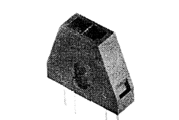
Figure 2: OPB745

The sonar chosen was the common SRF04 range finder (see Figure 3). This sonar was remarkable in its accuracy and linearity. An inch corresponded to exactly a 100us increase in the echo output of the sonar. I was impressed with the SRF04’s durability and reliability in practice. For all the problems I had building Ot, the sonar was the one system that never broke.
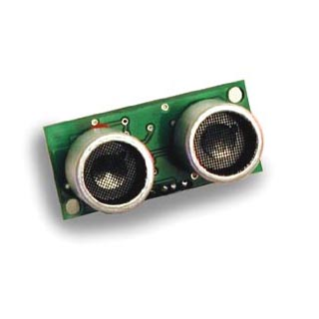
Figure 3: SRF04

Microcontroller and Boards
Like many this Summer, I chose to use BDMicro’s Mavrik-IIB board (see Figure 4) and the Atmega128 to control Ot. The board proved very convenient, and I believe the Atmega128 deserves the reputation which precedes it.
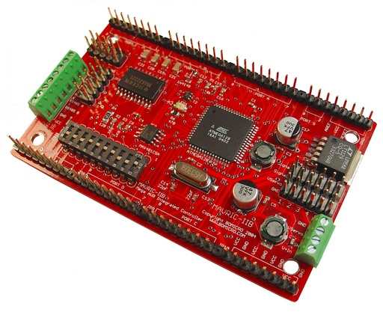
Figure 4: Mavrik-IIB and the Atmega128
I designed a powerboard for extra power connections and to help interface the LCD from a 10 pin connection to a 6 pin connection (with potentiometer for the contrast). The schematic and board designs can be found in Appendix A.
The line tracking board was designed for the OPB745 photoreflectors. The board uses the standard pull up resistor set up to read the value from the photoreflectors’ transistors. See Appendix B for the full schematic and board design.
Code and Intelligence
All of Ot’s code is reproduced in the Appendices. See Appendix C for behavior code, Appendix D for motor and servo control code, Appendix E for sonar code, and Appendix F for LCD code.
Ot’s behavior is designed to stay centered between two walls at as high a speed as possible. The sensors are designed to respond as quickly as possible while maintaining reliability. Ot’s behavior includes approximate heading correction to attempt to center himself after turning to avoid a wall. The key to Ot’s high speed is his responsiveness, prediction of incoming obstacles, and the highly tweaked motor and sensor code.
Ot’s behavior isn’t quite complete, though it performs superbly. When the motor broke, I had yet to test Ot using sharper turns and higher speeds (faster than I can run) or with proportional turning code. Though Ot reached a speed faster than I could keep up with which led to his ultimate demise, he never reached his full potential.
Problems
Perhaps I’m clumsy or unlucky, but Ot was plagued by an unusual number of hardware issues (even for a robot). From solder bridges, to cables that break every other day, to multiple shorts randomly appearing in my boards, I spent the great majority of my time fixing things I had already finished. In addition, after the digital speed controller broke, requiring a 2 hour trip to Ocala and $80 to replace. Unfortunately, the motor then broke the day before media day, making this investment worthless.
Mounting boards to the Bandit also proved surprisingly difficult. The Bandit is a smaller and more compact RC car than most of the other RC platforms used this summer in IMDL. Also, the range of motion required by the mechanical steering made boards difficult to mount in the front of the car. Though a workable solution was eventually found, mounting was primarily a process of trial and error that consumed far more time than I had allotted. (Here’s some advice: never try to find 4-40 size threaded rod in Gainesville.)
Although Murphy and I managed to break plenty of Ot’s components by ourselves, another problem presented itself toward the end of Ot’s design. As Ot’s intelligence and thus speed grew, he eventually reached a point where I could no longer run fast enough to keep up with him and prevent him from impacting the end of the hallway where he was being tested. I believe these impacts were a source of many of the more mysterious repairs I had to make, including the final death of my motor.

Appendix A
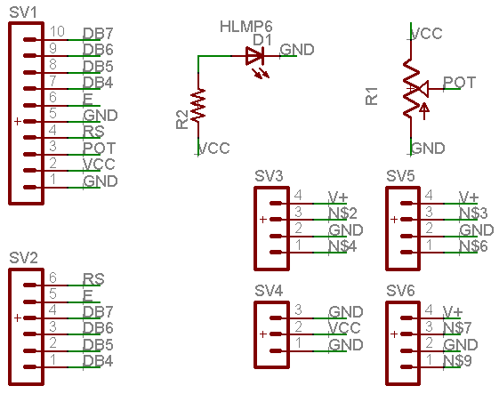
Powerboard Schematic

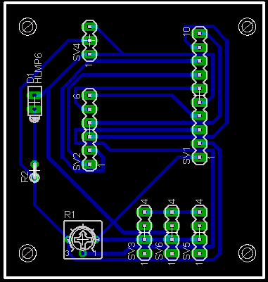
Powerboard Board Design

Appendix B

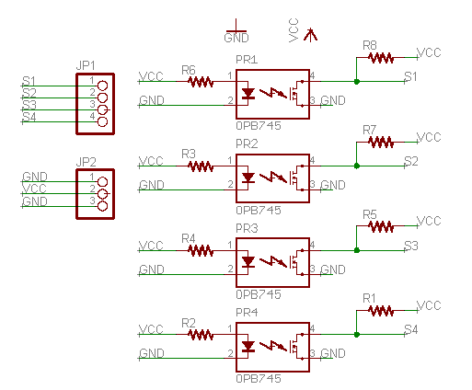
Photoboard Schematic

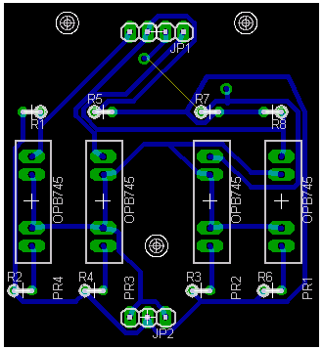
Photoboard Board Design

Appendix C

#include <avr/io.h>
#include <avr/interrupt.h>
#include <avr/signal.h>
#include <inttypes.h>

#include "LCD.h"
#include "sonar.h"
#include "drive.h"
#include <stdlib.h>
#include <stdio.h>

volatile int lastleft;

int main(void)
{
LCD_init();
sonar_init();
fdevopen(putCharLCD, NULL, 0);
init_servos();
correct_heading=0;
count_turns=0;

sei();

//driveMin();
SERVO2=3230;

while(1){
SampSonar();
us50_sleep(800);
clearDisp();
us50_sleep(200);
printf("%d %d %d %d %d",SERVO2,count_turns,correct_heading, turn_count, turn_count2);
//printf("%d %d %d %d",count_turns, correct_heading, turn_count, turn_count2);
//printf("%d",SERVO2);
if(dist1 < 90 && (SERVO1==2830 || dist1>50 || correct_heading))
{
SERVO2=3230;
correct_heading=0;
count_turns=1;
turn_count=0;turn_count2=0;
if(dist2<110) //turn left
{
SERVO1=3430;
lastleft=1;
}
else //turn right
{
SERVO1=2230;
lastleft=0;
}
}
else if(dist1 > 110)
{
SERVO2=3230;
if(count_turns)
{
count_turns=0;
turn_count=turn_count/3; turn_count2=turn_count2/3;
}

if(turn_count>0 || turn_count2>0)
{
correct_heading=1;
if(lastleft)
{
SERVO1=2230;
}
else
{
SERVO1=3430;
}
}
else
{
SERVO1=2830;
correct_heading=0;
}
}

if(dist1 < 20 || (SERVO2<3000))
{
count_turns=0;correct_heading=0;
turn_count=0;turn_count2=0;
//SERVO2=3000;

if(SERVO2>3000)
{
SERVO1=5660-SERVO1;
SERVO2=3000;
us50_sleep(100);
}
if(dist1<50)
{
SERVO2=2850;
}
}
/*else
{
//driveMin();
}*/
}

/*while(1)
{
SampSonar();
us50_sleep(1000);
clearDisp();
us50_sleep(200);
printf("%d %d",dist1,dist2);
}*/
}

Appendix D

#include <avr/io.h>
#include <avr/interrupt.h>
#include <avr/pgmspace.h>
#include <avr/signal.h>

#include <stdio.h>
#include <ctype.h>
#include <stdlib.h>
#include <string.h>

#define SERVO1 OCR3A
#define SERVO2 OCR3B

#define SERVO_MIN 2000
#define SERVO_MID 3000
#define SERVO_MAX 4000

SIGNAL(SIG_OVERFLOW3)
{
TCNT3 = 0;
PORTE |= 0x03;
}

SIGNAL(SIG_OUTPUT_COMPARE3A)
{
PORTE &= 0xFE;
}

SIGNAL(SIG_OUTPUT_COMPARE3B)
{
PORTE &= 0xFD;
}

void driveMin(void)
{
SERVO2=3130;
}

void init_servos(void)
{
DDRE |= _BV(PORTE0) | _BV(PORTE1);
TCCR3A &= ~(_BV(WGM31) | _BV(WGM30));
TCCR3B &= ~(_BV(WGM33) | _BV(WGM32) | _BV(CS32) | _BV(CS30));
TCCR3B |= _BV(CS31);
TCNT3 = 0;
ETIMSK |= (_BV(TOIE3) | _BV(OCIE3A) | _BV(OCIE3B));

SERVO1 = 2830;
SERVO2 = 3000;
}

Appendix E

#include <avr/io.h>
#include <avr/interrupt.h>
#include <avr/signal.h>
#include <inttypes.h>

#include "LCD.h"
#include <stdlib.h>
#include <stdio.h>

volatile uint16_t ms_count;
volatile int sonar1,sonar2;
volatile int Tdist1, Tdist2;
volatile int dist1,dist2;
volatile int inSonar1,inSonar2;
volatile int avg1,avg2,avg3,avg4;
volatile int turn_count, count_turns, correct_heading,turn_count2;

void us50_sleep(uint16_t us50)
{
TCNT0 = 0;
ms_count = 0;
while (ms_count != us50);
}

SIGNAL(SIG_OUTPUT_COMPARE0)
{
ms_count++;

if(count_turns)
{
turn_count++;
if(turn_count>3000)
{
turn_count-=300;
turn_count2++;
}
}

if(correct_heading)
{
turn_count--;
if(turn_count<1 && turn_count2>0)
{
turn_count+=300;
turn_count2--;
}
}

if(sonar1)
{
inSonar1 = PINC & (0x01);

if(inSonar1 != 0)
{
Tdist1 = Tdist1 + 1;
}
else
{
dist1 = Tdist1;
Tdist1 = 0;
sonar1 = 0;
}
}

if(sonar2)
{
inSonar2 = PINC & (0x10);

if(inSonar2 != 0)
{
Tdist2 = Tdist2 + 1;
}
else
{
dist2 = Tdist2;
Tdist2 = 0;
sonar2 = 0;
}
}
}

void init_timer(void)
{
/*
* Initialize timer0 to generate an output compare interrupt, and
* set the output compare register so that we get that interrupt
* every millisecond.
*/
TIFR |= _BV(OCIE0);
TCCR0 = _BV(WGM01)|_BV(CS02)|_BV(CS00); /* CTC, prescale = 128 */
TCNT0 = 0;
TIMSK |= _BV(OCIE0); /* enable output compare interrupt */
OCR0 = 6; /* match in 50 us */
}

void sonar_init(void)
{
DDRC |= 0x22;
DDRC &= 0xEE;

PORTC = 0x00;

sonar1 = 0;
sonar2 = 0;
dist1 = 1000;
dist2 = 1000;

init_timer(); // initializing timer for sonar
}

void trigSonar(void)
{
PORTC |= 0x22; //trigger high
us50_sleep(1);
PORTC &= 0xDD;
us50_sleep(5);
}

void SampSonar(void)
{
for(int j=2;j!=0;j--)
{

if (!sonar1&&!sonar2){
trigSonar();
sonar1 = 1;
sonar2 = 1;
}

while(sonar1 || sonar2);

us50_sleep(100);

if(j == 2)
{
avg1 = dist1;
avg3 = dist2;
}
if(j == 1)
{
avg2 = dist1;
avg4 = dist2;
}
}

dist1 = (avg1 + avg2)/2;
dist2 = (avg3 + avg4)/2;
us50_sleep(200);
}

Appendix F

#include <avr/io.h>
#include <avr/delay.h>
#include <stdio.h>
#include <stdlib.h>

#define EN 0x10
#define RS 0x20

int Count_lcd; //Global variables for putChar routine
//int char_count;
int Row2count;

void LCD_init(void)
{

Count_lcd = 0;
Row2count = 0;

_delay_loop_2(1000); //First 4 nibbles sets 4-bit mode

DDRA = 0xFF;

PORTA = 0x03;
PORTA = 0x13;
PORTA = 0x03;

_delay_loop_2(400);

PORTA = 0x03;
PORTA = 0x13;
PORTA = 0x03;

_delay_loop_2(400);

PORTA = 0x03;
PORTA = 0x13;
PORTA = 0x03;

_delay_loop_2(400);

PORTA = 0x02;
PORTA = 0x12;
PORTA = 0x02;

_delay_loop_2(160); // next two nibbles sets two line mode

PORTA = 0x02;
PORTA = 0x12;
PORTA = 0x02;

_delay_loop_2(160);

PORTA = 0x0C;
PORTA = 0x1C;
PORTA = 0x0C;

_delay_loop_2(160); // next two nibbles Display, Cursor, and Cursor Blink on

PORTA = 0x00;
PORTA = 0x10;
PORTA = 0x00;

_delay_loop_2(160);

PORTA = 0x0F;
PORTA = 0x1F;
PORTA = 0x0F;

_delay_loop_2(160); // clear display, cursor home

PORTA = 0x00;
PORTA = 0x10;
PORTA = 0x00;

_delay_loop_2(160);

PORTA = 0x01;
PORTA = 0x11;
PORTA = 0x01;

}

int putCharLCD(char ch)
{

int j;

if(Count_lcd != 16)
{

PORTA = (ch >> 4) | (EN | RS); //First nibble
_delay_loop_2(6000);
PORTA = (ch >> 4) | RS;

_delay_loop_2(160);

ch &= 0x0F;
PORTA = (ch | EN | RS); // second nibble
_delay_loop_2(6000);
PORTA = (ch | RS);

Count_lcd = Count_lcd + 1;
//char_count = char_count - 1;

}

else
{

if(Row2count == 0)
{
PORTA = 0x0C | EN; // jump to second line
_delay_loop_2(6000);
PORTA = 0x0C;

_delay_loop_2(160);

PORTA = 0x00 | EN;
_delay_loop_2(6000);
PORTA = 0x00;

j = 16;

do // clear line 2
{

PORTA = 0x02 | EN | RS;
_delay_loop_2(6000);
PORTA = 0x02 | RS;

PORTA = 0x00 | EN | RS;
_delay_loop_2(6000);
PORTA = 0x00 | RS;

j = j - 1;

}while(j != 0);

j = 16;

do
{

PORTA = 0x01 | EN; // Back to left of line 2
_delay_loop_2(6000);
PORTA = 0x01;

_delay_loop_2(160);

PORTA = 0x00 | EN;
_delay_loop_2(6000);
PORTA = 0x00;

j = j - 1;

}while(j != 0);

PORTA = (ch >> 4) | (EN | RS); //First nibble
_delay_loop_2(6000);
PORTA = (ch >> 4) | RS;

_delay_loop_2(160);

ch &= 0x0F;
PORTA = (ch | EN | RS); // second nibble
_delay_loop_2(6000);
PORTA = (ch | RS);

Count_lcd = 1; // equals 1 because there is already 1 char on row 2
// when row two write operations begin.
Row2count = 1;

}

else
{

PORTA = 0x00 | EN; // cursorback home
_delay_loop_2(6000);
PORTA = 0x00;

_delay_loop_2(160);

PORTA = 0x02 | EN;
_delay_loop_2(6000);
PORTA = 0x02;

j = 16;

do // clear line 1
{

PORTA = 0x02 | EN | RS;
_delay_loop_2(6000);
PORTA = 0x02 | RS;

PORTA = 0x00 | EN | RS;
_delay_loop_2(6000);
PORTA = 0x00 | RS;

j = j - 1;

}while(j != 0);

PORTA = 0x00 | EN; // cursorback home
_delay_loop_2(6000);
PORTA = 0x00;

_delay_loop_2(160);

PORTA = 0x02 | EN;
_delay_loop_2(6000);
PORTA = 0x02;

PORTA = (ch >> 4) | (EN | RS); //First nibble
_delay_loop_2(6000);
PORTA = (ch >> 4) | RS;

_delay_loop_2(160);

ch &= 0x0F;
PORTA = (ch | EN | RS); // second nibble
_delay_loop_2(6000);
PORTA = (ch | RS);

Count_lcd = 1; // equals 1 because there is 1 char on line 1
// when writes to line 1 begin
Row2count = 0;

}

}

return ch;
}

void clearDisp(void)
{

_delay_loop_2(400);
PORTA = 0x00 | EN; // cursorback home & clear
_delay_loop_2(6000);
PORTA = 0x00;

_delay_loop_2(160);

PORTA = 0x01 | EN;
_delay_loop_2(6000);
PORTA = 0x01;

Count_lcd = 0;
Row2count = 0;
_delay_loop_2(400);
}

/*int main(void)
{
fdevopen(putCharLCD, NULL, 0);

LCD_init();

clearDisp();
printf("Hello World");
}*/

