Carlo Pascoe

University of Florida
Department of Electrical Engineering
EEL 5666
Intelligent Machines Design Laboratory

Sensor Report: Automated Poker Dealer

Just as it sounds the Automated Poker Dealer acts as the dealer for a poker game. It does this through the aid of several sensors. The first type of sensor is 12 standard SPST switches-- 8 switches corresponding to 8 players and their positions on the table, 3 switches corresponding to 8 different types of poker games, and a single switch that indicates that a rigged deck of cards hidden inside the robot should be put in play. These switches are active before game play begins and become inactive when the next sensor is activated, the next sensor being a set of weight sensors that determine when a deck of cards has been placed in the card loader. Once the deck has been loaded into the robot game play commences and only stops again for four different reasons:

- The round is complete
- The IRPD-01 Proximity Sensor has determined that an obstacle impedes the robots movement
- 1 of the 4 standard bump switches has determined that an obstacle impedes the robots movement
- Some aspect of the current game requires human input communicated through the SR-07 voice recognition system

The remainder of this report discusses the Scope, theory, objectives, and references for each of these sensors.

Sensor 1: SPST Switches
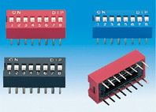
Vendor: Lab
Part#: unknown
These are your standard SPST switches. One set of switches is an 8 switch DIP pack and the other is a 4 switch DIP pack for a total of 12 SPST switches. As stated above these switches will allow the processor to determine the number of players and their positions on the table (8s DIP pack), what game the users want to play, and if the user wants to use the rigged deck of cards (4s PID pack). These switches will be connected with a pull-up resistor and signal line on one terminal and GRND on the other terminal so that +5V and GRND will be on the signal line when the switch is open or closed respectively. I wired up 3 different switches and with a volt meter proceeded to test the reliability of these switches. I performed 25 tests on each switch and recorded 100% reliability on each switch.
Images from: www.emulation.com/catalog/

Sensor 2: Weight Sensors
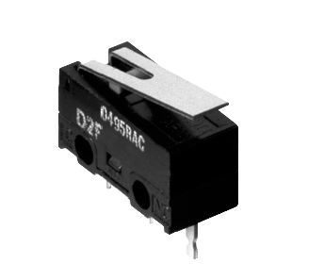
Vendor: Spark Fun Electronics
2500 Central Ave.
Suite Q
Boulder, CO 80301
Tel: 1-303-284-0979
Fax: 1-303-443-0048
E-m: fun@sparkfun.com
Web: www.sparkfun.com/
Part#: D2F-L
Since the deck of cards is either placed in the loader or it’s not I used a Subminiature Snap Action Switch to act as a digital weight sensor rather than using its analog counterpart. Two of these switches, one for each card slot, will be used to determine if a cut deck of cards has been placed in the loader. The microcontroller will wait until it receives signals from both of these switches before it commences game play. This switch has three terminals as depicted below (COM, NC, NO).
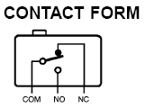

The signal line that is sent to the microcontroller will be connected to the COM terminal with a resister in series, the NC terminal will be connected to GRND, and the NO terminal will be connected to VCC. This connection will ensure that when the cards are placed in the loader +5V will be sent to the microcontroller. I wired up the 2 sensors and with a volt meter proceeded to test the reliability of these weight sensors. I performed 25 tests on each and recorded 100% reliability.
Images From: www.sparkfun.com

Sensor 3: IRPD-01 Proximity Sensor
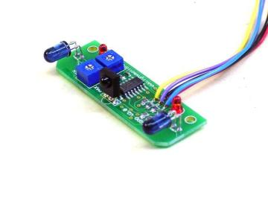
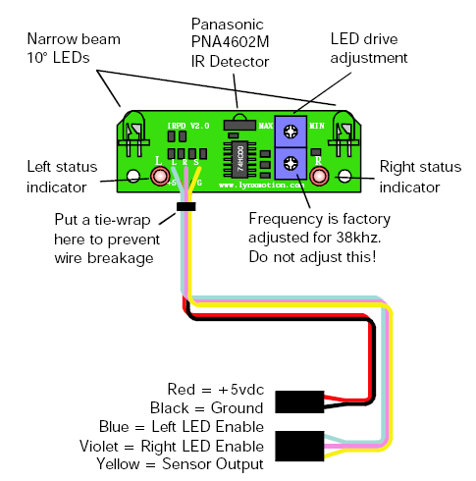
Vendor: Lynxmotion, Inc.
PO Box 818
Pekin, IL 61555-0818
Tel: 309-382-1816 (Sales)
Tel: 309-382-2760 (Support)
Fax: 309-382-1254
E-m: sales@lynxmotion.com
E-m: tech@lynxmotion.com
Web: http://www.lynxmotion.com
Part#: IRPD-01
This sensor detects small objects that pass in front of it. Through the use of 2 LED’s transmitting at 38kHz and a Panasonic PNA4602M IR Detector, the sensor is able to detect when the pattern of reflecting light changes thereby deducing that some object in front of the sensor is causing the altered pattern. This device has many other components that make it easy to interface with a microcontroller— when wired up as the image above depicts one only needs 1 input pin to determine if an object is in front of the device. The other components are connected as the image below depicts.

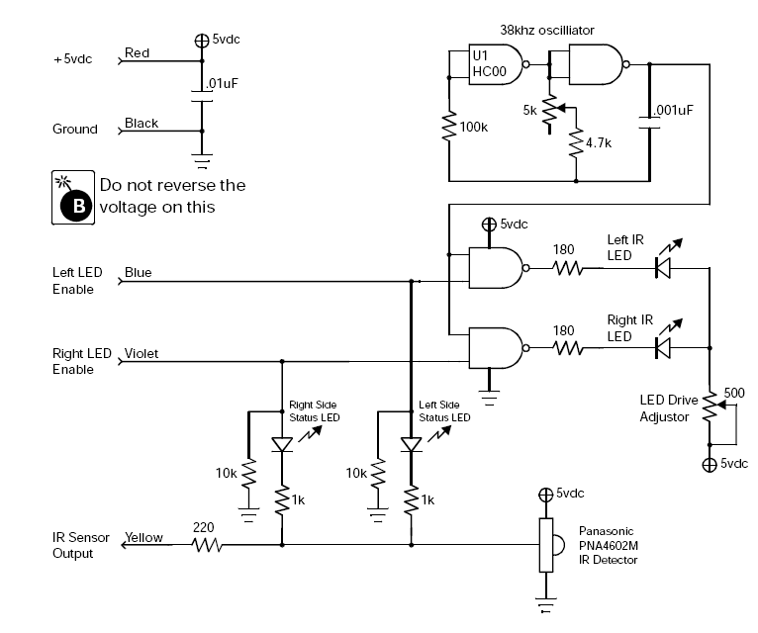
Though the device can detect objects in 3 different cones as the picture below shows, there is only 1 sensor output signal that goes low when an object is detected and is high otherwise. Alternating the LED enable signals will allow the microcontroller to distinguish which cone the object is in.

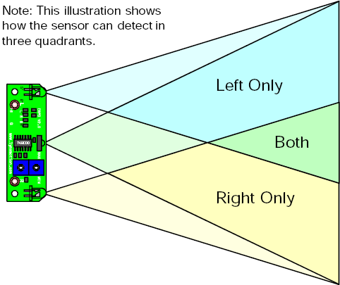

The truth table below shows the appropriate IR detector output given the various inputs.
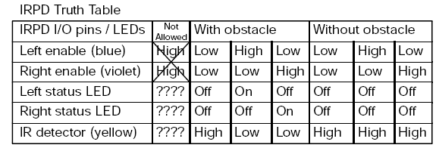
My testing shows that this sensor will reliably detect object that are within 5 to 7 inches of the IR Detector. This relatively large range is due to that fact that dark and light colors reflect light differently. The sensor will detect a white object from about 7 inches and a black object from about 5 inches.
Images From: www.lynxmotion.com

Sensor 4: Bump Switches
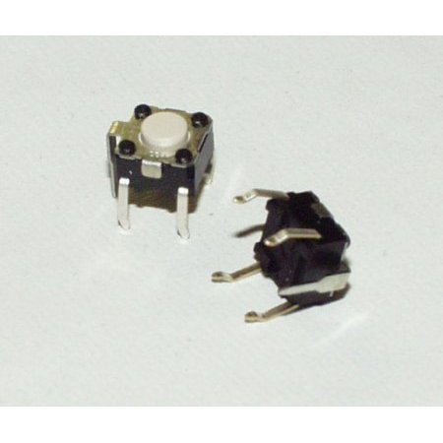
Vendor: Lab
Part#: unknown
Four standard bump switches are used as a fail safe when the IRPD-01 Proximity Sensor does not detect an object. The object will have to come in contact with a wooden strip that closes the bump switch indicating to the processor that the robot has hit something. When a bump switch is activated the robot immediately stops and waits for the object that has triggered the bump switch to be removed. These bump switches are wired up just like the SPST switches from above. I wired up 3 different bump switches and with a volt meter proceeded to test their reliability. I performed 25 tests on each and recorded 100% reliability.
Images From: www.sparkfun.com

Sensor 5: SR-07 Voice Recognition System
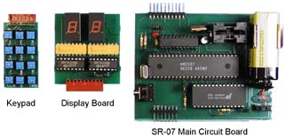
Vendor: Images Scientific Instruments INC.
109 Woods of Arden Road
Staten Island NY 10312
Tel: (718) 966-3694
Fax: (718) 966-3695
E-M: Imagesco@bellatlantic.net
Part#: SR-07
The SR-07 voice recognition system is a standalone development board that allows a user to train up to 40 different words then indicate through a BCD output signal that a word has been recognized. This system works by utilizing a HM2007 chip which is a speech recognition chip that provides the options of recognizing either 40 .96 second words or 20 1.92 second words. When turned on, the HM2007 checks the static 8K X 8 static RAM for instructions. When the board is ready for use it will output a “00” BCD signal. Regardless if there are any words stored in memory, you can train a new word by entering a number 1-40 on the keypad then pressing the train button. The circuit will then record the next word you say and then blink an LED to indicate that the word has been recorded. When recording the board will output a “55” when a word is to long or a “66” when a word is to short, prompting the user to try and train the word again. Once words are stored in the device, it is continually monitoring speech for a potential match to a word. When a mach is found the board will output the number of the word that it matched. If there is not a match to words spoken the board will output a “77.” The way this circuit works makes it vary easy to interface with a microcontroller. The jobs of listening and recognition don’t occupy any microcontroller clock cycles. The output of the board can be continually fed into an input port on the mavrik board and only worry about the data when it needs to. A diagram of the entire SR-07 voice recognition system is provided below.
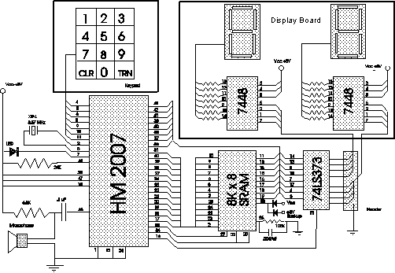

In order to test this circuit I trained the device with the different words I will need my robot to recognize:

- “Continue”- needed when the players want to convey that game play is ready to continue
- “One”- needed when a player needs 1 card
- “two”- needed when a player needs 2 cards
- “three”- needed when a player needs 3 cards
- “four”- needed when a player needs 4 cards
- “five”- needed when a player needs 5 cards
- “done”- needed to signal that the game is over

The table below shows the results of my tests

Word | #of success out of 50 (no noise) | Percentage | #of success out of 50 (noise) | Percentage
Continue | 47 | 94 | 44 | 88
One | 38 | 76 | 23 | 46
Two | 35 | 70 | 22 | 44
Three | 41 | 82 | 23 | 46
Four | 38 | 76 | 18 | 36
Five | 37 | 74 | 30 | 60
Done | 40 | 80 | 27 | 54

As you can see the results are satisfactory for multi-syllable words but are not so great for one syllable words. I think I will have to change the words I want to recognize to multi-syllable words for the actual robot. We will see.
Images From: www. imagesco.com/catalog/

