INSTIGATOR
Start Something Today.

EEL 5666: Intelligent Machine Design Laboratory
University of Florida

Dr. Eric M. Schwartz
Dr. A. Antonio Arroyo

ABSTRACT: 3
EXECUTIVE SUMMARY: 3
INTEGRATED SYSTEM: 6
MOBILE PLATFORM: 7
ACTUATION: 8
DRIVE: 9
STEERING: 9
CONTROL: 11
PERCEPTION: 12
IR: 12
SONAR: 13
ROAD FINDER: 13
BEHAVIOR: 15
EXPERIMENTAL SETUP: 17
CONCLUSION: 18
WORKS CITED: 19
APPENDIX: PROGRAM CODE 20
PC HEADER FILE: 20
PC SOURCE FILE: 28
MICROCONTROLLER HEADER FILE: 30

ABSTRACT:

The goal of the InstiGator project is to develop a working and ever evolving test-bed platform for the development of smart sensing components, specifically a road-finding vision system. The platform was designed to mimic many of the basic driving characteristics of a full-sized automobile while providing a low-cost re-configurable platform capable of carrying a variety of sensor payloads with sufficient computing and power resources. To this end a design was proposed and subsequently produced which satisfied these requirements. The resulting vehicle provides a robust platform with respect to controllability and expandability and whose first sensor payload (the Road Finder) is extremely effective.

EXECUTIVE SUMMARY:

The platform designed and deployed in this project is intended first and foremost as a test-bed sub-system to be used in the testing of new smart sensing components prior to their integration into the University of Florida’s 2007 DARPA Urban Challenge vehicle, a full-sized Toyota Highlander Hybrid SUV. The impetus for this project is to provide developers on the perception and sensing team to test their components on a comparatively inexpensive and easily repairable platform. By doing such scaled down tests, a given developers work can be demonstrated in a smaller, lower cost and safer environment.

The second part of the design project is to develop my own contribution to the suite of smart-sensing devices being produced by CIMAR (Center for Intelligent Machines And Robotics) and the MIL (Machine Intelligence Lab). In particular I propose to develop a vision based sensor payload capable of capturing full-color images via a low-cost USB web-camera and subsequently process each frame to extract so-called “meta-data” regarding the location and orientation of lane centers on a given stretch of road. The problem of accurately classifying road lines within a given image and then determining the location of the lane-center relative to the vehicle is a direct issue from the latest DARPA Urban challenge. While this problem is both unstructured and open to innumerable solutions it was opted to pursue a color-based classification scheme.

The development of both the vehicle and sensor systems resulted in a relatively large-scale robotic platform measuring 48” long by 32” wide by 31” tall which is capable not only of simple obstacle avoidance and autonomous control of both steering and throttle systems but which posses a near-real-time computer vision system which can actively determine the location of both road-lines and their resultant lane-centers. The later was accomplished by developing a linear classification algorithm in C++ which relies on the Open Source Computer Vision Libraries (OpenCV for short). These libraries, combined with a custom searching/classification algorithm developed during the project allow the smart-sensor to isolate road-lines of specific color ranges, classify each pixel for its color values, and finally search line by line to locate the start and end locations (measured in pixels) of each lane. By simply averaging these positions and subtracting ½ of the image width, and simple error signal is generated to close the control loop around the vehicle actuators.

The final deployment of the above systems consisted of a rugged vehicle platform outfitted with a 350 watt electric drive motor connected through a 7.2:1 chain reduction for increased torque and low-speed operation, a 200 watt gear-motor equipped with potentiometer absolute position feedback, a forward-looking infrared sensor and a rear-looking ultrasonic sensor for obstacle avoidance, and a forward-looking web-cam used for lane localization and navigation. These systems were powered by a series of two 12V deep-cycle batteries capable of 4 hours continuous operation between charging. Moreover, the vehicle is driven by two computing devices. First, high-level operations including computer vision processing and navigation are carried out by an AMD based 64-bit computing node in a 1-U form-factor. The commands generated by the high-level processes are then passed via RS-232 to a BD Micro Mavric IIB Atmel mega128 based microcontroller. It is at the microcontroller level that the vehicle carries out PID based control of both drive and steering systems and integrates the obstacle avoidance systems. The result is a rugged development platform which can be used to verify the stability and performance of new and developing sensing and control technologies safely and at lower-cost.

INTRODUCTION:

The problem of not only developing a versatile autonomous platform but of developing a reliable and intelligent means of localizing perceived road markings for navigation is daunting to say the least. While a great portion of the project involves overcoming physical problems in the realm of nuts and bolts, a considerable amount of work and development is required to produce vision based navigation systems for robotic use.

Over the last several decades many researchers have attempted to tackle the problem of vision based obstacle detection and navigation with varying measures of success. To date, many of these efforts have been focused on stereo or stereopsis in which a pair of like cameras is co-located with a pre-defined offset and like orientation. The images produced by the two slightly offset cameras mimics the way in which human vision functions (ocular depth perception). By taking the two offset images and comparing them and looking for where the image changes from one camera to another, developers are able to create a difference map like the one pictured in Figure 1 below.

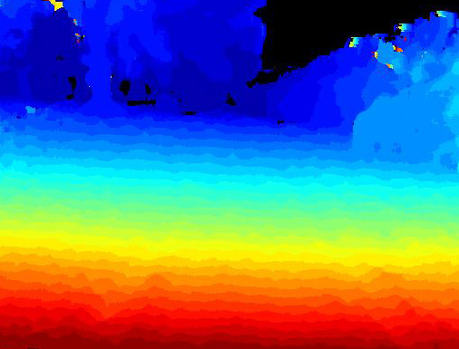
Figure 1: Stereo-Vision Difference Map

While the results of such processes are visually impressive the body of work on the subject has shown that there are many fundamental limitations to the technology. One of these primary limitations is the resolution and corresponding processing time required to effectively generate useful information from stereo-imagery. This limitation is due to the fact that the human eye can see on the order of 500 mega pixels compared to the majority of digital cameras on the market today which top out around 10 mega pixels.

Another limitation is the fact that people do not actually use their entire resolution. In fact, at any given instant only a small fraction of a person’s visual range is in high resolution (See Figure 2)

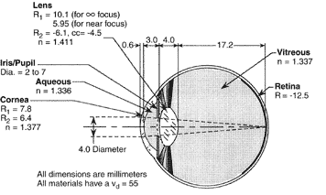
Figure 2: Optical Range of Human Eye
.
This single aspect exposes a major hole in most stereo-vision systems in which they attempt to characterize an entire scene while a human intuitively characterizes only a small region of importance. Lastly, all computer vision based systems are subject to failure in adverse lighting conditions. In short, shadow is the bane of stereo-vision’s existence as shifting shadows can create false measurements and introduce large errors to the generated difference map.

For the approach outlined in this paper, a monocular vision system was designed in which a single camera pointed at a declination of approximately 30º is used to capture streaming video. The video is then classified according to color into one of 3 possible colors: red, blue, and black. For the purposes of this project blue objects are representative of road-lines delineating road lanes, red objects are representative of control devices such as stop signs, and black is the default color into which all other pixels not previously classified as red or blue are colored.

By classifying the captured image and then applying the Road Finder algorithm we can determine the location of the center of a perceived lane (when present) and thus generate an error signal to command and control the actuation of the InstiGator platform. In the coming sections, each of the vehicles primary systems will be discussed and finally the theory behind the Road Finder algorithm will be covered and future improvements outlined.

INTEGRATED SYSTEM:

The basic layout of the InstiGator platform is hierarchal in nature. The high-level controller located in the vision computing node provides planning and navigation commands to the low-level controller (referred to as the primitive driver or PD). This relationship is represented in Figure 3 below.

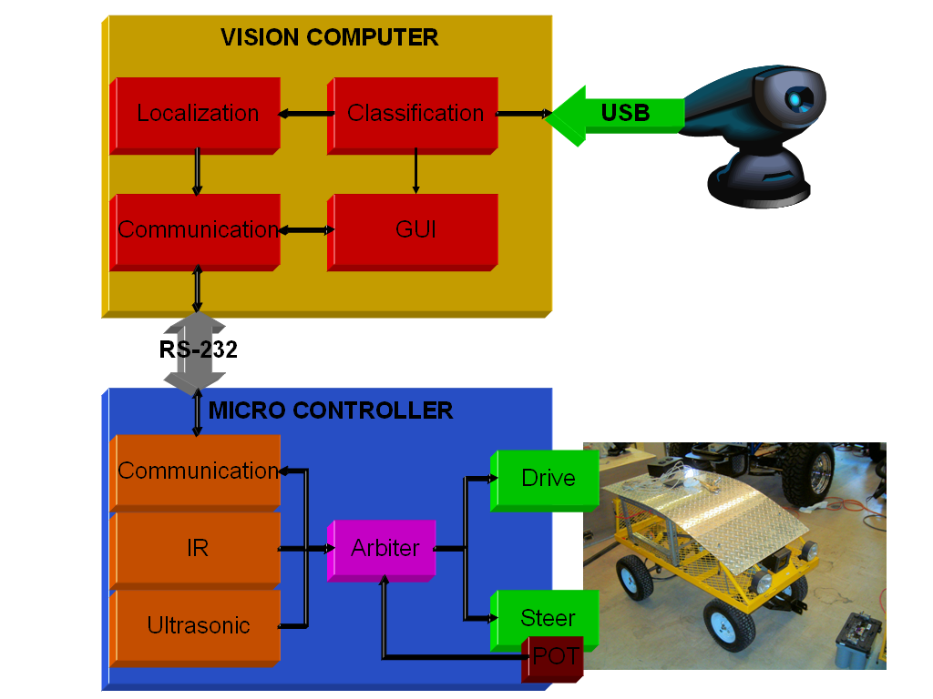
Figure 3: Block Diagram of InstiGator Integrated Systems

The figure depicts how the two computing resources communicate and manage data obtained from either low-level or high-level sensors. Additionally, the diagram shows a GUI or graphical user interface. This is akin to the Operator Control Unit (OCU) utilized by military robotic systems and is essentially a placeholder interface until the entire system can be brought up to JAUS standard (Joint Architecture for Unmanned Systems) and a proper OCU deployed. At current, the GUI employed is a simple command line interface with numerical options for user input.

It should be noted the types of information being passed over the various connections and how the different programming functions are defined and memory allocated. In writing the software for both the low and high-level controllers, general functions or sections of general code were functionalized and transferred into a separate header file. This header file also contains any and all variable declarations and definitions that can be accomplished outside of the main function. Where possible, the smallest data types were employed to minimize the memory utilized and the subsequent processing time required for transferring data between processing registers. For instance, the data being taken in by the camera stream is stored in a structured object of a class defined by the OpenCV library. This object is by nature floating point.

However, most of the processes carried out by the Road Finder algorithm do not require floating point calculation and thus in extracting the information from the image object into separate arrays for each color channel (RGB) short integers were used. Similarly, for pixel counters which can reach into the millions or beyond and which are subsequently used in averaging schemes, float or double data types were employed. Moreover, to minimize serial communication transfer times, a single character variable is used to send the error signal across the serial line to command the steering correction to the PD. However, this variable is signed as the Road Finder algorithm produces an error signal with both magnitude and direction.

The layout described above is suitable for the goals of the InstiGator in that multiple high-level smart sensing components can be integrated into a high-level arbitration process in which a single error command is generated. The single error command, whether generated by one or a dozen smart sensors is then transmitted to the PD which then effects the actuation. This design lends itself to expandability and versatility and provides the desired performance for development.

MOBILE PLATFORM:

The platform designed for the InstiGator came about through a combination of necessity, cost, and performance. The basic chassis and drive system is taken from a commercially available garden cart purchased from a local big-box home improvement store. With a sticker tag less than $70 a basic frame, 4 pneumatic tires, and an Ackerman steering linkage were obtained (Figure 4 below).

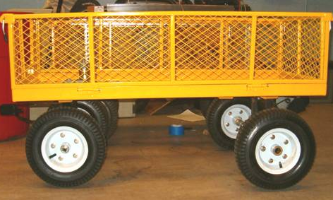
Figure 4: InstiGator Base Chassis/Drive Train

Furthermore, the sheer size of the platform lends it to integrating a large server rack and provides ample space for large battery banks. This aspect is critical to the success of the InstiGator as it is intended as a development platform for multiple sensor systems as modeled on the University of Florida’s 2005 DARPA Grand Challenge vehicle, the NaviGator. Thus, the platform must include ample room to host at least 3 1U form-factor servers and provide the associated power required to run them (See Figure 5 below).

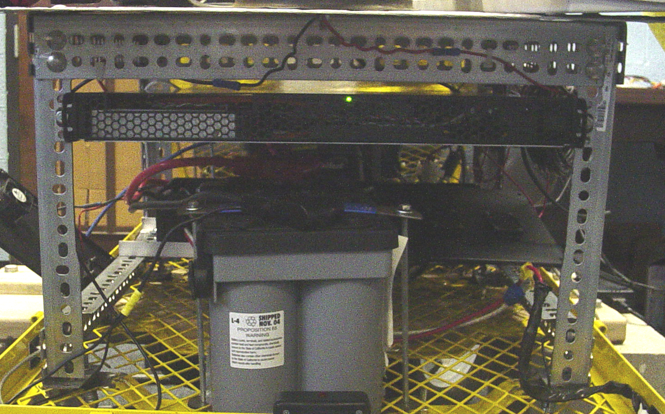
Figure 5: InstiGator Server Rack

Additionally, the platform features a stylish yet functional hood/roof system formed from a single sheet of diamond plate aluminum as depicted in Figure 6 below. This hood serves to provide a large unobstructed mounting surface for future sensing components including GPS antennas, scanning LADAR’s, and more. As a feature of the hood, the bend in the forward section can be adjusted by tightening or loosening the two tensioning rods located at the front of the vehicle.

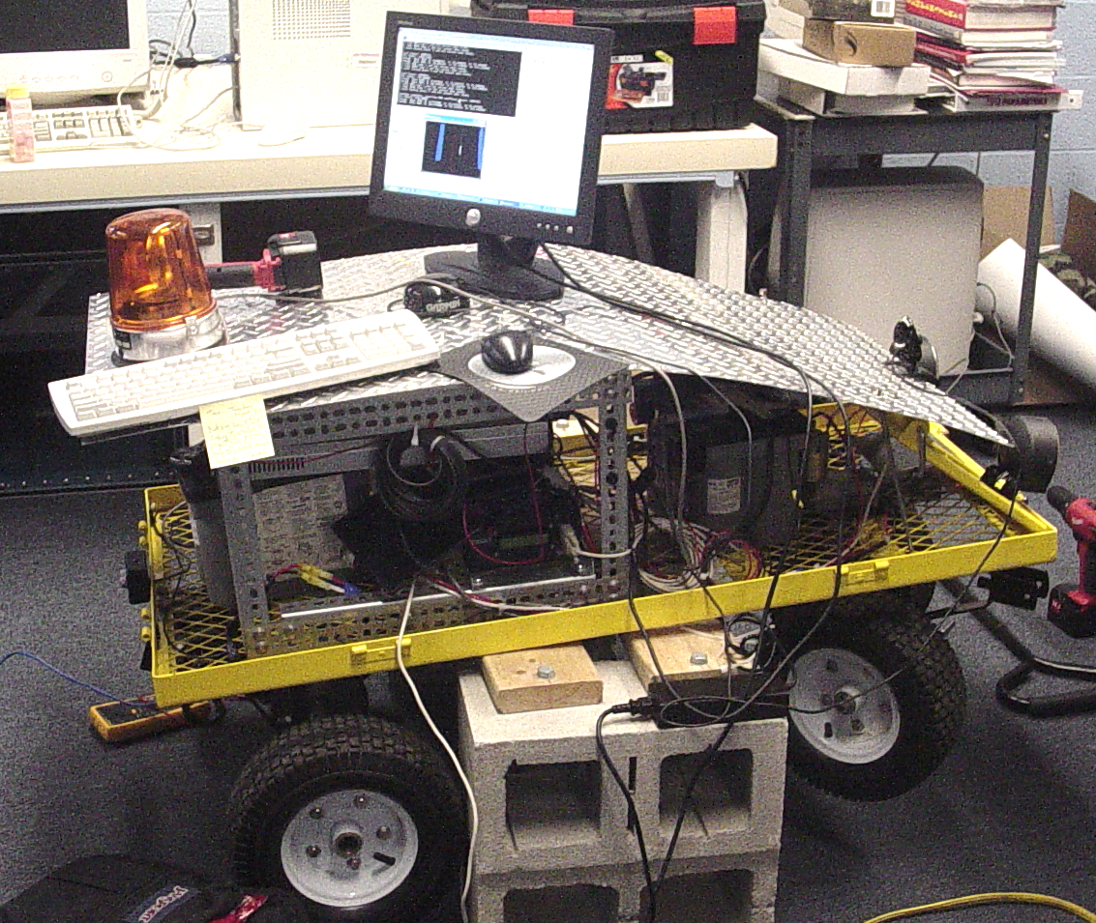
Figure 6: InstiGator Hood Mounting System

In the design and construction of the platform, it was found that vibration was a major concern. This is due primarily to the fact that the rear axle would not have a slipping differential and thus would skid on indoor surfaces like tile or concrete. This skid-slip behavior creates large amplitude, low frequency vibration of the entire frame which could potentially lead to a mechanical failure in the server hard drive. To correct this issue, a series of rubberized shock mounts were added to the server rack mounting points to attenuate the vibration to an acceptable frequency of approximately 5 Hz.

ACTUATION:

The InstiGator is actuated for front-wheel steering and rear-wheel drive. The resulting driving characteristics are that of a consumer 4WD SUV. The goal of the actuation is to provide a robust vehicle platform capable of high speed navigation over outdoor terrain. Additionally, the platform must provide for accurate and controllable steering and drive control while providing for smooth and stable motion. To do so the two main actuation systems and their accompanying components were sized, designed, and implemented as outline below.

DRIVE:

This feat was accomplished by using a high-powered permanent magnet DC motor with a maximum power rating of 350 watts. The motor is equipped with an 11-tooth #25 sprocket on the output shaft which was subsequently reduced via a chain and larger sprocket by a ratio of 7.2:1. With this gear ratio, the maximum speed of the vehicle if driven at 24V is approximately 14 mph with no inertial or friction loads. The motor is mounted such that the output sprocket is aligned along the vehicle’s center axis. The larger driven sprocket in the train is connected to a steel drive shaft that is supported between the drive-frame via two bearing blocks. These bearing blocks help to alleviate radial forces and to adjust the alignment of the drive wheels. The drive assembly is depicted below in Figure 7.

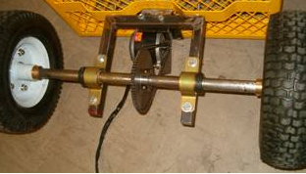
Figure 7: InstiGator Drive System

Despite the considerable power of the drive motor it lacks a differential to distribute power to the wheels effectively. This shortcoming presents itself in the platform shuddering and slipping on high-friction surfaces. However, this characteristic is advantageous for off-road operation which is where the InstiGator is intended to operate. Under such conditions, the InstiGator takes advantage of the locked rear drive to effectively transfer power to the driving surface where other differential driven vehicles would become stuck and left with their wheels spinning.

STEERING:

The steering actuation was accomplished by using a 12V gear motor with an estimated output torque of 1200 in-oz. The motor is mounted over the front steering linkage and connected to the drive link via a fitted shaft which is secured by set screws and welded to the output link of the Ackerman linkage. Like the drive motor, the steering motor is capable of 24V operation but during testing it was shown that driving the steering at 12V was more than sufficient to actuate the steering while static on a high-friction surface. Figure 8 shows the steering linkage, motor mount, and steering drive shaft.

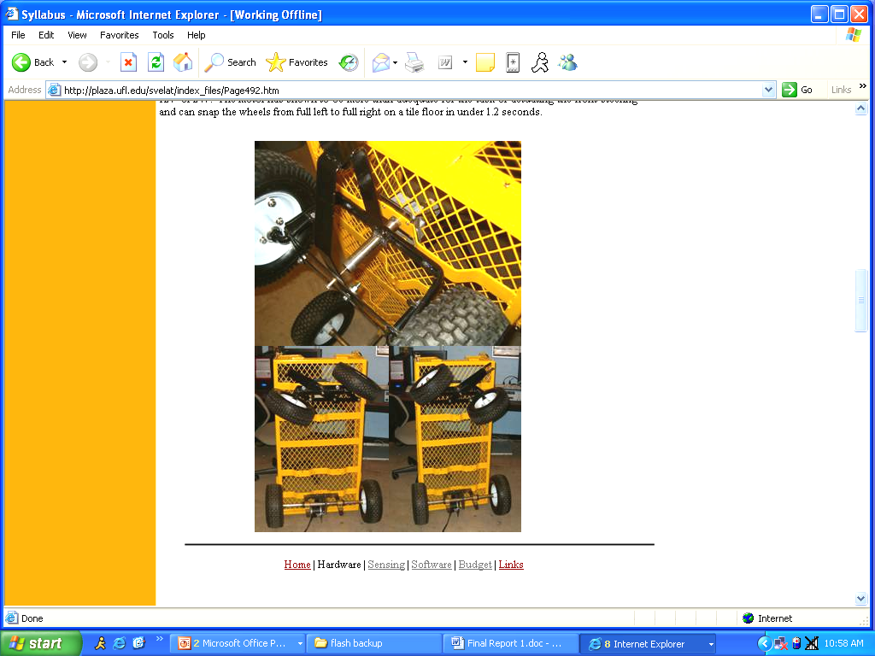
Figure 8: InstiGator Steering Linkage

From Figure 8, it is apparent that the linkage is limited by the throw of the Ackerman 4-bar mechanism. This limitation represents a hard stop condition for the platform and limits the vehicle to a minimum turn radius of turn radius of less than 10 ft. Figure 9 depicts the maximum turning limits of the platform.

Figure 9: InstiGator Turning Limits

These limitations in addition to the planned control implementation made it necessary to encode the steering shaft for position feedback. To do so, a 50 k-ω linear potentiometer was threaded into the output shaft and its base held to the ground link of the steering linkage. However, because of slight misalignments in the steering shaft the potentiometer the system was prone to catastrophic failure. To fix the encoding problem, the shaft of the potentiometer was shortened and a reduced-diameter extension was added to the steering shaft. Next, a length of stiff rubber hose was slipped over both the extension and the potentiometer. This hose permits easy transfer of rotational motion to the potentiometer while allowing the two shafts to slip and accommodate misalignments. The output of the linear potentiometer accurately encodes the motion of the steering linkage over a range of 0 – 255 in increments of approximately 0.3°.

CONTROL:

Each of the actuators is controlled via a high-powered motor driver originally designed by Dr. Chuck C. McManus. Each board is capable of driving either a single motor in two directions or two motors in a single direction. The board is rated for 40A at 24V however, the FET’s on the board lack sufficient heat-sinks to disperse the thermal load. To fix the thermal problem, additional aluminum heat sinks were added to each of the FET’s and the board was mounted into an enclosure with a substantial active cooling system. The motor driver board is depicted below in Figure 10.

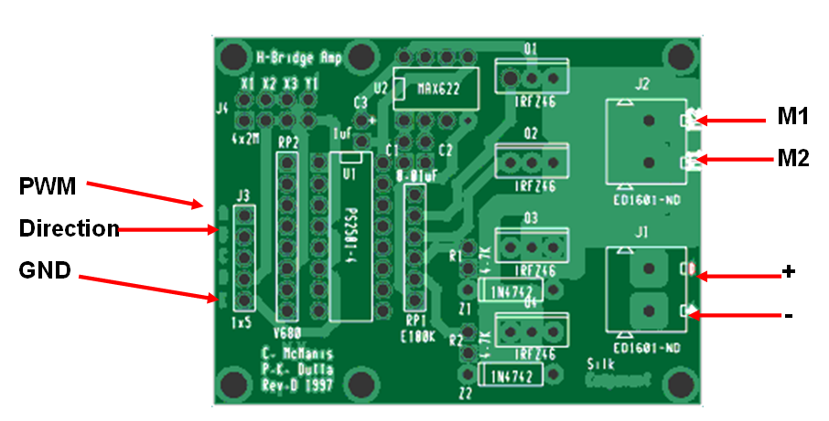
Figure 10: Motor Driver Board

For the InstiGator, a set of two boards were mounted into the cooled enclosure and their power systems routed through a set of 30A fuse terminals and switches to allow for safe operation and protect the boards from current spikes.

With the hardware of the actuation systems in place, the next step is to develop the software to utilize the steering and drive. The software was designed to be modular in nature. I.e. the PID control systems used for the steering and drive systems were functionalized and added to the PD programming in a header file. The advantage to this level of coding is a more efficient and clean implementation which provides ready access to vehicle control. A rudimentary discrete PID control system was designed for the steering actuator which puts the greatest weight on the proportional error/gain of the system. However, during tuning it was shown that commanding such large proportional gains leads to rapid and successive switching of direction in the steering motor. This issue has the potential to cause damage to the motor driver and thus some integral and derivative gain was added to the system. The net effect of the PID is to close the steering control loop and successfully minimize the error in steering position while preventing harmful oscillations or proportional errors.

In all, the process of actuating the vehicle was time consuming and difficult. The sheer size and mass of the platform made relatively straightforward processes difficult and awkward. For instance, to simply mount the drive train required more than 30 hours of work between fabrication, mounting, testing, and modification. Nevertheless, the actuation systems are robust. Likely the most interesting disaster encountered during the actuation process was a failure of the steering motor in which the output shaft failed in compression (a difficult task for soft metal) where in the shaft was actually flattened until fracture. Nevertheless, the vehicle represents a robust and rugged platform.

PERCEPTION:

The perception and sensing elements of the InstiGator are geared toward obstacle avoidance with an emphasis on road-line detection and lane following. To this end, a set of simple obstacle detection sensors were integrated on the front and rear of the platform along with a forward facing color camera. The simple obstacle detection sensors include a Sharp IR sensor and Devantech SRF08 sonar. The goal of these low-level sensors is to detect close-in obstacles which were not detected by the Road-Finder vision system. In contrast, the Road-Finder vision system is designed to isolate road-lines of specific color and to estimate the location of the center of the perceived lane. This process generates a reasonable approximation of the error between the vehicles position and the center of the intended lane and results in a commanded error signal which represents the error in orientation.

IR:

Rear obstacle detection was accomplished by utilizing the Sharp GP2Y0A21YK obtained from SparkFun.com for approximately $12.00. The sensors analog output ranges from 3.1V at 10cm to 0.41V at 80cm. In testing the sensor performed acceptably well while indoors but exhibited erratic behavior when outside in daylight. The apparent cause of the erratic outdoor performance is IR interference from sunlight. However, by applying an averaging scheme to the measured values it was possible to produce smoothed output and eliminate erratic and inaccurate readings. The IR sensor was integrated into the platform frame and connected to the microcontroller via ADC channel 1. Figure 11 depicts indoor sampled data obtained by writing measured IR values to an array and recalling the information via the programming interface.

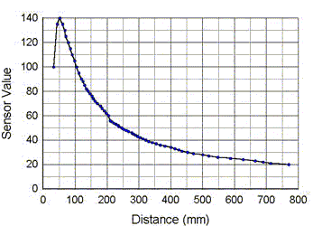
Figure 11: Sampled IR Sensor Readings from 0 to 80 cm.

From the figure it is clear that the IR sensor is not linear which is expected from the inverse-square relationship of optical sensors (as an object closes ½ of the distance appears four times as large, and thus a greater amount reflected IR is sensed). Due to the non-linear nature of the sensor it was necessary to have multiple tests against the sensor reading to determine appropriate vehicle response. For instance, if the IR reading was between 0.4V and 0.6V it is safe to say that there exists and obstacle approximately 50cm away. In response it is appropriate for the vehicle to attempt to either turn sharply or slow down. However, if the sensor reads say between 1.2V to 3.0V then it is not appropriate to attempt a sharp turn as the obstacle is imminent and thus the vehicle would be commanded to fully stop. In either case the sensor simply implies what obstacle condition the vehicle is currently in. The decision on how to deal with the current situation I handled by the system arbiter.

SONAR:

Forward obstacle detection was accomplished by utilizing the Devantech SRF08 obtained from Acroname.com for approximately $60.00. The sensors reports ranges from 3cm to 600cm. In testing the sensor performed acceptably well both indoors and outdoors though indoors it exhibits erratic behavior in irregularly shaped rooms (echo behavior). However, by again applying an averaging scheme to the measured values it was possible to produce smoothed output. The sonar was integrated into the platform frame and connected to the microcontroller via I2C bus and a maximum analog gain of 94. Figure 12 depicts the manufacturers beam pattern.

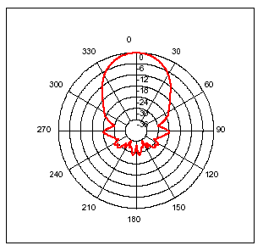
Figure 12: SRF08 Beam Pattern

From the figure it is clear that the sonar beam is projected primarily forward though there is the potential for some noise from near objects both beside and behind the transducer. This beam pattern is apparently directly related to the size of the transducer and is not adjustable. However, the sonar functioned acceptably as is and no adjustment was deemed necessary. Again, the output of the sonar is compared to various cases to set system states and appropriate the appropriate action is then determined and affected by the arbitration process.

ROAD FINDER:

The primary sensing element of the InstiGator is the Road-Finder system in which a forward facing color camera oriented along the vehicle central axis with an approximately 30° declination is used to locate and isolate road lines of specific color and intensity and then to determine the center of the lane formed by the road lines. To accomplish the goals of the Road-Finder it was determined that the component would require more processing power than the mega128 processor could provide. As such, a AMD based 64-bit computer was built and integrated into the vehicle platform via the integrated server rack. This system serves to acquire an image stream from a Creative WebCam live pictured in Figure 13 below.

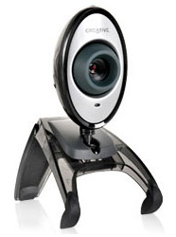
Figure 13: Creative WebCam Live USB Camera

This camera was chosen both because of its relatively low cost (under $50.00) and its image quality and frames per second. In all, the camera can produce 30 FPS of 24-bit RGB video at a resolution of 320 x 240. To accomplish the goals of the Road-Finder algorithm, first a Visual C++ program was created which generates a video structured object via the OpenCV library. This video object sets up access to the camera video stream and allows the algorithm to sample a single frame as fast as the computer will allow. Once a given frame is captured, the image is broken into three arrays (Red, Green, and Blue channels respectively). Each array is then used to classify the image based on previously tuned values for what color values/ratios are representative of the target road lines. As each element of the three arrays are tested they are then repainted to reflect whether the element is an obstacle, road line, or indeterminate.

Next, the image is filtered using a median filtering algorithm with an 11 x 11 kernel size. This process serves to eliminate noise elements from the classified image and thus reduce the possibility of erroneous results in locating lane centers. Once the image has been effectively classified it is then processed for lane information. This process is accomplished by searching for continuous linear segments of lane colored elements. By incrementing first row by row and then column by column several counters keep track of the number of continuous elements that are classified as road, line, or obstacle. If more than a minimum number of line elements are located followed subsequently by a minimum number of road elements and an additional set of line elements it is determined that there exists a lane and its center is determined. The lane center is found by first adding the horizontal address of the innermost element of the left road line to the innermost element of the right road line. By averaging the two addresses a reasonable approximation of the lane center is generated.

The above process is repeated for each row of the image and the set of mid-point values are stored in an array with as many elements as there are rows in the image (240 in the case of the InstiGator). However, due to adverse lighting conditions and the current lack of a dynamic training aspect to the algorithm, the perceived midpoints are subject to noise and/or erratic readings. While some of the error can be taken care of through careful tuning it is necessary to again apply a running average function to the array of midpoints. In the current version of the algorithm the last 10 calculated midpoints are stored in a ring-buffer and the average of the elements in the ring-buffer is then taken to produce the averaged lane center. The result of the filtering process is to generate a smoothed output which minimizes the affect of noise or false classifications. Figure 14 shows a sample output of the Road-Finder algorithm and its visualization.

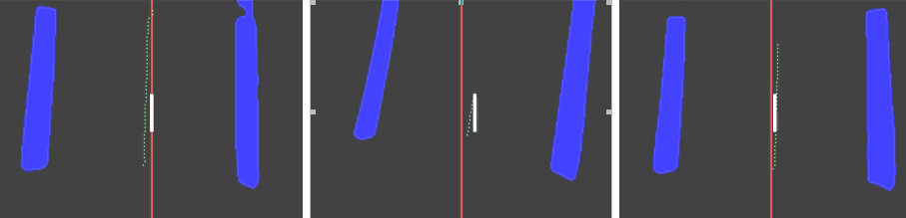
Figure 14: Road-Finder Sample Output (centered lines, lane, right offset)

From the figure, it is clear that the classification portion of the algorithm effectively isolated the colored lines from the image and the center of the lane was found. In the image, the green dots represent the discrete lane centers and the white vertical bar represents the averaged midpoint location. Furthermore, difference in position of the white bar and the vertical red line represents the error between vehicle orientation and the center of the lane. This difference between the calculated midpoint and the image center is then calculated and the value sent to the microcontroller via the RS-232 interface. This error signal serves as the primary feedback for lane navigation and is used to command and control the vehicle.

It should be noted that the Road-Finder is susceptible to sudden changes ambient lighting conditions and does not possess a dynamic tuning system.. Instead, a single tuning process is completed during the initialization of the algorithm in which each cell is analyzed for the ratio of intensity of its RGB content. Cells which qualify as having appropriate color content then have their RGB values averaged. The resulting value is then used to determine upper and lower limits for what colors represent road lines.

BEHAVIOR:

The behavior element of the InstiGator is geared toward obstacle avoidance with a goal centered approach. In short, the vehicle will attempt to maintain forward motion while remaining within a bounded lane until one of three events occurs: an emergency stop is triggered, a goal is reached, or an impassable obstruction is reached. The means for determining which scenario is being experienced is handled by an arbitration function consisting of a series of logical statements organized in a switch statement. The logical statements poll sensor acquisition functions for both the IR and sonar sensors as well as the commanded error signal for following the lane center. In addition, the function checks the commanded signal for a flag value which indicates that the vision system has acquired a goal location (denoted by an arbitrarily sized and colored goal). Table 1 shows the truth table describing the behavior system followed by the InstiGator and the resulting actions the combinations trigger.

TABLE 1. Decision Matrix
IR | SONAR | VISION | Command
T | T | F | EVADE
T | T | T | STOP
T | F | F | PAUSE
F | T | T | EVADE
T | F | T | STOP
F | T | T | STOP
F | F | F | RUN
F | F | T | STOP

As shown in table one there are three possible triggers which can be set to determine the platforms operation. Depending on the combination of triggered sensors and whether or not the vision system is reporting a reached goal the system will RUN, PAUSE, STOP, or EVADE. In the RUN case, the vehicle continues to pursue forward motion while remaining within the bounded lane. In the PAUSE case, the platform has been triggered by its rear IR sensor and will simply go into a holding pattern until the PAUSE is cleared. This case represents the scenario in which the operator attempts to take control of the vehicle by approaching it from the rear at which time the operator can choose to disable the vehicle by disabling power or depressing an E-stop. In the case of a STOP scenario, the vehicle has to have sensed a reached goal. Lastly, in the EVADE case the vehicle is partially blocked and will attempt a nudge maneuver by first drastically cutting its wheels toward the last known lane center and then slowly driving forward. In such a case a timer is used to limit how long the vehicle can nudge before entering a paused state. It should be noted that in any case, if an E-stop is depressed the system will immediately halt and disable itself.

The next level of the arbitration process is actually integrated into the Road-Finder algorithm as a form of specialist system. This component of the algorithm actually remembers the last known bias of the lane center. This bias tracking is done in order to alleviate the problem of totally losing the lane center within the image due to over-steer or other obscuring of road lines. This process is accomplished by checking if the current commanded lane center is either to the left or right of the center position. If the command is to the left, then the bias is less than 1, else if the command is to the right the bias is greater than one. In this way, if the lane center is lost, the algorithm will command a hard left or right respectively. In this way the vehicle can attempt to re-acquire the lane center and return to the bounded lane.

Probably the most interesting and frustrating problem encountered in developing the reflexive behaviors was the affect of environmental variables on sensor input. In short, it is extremely difficult to develop effective behavior systems that can operate in dynamic environments without adaptive tuning systems to maintain sensor reliability. Such issues presented themselves by way of shadows caused by people waling into and out of the bounded lane disrupting the Road-Finder algorithm and causing premature stop conditions or pauses.

EXPERIMENTAL SETUP:

The experimental setup used in the testing of the InstiGator was an important aspect of the overall platform development. Due to the size, mass, and power of the platform, it was necessary to be able to test vehicle actuators and sensors in a benign environment. To create such an environment, a rack consisting of several cinder blocks bridged by section of 8 x 2 boards was built to completely lift the vehicle off the ground and allot each wheel to turn/rotate freely. The test setup is depicted in Figure 15 below.

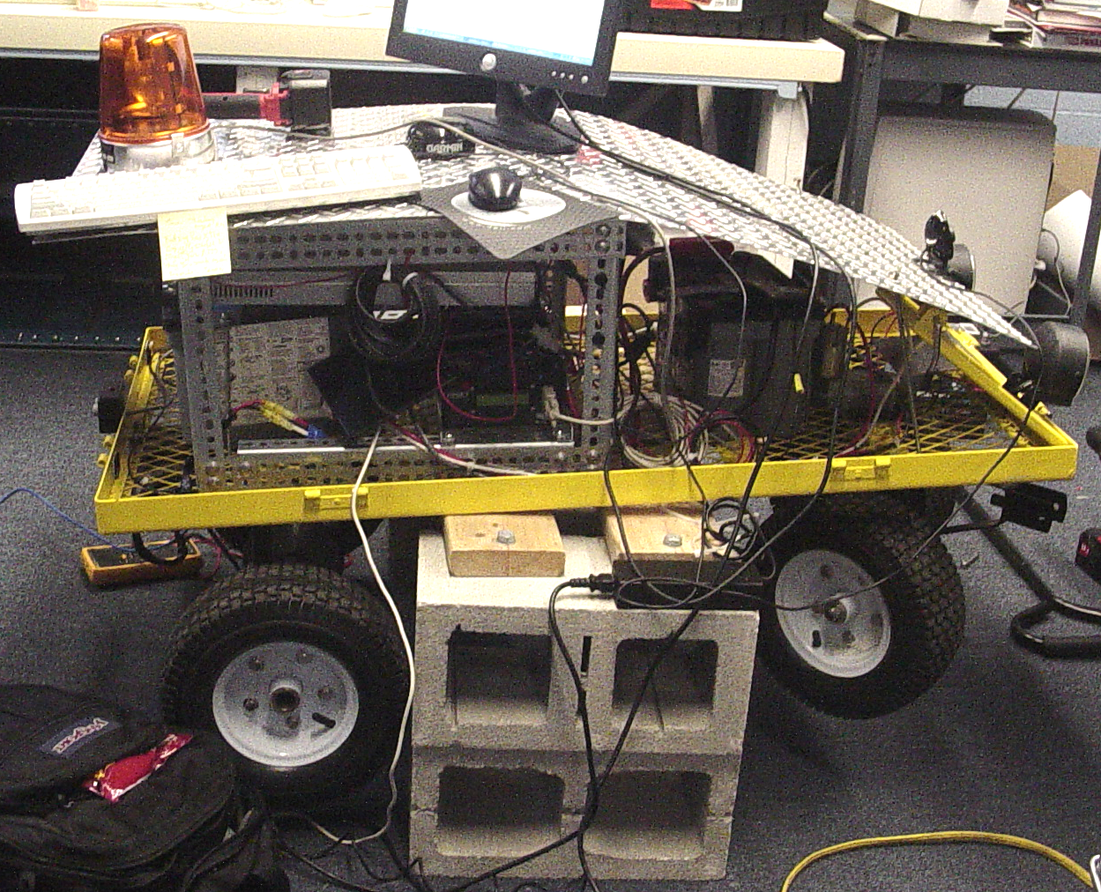
Figure 15: InstiGator Test Setup

To test the effectiveness of the Road-Finder algorithm, a set of road-lines (arbitrarily painted blue) were drawn on a large piece of cardboard. This allows the perceived lines to be manipulated in the image frame and different sizes and shapes of lanes to be tested without requiring the vehicle to actually move. Nevertheless, additional tests were performed with actual road lines while the vehicle was either static or under manual control.

However, during the testing of the platform a simple yet fatal error in the programming of the microcontroller and was discovered only after serious damage had occurred to the drive systems motor driver. After extensive analysis, it was determined that the clock speed for the timer used to control the PWM signal to the drive motor was initialized at too high of a rate and effectively caused the motor driver to switch above its critical rate. The result being that the motor-driver quickly reached its thermal limit first one then another diode to fail. Nevertheless, the tests showed that the commanded output of the Road-Finder vision algorithm was effective.

CONCLUSION:

In all, the InstiGator project has been a success. Despite some significant setbacks in the deployment of the platform for the intended goal the developer has learned a great deal about micro control of robotic systems and a very powerful vision algorithm has been developed which will serve as the backbone of the next University of Florida DARPA Grand Challenge entrant. While the completed testing has not proven the InstiGator platform in the field, the bench testing of the platform shows great promise and versatility. However, the testing has not been sufficient to absolutely qualify the effectiveness and robustness of the Road-Finder algorithm and thus in order for the algorithm to continue being developed in the near future it will need to be transplanted to a full-sized vehicle and operate on real road networks.

In many ways the InstiGator exceeded expectations in its sensor speed and performance as well as the platforms driving and steering performance. However, the current steering encoding system is prone to error and failure and in the future should be replaced with a more durable system with finer resolution. Moreover, the system of searching for visual goal locations alone is also prone to error and/or false recognition. Eventually, this system will need to be augmented by a waypoint based navigation system using GPS localization. Such a change would allow the platform o operate over larger areas and at high speeds while still remaining the ability to visually detect goals/obstacles and road lines.

In terms of lessons learned and the sharp sting of hindsight, I would suggest that future students take the lesson to heart that the best laid plans can fall apart with a single stupid mistake. Case in point, the failure of my motor-driver is due entirely to negligence on my part. If given the chance to do the project over, I would have opted to do a skid-steer system in order to simplify the actuation of the vehicle. Though such a vehicle does not as accurately represent the handling characteristics of a consumer automobile, it requires far less platform complexity and power.

WORKS CITED:

McConnell, Robert K., and Henry H. Blau. "Color Classification of Non-Uniform Baked and Roasted Foods." Way2C. 5 Nov. 1995. Food and Process Engineering Institute A Unit of ASAE. 20 July 2006 <http://www.way2c.com/w2bkrst.php>.

Part II: Template Matching Algorithms, GM ResearchTR, November 1989. BibRef 8911, SPIE(1195), November 1989. Report on GM effort in road detection, find likely boundaries, and track through the frames. BibRef

Bacha, Andrew R. Line Detection and Lane Following for an Autonomous Mobile Robot. Diss. Virginia Polytechnic Institute and State Univ., 2005. 21 July 2006 <http://scholar.lib.vt.edu/theses/available/etd-05262005-103758/unrestricted/bacha_thesis.pdf>

APPENDIX: PROGRAM CODE

PC HEADER FILE:

unsigned int tune = 0;
short int red[480][640] = {0};
short int green[480][640] = {0};
short int blue[480][640] = {0};
int average = 0;
short int userInput;
short int h = 0;
short int w = 0;
short int hh = 0;
short int ww = 0;
short int pp = 0;
short int tt = 0;
short int rr = 0;
short int nn = 0;
short int mm = 0;
int prevMidpoint[10] ={0};
int midpoint = 0;
short int matcnt = 0;
short int blackFlag = 0;
int REDCount = 0;
int BLACKCount = 0;
int BLUECount = 0;
char error = 0;
char errorSignal = 0;
int pointCounter = 0;
int startAddress = 0;
int endAddress = 0;
short int R,G,B = 0;
short int pxlRed = 0;
short int pxlGreen = 0;
short int pxlBlue = 0;
int midH[240] = {0};
short int a = 0;
short int bias = 0;
short int b = 0;
float midSum = 0;
float sum = 0;
long double avgBRmax = 0;
long double avgBGmax = 0;
long double avgBBmax = 0;
long double avgBRmin = 0;
long double avgBGmin = 0;
long double avgBBmin = 0;
long double avgRRmax = 0;
long double avgRGmax = 0;
long double avgRBmax = 0;
long double avgRRmin = 0;
long double avgRGmin = 0;
long double avgRBmin = 0;
long double redCount = 0;
long double greenCount = 0;
long double blueCount = 0;
long double avgRed = 0;
long double avgGreen = 0;
long double avgBlue = 0;
long double pxlCount = 0;
CvCapture* capture;
IplImage* imRed = 0;
IplImage* imGreen = 0;
IplImage* imBlue = 0;
IplImage* image = 0;
IplImage* ImgResult = 0;
IplImage* ImgResultR = 0;
IplImage* ImgResultG = 0;
IplImage* ImgResultB = 0;
IplImage* smoothImage = 0;
IplImage* blurrImage = 0;
CvSize sourceSize;
/*
--------------------------------------------------------------------------------------------
Function: void train(void)

Description: Used to train the camera for the colored lines it is going to track

Comments: Tuning parameters can be adjusted to shift the range of tolerance. This
tolerance can also be offset from the average attained in the acquisition
period to give bias to the high or low end of the tolerance.
-------------------------------------------------------------------------------------------
*/

void train(void)
{
tune = 1;
userInput = 0;

while(tune!=0)
{
userInput = 0;
printf("To tune RED type 1 and hit return when ready.\n");
printf("To tune BLUE type 2 and hit return when ready.\n");
printf("To exit tuning press 3 and hit return when ready.\n");
scanf("%d", &userInput);
if(userInput==3)
{
tune = 0;
printf("Training complete, starting RUN now!");
}
else if(userInput==1)
{
avgRRmax=0;
avgRGmax=0;
avgRBmax=0;
avgRRmin=0;
avgRGmin=0;
avgRBmin=0;
avgRed = 0;
avgGreen = 0;
avgBlue = 0;
redCount = 0;
greenCount = 0;
blueCount = 0;
cvNamedWindow( "RED TUNER", 0 );
cvResizeWindow( "RED TUNER", 320, 240 );
pxlCount = 0;
for(matcnt=0;matcnt<100;matcnt++)
{
cvGrabFrame( capture );
image = cvRetrieveFrame( capture );
cvShowImage( "RED TUNER", image );
if( cvWaitKey(10) >= 0 )
break;
cvCvtPixToPlane(image, imBlue,imGreen, imRed,NULL);
for(hh=0; hh<h; hh++)
{
for(ww=0; ww<w; ww++)
{
pxlRed = (short int)cvGetReal2D(imRed , hh ,ww);
pxlGreen =(short int)cvGetReal2D(imGreen ,hh,ww);
pxlBlue = (short int)cvGetReal2D(imBlue , hh ,ww);
if(((pxlRed>=200)&&(pxlGreen<(.6*pxlRed))&&(pxlBlue<(.6*pxlRed))))
{
redCount += pxlRed;
greenCount += pxlGreen;
blueCount += pxlBlue;
pxlCount++;
}
}
}
}
if(pxlCount !=0)
{
if(!(redCount <=0))
{
avgRed = (redCount)/(pxlCount);
avgRRmin = avgRed - 60;
avgRRmax = avgRed + 60;

if(avgRRmin < 0)
{
avgRRmin = 0;
}
else if (avgRRmax > 255)
{
avgRRmax = 255;
}
}
else
{
redCount = 0;
}
if(!(redCount <=0))
{
avgGreen = (greenCount)/(pxlCount);
avgRGmin = avgGreen - 20;
avgRGmax = avgGreen + 20;

if(avgRGmin < 0)
{
avgRGmin = 0;
}
else if (avgRGmax > 255)
{
avgRGmax = 255;
}
}
else
{
greenCount = 0;
}
if(!(blueCount <=0))
{
avgBlue = (blueCount)/(pxlCount);
avgRBmin = avgBlue - 20;
avgRBmax = avgBlue + 20;
if(avgRBmin < 0)
{
avgRBmin = 0;
}
else if (avgRBmax > 255)
{
avgRBmax = 255;
}
}
else
{
blueCount = 0;
}
printf("Pixel Count: %3.lf \n",pxlCount);
printf("Red Count: %3.lf \n",redCount);
printf("Average Red MIN: R: %lf G: %lf B: %lf\n",avgRRmin,avgRGmin,avgRBmin);
printf("Average Red MAX: R: %lf G: %lf B: %lf\n",avgRRmax,avgRGmax,avgRBmax);
cvDestroyWindow( "RED TUNER" );
continue;
}
}
else if(userInput==2);
{
avgBRmax=0;
avgBGmax=0;
avgBBmax=0;
avgBRmin=0;
avgBGmin=0;
avgBBmin=0;
avgRed = 0;
avgGreen = 0;
avgBlue = 0;
redCount = 0;
greenCount = 0;
blueCount = 0;

cvNamedWindow( "BLUE TUNER", 0 );
cvResizeWindow( "BLUE TUNER", 320, 240 );
pxlCount = 0;
for(matcnt=0;matcnt<100;matcnt++)
{
//capture image
cvGrabFrame( capture );
image = cvRetrieveFrame( capture );
cvShowImage( "BLUE TUNER", image );
if( cvWaitKey(10) >= 0 )
break;
cvCvtPixToPlane(image, imBlue,imGreen, imRed,NULL);
for(hh=0; hh<h; hh++)
{
for(ww=0; ww<w; ww++)
{
pxlRed = (short int)cvGetReal2D(imRed , hh ,ww);
pxlGreen = (short int)cvGetReal2D(imGreen , hh ,ww);
pxlBlue = (short int)cvGetReal2D(imBlue , hh ,ww);
if(((pxlBlue >= 50 )&&(pxlGreen<(.6*pxlBlue))&&(pxlRed<(.6*pxlBlue))))
{
redCount += pxlRed;
greenCount += pxlGreen;
blueCount += pxlBlue;
pxlCount++;
continue;
}
else
{
continue;
}
}
}
}
if(pxlCount!=0)
{
if(!(redCount <=0))
{
avgRed = (redCount)/(pxlCount);
avgBRmin = avgRed - 25;
avgBRmax = avgRed + 25;

if(avgBRmin < 0)
{
avgBRmin = 0;
}
else if (avgBRmax > 255)
{
avgBRmax = 255;
}
}
else
{
redCount = 0;
}

if(!(redCount <=0))
{
avgGreen = (greenCount)/(pxlCount);
avgBGmin = avgGreen - 25;
avgBGmax = avgGreen + 25;
if(avgBGmin < 0)
{
avgBGmin = 0;
}
else if (avgBGmax > 255)
{
avgBGmax = 255;
}
}
else
{
greenCount = 0;
}
if(!(blueCount <=0))
{
avgBlue = (blueCount)/(pxlCount);
avgBBmin = avgBlue - 60;
avgBBmax = avgBlue + 80;
if(avgBBmin < 0)
{
avgBBmin = 0;
}
else if (avgBBmax > 255)
{
avgBBmax = 255;
}
}
else
{
blueCount = 0;
}
printf("Pixel Count: %3.lf \n",pxlCount);
printf("Blue Count: %3.lf \n",blueCount);
printf("Average Blue MIN: R: %lf G: %lf B: %lf\n",avgBRmin,avgBGmin,avgBBmin);
printf("Average Blue MAX: R: %lf G: %lf B: %lf\n",avgBRmax,avgBGmax,avgBBmax);
cvDestroyWindow( "BLUE TUNER" );
continue;
}
}
}
}

/*
--------------------------------------------------------------------------------------------
Function: int roadFinder(void)

Description: Used to classify the image for color and extracts center-of lane location

Comments: Tuning parameters can be adjusted to shift the range of tolerance. This
olerance controls the width of line with which a line is declared and the
width of open (un-classified) area between two lines to define a lane..
--------------------------------------------------------------------------------------------
*/

int roadFinder(void)
{
for( hh =1;hh<(h);hh++)
{
for( ww=0;ww<w;ww++)
{
R = (short int)cvGetReal2D(imRed ,hh,ww);
G = (short int)cvGetReal2D(imGreen,hh,ww);
B = (short int)cvGetReal2D(imBlue ,hh,ww);
if( R > avgBRmin && R < avgBRmax && G > avgBGmin && G < avgBGmax && B > avgBBmin && B < avgBBmax)
{
red[hh][ww] =0;
green[hh][ww]=0;
blue[hh][ww] =255;
((uchar*)(ImgResultR->imageData + ImgResultR->widthStep*(h-hh)))[ww] = (char)(0);
((uchar*)(ImgResultG->imageData + ImgResultG->widthStep*(h-hh)))[ww] = (char)(0);
((uchar*)(ImgResultB->imageData + ImgResultB->widthStep*(h-hh)))[ww] = (char)(255);

}
else if( R > avgRRmin && R < avgRRmax && G > avgRGmin && G < avgRGmax && B > avgRBmin && B < avgRBmax)
{
red[hh][ww] =255;
green[hh][ww]=0;
blue[hh][ww] =0;
((uchar*)(ImgResultR->imageData + ImgResultR->widthStep*(h-hh)))[ww] = (char)(255);
((uchar*)(ImgResultG->imageData + ImgResultG->widthStep*(h-hh)))[ww] = (char)(0);
((uchar*)(ImgResultB->imageData + ImgResultB->widthStep*(h-hh)))[ww] = (char)(0);
}
else
{
red[hh][ww] =0;
green[hh][ww]=0;
blue[hh][ww] =0;
((uchar*)(ImgResultR->imageData + ImgResultR->widthStep*(h-hh)))[ww] = (char)(0);
((uchar*)(ImgResultG->imageData + ImgResultG->widthStep*(h-hh)))[ww] = (char)(0);
((uchar*)(ImgResultB->imageData + ImgResultB->widthStep*(h-hh)))[ww] = (char)(0);
}
}
}

average = 0;
sum = 0;
midSum = 0;
pointCounter = 0;

for(a=0;a<h;a++)
{
midH[a] = 0;
}

for( hh=0;hh<(h);hh=hh+4)
{
BLACKCount = 0;
BLUECount = 0;
REDCount = 0;

blackFlag = 0;

for(ww=0;ww<w;ww++)
{
R = red[hh][ww];
G = green[hh][ww];
B = blue[hh][ww];
//printf("R: %3.lf G: %3.lf B: %3.lf \n",R,G,B);

//Is Blue?
if(R == 0 && G == 0 && B == 255)
{
BLUECount++;

BLACKCount = 0;
REDCount = 0;
blackFlag = 0;
}
//Is Black?
else if(R == 0 && G == 0 && B == 0)
{
BLACKCount++;

BLUECount = 0;
REDCount = 0;

}
//Is Red?
else if(R == 255 && G == 0 && B == 0)
{
REDCount++;

BLUECount = 0;
BLACKCount = 0;
blackFlag = 0;
}

//Is it Big enough for a blue line?
//--------------------------------------------------------------------------------------------------------------------------------------------------------------------------------------------
if(BLUECount>20)
{
//printf("BLUECount: %3.d \n",BLUECount);
for( tt=ww;tt<w;tt++)
{
R = red[hh][tt];
G = green[hh][tt];
B = blue[hh][tt];
//Is Blue?
if(R == 0 && G == 0 && B == 255)
{
BLUECount++;

BLACKCount = 0;
REDCount = 0;

blackFlag = 0;
}
//Is Red?
else if(R == 255 && G == 0 && B == 0)
{
REDCount++;

BLACKCount = 0;
BLUECount = 0;
blackFlag = 0;
ww=tt;
break;
}
//Is Black?
else if(R == 0 && G == 0 && B == 0)
{
BLACKCount++;

REDCount = 0;
BLUECount = 0;

//Is Flag Already Set?
if(blackFlag == 0)
{
blackFlag = 1;
startAddress = tt;
}
for(rr=tt+1;rr<w;rr++)
{
R = red[hh][rr];
G = green[hh][rr];
B = blue[hh][rr];

//Is Blue?
if(R == 0 && G == 0 && B == 255)
{
BLUECount++;

REDCount = 0;
blackFlag = 0;
if(BLACKCount > 800)
{
endAddress = rr;
average = ((startAddress+endAddress)/2);
midH[pointCounter] = average;
//midV[pointCounter] = hh;
((uchar*)(ImgResultR->imageData + ImgResultR->widthStep*(h-hh)))[average] = (char)(0);
((uchar*)(ImgResultG->imageData + ImgResultG->widthStep*(h-hh)))[average] = (char)(255);
((uchar*)(ImgResultB->imageData + ImgResultB->widthStep*(h-hh)))[average] = (char)(0);
tt=rr;
BLACKCount = 0;
blackFlag = 0;
pointCounter++;
break;
}
else
{

break;
}
}
//Is Black?
else if(R == 0 && G == 0 && B == 0)
{
BLACKCount++;

REDCount = 0;
BLUECount = 0;

continue;
}
//Is Red?
else if(R == 255 && G == 0 && B == 0)
{
REDCount++;

BLACKCount = 0;
BLUECount = 0;
blackFlag = 1;

tt=rr;
break;
}
}
}
}
}
}
}

if(pointCounter < 1)
{
pointCounter = 1;
if(bias >0)
{
for(a=9;a>0;a--)
{
midSum +=prevMidpoint[a];
prevMidpoint[a] = prevMidpoint[a-1];
}
prevMidpoint[0] = w-1;
midSum += prevMidpoint[0];

midpoint = (int)midSum/10;
for(a=100;a<(h-100);a++)
{
((uchar*)(ImgResultR->imageData + ImgResultR->widthStep*(h-a)))[midpoint] = (char)(255);
((uchar*)(ImgResultG->imageData + ImgResultG->widthStep*(h-a)))[midpoint] = (char)(255);
((uchar*)(ImgResultB->imageData + ImgResultB->widthStep*(h-a)))[midpoint] = (char)(255);

((uchar*)(ImgResultR->imageData + ImgResultR->widthStep*(h-a)))[midpoint-2] = (char)(255);
((uchar*)(ImgResultG->imageData + ImgResultG->widthStep*(h-a)))[midpoint-2] = (char)(255);
((uchar*)(ImgResultB->imageData + ImgResultB->widthStep*(h-a)))[midpoint-2] = (char)(255);

((uchar*)(ImgResultR->imageData + ImgResultR->widthStep*(h-a)))[midpoint-1] = (char)(255);
((uchar*)(ImgResultG->imageData + ImgResultG->widthStep*(h-a)))[midpoint-1] = (char)(255);
((uchar*)(ImgResultB->imageData + ImgResultB->widthStep*(h-a)))[midpoint-1] = (char)(255);
}
}
else if(bias <0)
{
for(a=9;a>0;a--)
{
midSum +=prevMidpoint[a];
prevMidpoint[a] = prevMidpoint[a-1];
}
prevMidpoint[0] = 0;
midSum += prevMidpoint[0];

midpoint = (int)midSum/10;
for(a=100;a<(h-100);a++)
{
((uchar*)(ImgResultR->imageData + ImgResultR->widthStep*(h-a)))[midpoint] = (char)(255);
((uchar*)(ImgResultG->imageData + ImgResultG->widthStep*(h-a)))[midpoint] = (char)(255);
((uchar*)(ImgResultB->imageData + ImgResultB->widthStep*(h-a)))[midpoint] = (char)(255);

((uchar*)(ImgResultR->imageData + ImgResultR->widthStep*(h-a)))[midpoint+2] = (char)(255);
((uchar*)(ImgResultG->imageData + ImgResultG->widthStep*(h-a)))[midpoint+2] = (char)(255);
((uchar*)(ImgResultB->imageData + ImgResultB->widthStep*(h-a)))[midpoint+2] = (char)(255);

((uchar*)(ImgResultR->imageData + ImgResultR->widthStep*(h-a)))[midpoint+1] = (char)(255);
((uchar*)(ImgResultG->imageData + ImgResultG->widthStep*(h-a)))[midpoint+1] = (char)(255);
((uchar*)(ImgResultB->imageData + ImgResultB->widthStep*(h-a)))[midpoint+1] = (char)(255);
}
}
midpoint = 0;
error = (midpoint-(w/2));
return(error);
}
else
{
for(a=0;a<h;a++)
{
if(midH[a] > 0 && midH[a]<=w)
{
sum += midH[a];
}
}
//printf("\nSum :%3.2f\t",sum);
for(a=9;a>0;a--)
{
midSum +=prevMidpoint[a];
prevMidpoint[a] = prevMidpoint[a-1];
//printf("%3d\t",prevMidpoint[a]);
}

prevMidpoint[0] =(int)(sum/pointCounter);
//printf("Prev Midpoint: %3.2f\t",prevMidpoint[0]);
//printf("SumoverCounter: %3f\n",sum/pointCounter);
midSum += prevMidpoint[0];
midpoint = (int)midSum/10;
for(a=100;a<(h-100);a++)
{
((uchar*)(ImgResultR->imageData + ImgResultR->widthStep*(h-a)))[midpoint] = (char)(255);
((uchar*)(ImgResultG->imageData + ImgResultG->widthStep*(h-a)))[midpoint] = (char)(255);
((uchar*)(ImgResultB->imageData + ImgResultB->widthStep*(h-a)))[midpoint] = (char)(255);

((uchar*)(ImgResultR->imageData + ImgResultR->widthStep*(h-a)))[midpoint+1] = (char)(255);
((uchar*)(ImgResultG->imageData + ImgResultG->widthStep*(h-a)))[midpoint+1] = (char)(255);
((uchar*)(ImgResultB->imageData + ImgResultB->widthStep*(h-a)))[midpoint+1] = (char)(255);

((uchar*)(ImgResultR->imageData + ImgResultR->widthStep*(h-a)))[midpoint-1] = (char)(255);
((uchar*)(ImgResultG->imageData + ImgResultG->widthStep*(h-a)))[midpoint-1] = (char)(255);
((uchar*)(ImgResultB->imageData + ImgResultB->widthStep*(h-a)))[midpoint-1] = (char)(255);
}
error = (midpoint - (w/2));
if(midpoint >(w/2))
{
bias = 1;
}
else if (midpoint <(w/2))
{
bias = -1;
}
else
{
bias = 0;
}
return error;
}

}

/*CConnection::EPortStatus CConnection::CheckPort(CString csPort)
{
// Try to open the device
HANDLE hFile = ::CreateFile(csPort,
GENERIC_READ|GENERIC_WRITE,
0,
0,
OPEN_EXISTING,
0,
0);

// Check if we could open the device
if (hFile == INVALID_HANDLE_VALUE)
{
// Display error
switch (::GetLastError())
{
case ERROR_FILE_NOT_FOUND:
// The specified COM-port does not exist
return EPortNotAvailable;

case ERROR_ACCESS_DENIED:
// The specified COM-port is in use
return EPortInUse;

default:
// Something else is wrong
return EPortUnknownError;
}
}

// Close handle
::CloseHandle(hFile);

// Port is available
return EPortAvailable;
}

Just call this function for every COM port you expect, e.g.

CString csCom;
for(int i=1;i<=20;i++)
{
csCom.Format(_T("COM%d"),i);
if(CConnection::CheckPort(csCom)==CConnection::EPortAvailable)
m_cPort.AddString(csCom);
}

If you want to copy this code you will need the following enum:

typedef enum
{
EPortUnknownError = -1, // Unknown error occurred
EPortAvailable = 0, // Port is available
EPortNotAvailable = 1, // Port is not present
EPortInUse = 2 // Port is in use
}
EPortStatus;
*/

PC SOURCE FILE:

//CIMAR--CIMAR--CIMAR--CIMAR--CIMAR--CIMAR--CIMAR--CIMAR--CIMAR--CIMAR--CIMAR--CIMAR--CIMAR--CIMAR--CIMAR--
//InstiGator Road Finding Algorithm----VERSION 1.0
//Author: Steven J. Velat
//Date: 07-31-2006
//University of Florida
//Department of Mechanical & Aerospace Engineering
//Center for Intelligent Machines And Robotics
//CIMAR--CIMAR--CIMAR--CIMAR--CIMAR--CIMAR--CIMAR--CIMAR--CIMAR--CIMAR--CIMAR--CIMAR--CIMAR--CIMAR--CIMAR--
#include <cv.h>
#include <cxcore.h>
#include <cvcam.h>
#include <highgui.h>
#include <stdio.h>
#include <math.h>
#include "InstiGator.h"
//Serial Includes
#include <windows.h>
#include <string.h>
#include <tchar.h>
#include "Serial.h"
#define WIN32_LEAN_AND_MEAN
int main()
{
char buf[50];
errorSignal = 10;
hSerial = CreateFile("COM1", GENERIC_READ | GENERIC_WRITE,0,NULL,OPEN_EXISTING, FILE_ATTRIBUTE_NORMAL | FILE_FLAG_OVERLAPPED | FILE_FLAG_NO_BUFFERING,NULL);
/*if (hSerial == INVALID_HANDLE_VALUE)
{
return GetLastError();
}*/
SetCommDefaults(hSerial);
memset(&ovWrite,0,sizeof(ovWrite));
sprintf(buf,"%d\n\r",errorSignal);
WriteFile(hSerial,buf,strlen(buf), &dwBytesWritten,&ovWrite);
capture = cvCaptureFromCAM(0);
cvGrabFrame( capture );
image = cvRetrieveFrame( capture );
sourceSize = cvGetSize(image);
h= sourceSize.height;
w=sourceSize.width;
printf("%d %d\n", h, w);
ImgResultR = cvCreateImage(sourceSize, 8, 1); //create gray image
ImgResultG = cvCreateImage(sourceSize, 8, 1); //create gray image
ImgResultB = cvCreateImage(sourceSize, 8, 1); //create gray image
ImgResult = cvCreateImage(sourceSize, 8, 3); //create gray image
smoothImage = cvCreateImage(sourceSize, 8, 3);
image = cvCreateImage(sourceSize, 8, 3); //
imRed = cvCreateImage(sourceSize, 8, 1);
imGreen = cvCreateImage(sourceSize, 8, 1);
imBlue = cvCreateImage(sourceSize, 8, 1);
train();
cvNamedWindow( "InstiGator", 0 );
cvResizeWindow( "InstiGator", 320, 240 );
for(a=0;a<10;a++)
{
prevMidpoint[a] = (float)(w/2);
}
while(1)
{
cvShowImage( "InstiGator", ImgResult );
cvGrabFrame( capture );
image = cvRetrieveFrame( capture );
cvSmooth(image,smoothImage,CV_GAUSSIAN,11,11,11);
cvSmooth(smoothImage,image,CV_MEDIAN,7,7,7);
cvCvtPixToPlane(image,imBlue,imGreen,imRed,NULL);

errorSignal = (char)roadFinder();

sprintf(buf,"%d\n\r",errorSignal);
WriteFile(hSerial,buf,strlen(buf), &dwBytesWritten,&ovWrite);

for(a=0;a<(h);a++)
{
((uchar*)(ImgResultR->imageData + ImgResultR->widthStep*(h-a)))[w/2] = (char)(255);
((uchar*)(ImgResultG->imageData + ImgResultG->widthStep*(h-a)))[w/2] = (char)(0);
((uchar*)(ImgResultB->imageData + ImgResultB->widthStep*(h-a)))[w/2] = (char)(0);

((uchar*)(ImgResultR->imageData + ImgResultR->widthStep*(h-a)))[w/2] = (char)(255);
((uchar*)(ImgResultG->imageData + ImgResultG->widthStep*(h-a)))[w/2] = (char)(0);
((uchar*)(ImgResultB->imageData + ImgResultB->widthStep*(h-a)))[w/2] = (char)(0);

((uchar*)(ImgResultR->imageData + ImgResultR->widthStep*(h-a)))[w/2] = (char)(255);
((uchar*)(ImgResultG->imageData + ImgResultG->widthStep*(h-a)))[w/2] = (char)(0);
((uchar*)(ImgResultB->imageData + ImgResultB->widthStep*(h-a)))[w/2] = (char)(0);
}
cvCvtPlaneToPix(ImgResultB,ImgResultG,ImgResultR,NULL,ImgResult);
if( cvWaitKey(10) >= 0 )
break;
}
cvReleaseCapture( &capture );
cvReleaseImage( &ImgResult );
cvReleaseImage( &ImgResultR );
cvReleaseImage( &ImgResultG );
cvReleaseImage( &ImgResultB );
cvReleaseImage( &imBlue );
cvReleaseImage( &imRed );
cvReleaseImage( &imGreen );
cvReleaseImage( &smoothImage );
cvDestroyWindow( "InstiGator" );
return 0;
}

MICROCONTROLLER HEADER FILE:

//Command definitions for driving
#define POWER_INDICATOR_LIGHT PORTB.0
#define DRIVE_DIRECTION PORTB.3
#define DRIVE_DUTY_CYCLE OCR1B

//Pre-defined Driving Limits
#define DRIVE_MAX_EFFORT 100
#define DRIVE_MIN_EFFORT -100
#define DRIVE_EMERGENCY_EFFORT 0
#define DRIVE_GAIN_P 1
#define DRIVE_GAIN_I 1
#define DRIVE_GAIN_D 1
#define DRIVE_MAX_DUTY_CYCLE 55536
#define DRIVE_MIN_DUTY_CYCLE 0

//Command definitions for steering
#define STEERING_DIRECTION PORTB.2
#define STEERING_DUTY_CYCLE OCR1A

//Pre-defined Steering Limits
#define STEERING_CENTER_LIMIT 128
#define STEERING_RIGHT_LIMIT 188
#define STEERING_LEFT_LIMIT 68
#define STEERING_MAX_EFFORT 100
#define STEERING_MIN_EFFORT -100
#define STEERING_SCALE_FACTOR 255
#define STEERING_GAIN_P 1
#define STEERING_GAIN_I 1
#define STEERING_GAIN_D 1
#define STEERING_MAX_DUTY_CYCLE 55536
#define STEERING_MIN_DUTY_CYCLE 0

//I2C definitions
#define I2C_INDICATOR_LIGHT PORTB.4

//Pre-defined I2C Limits
#define I2C_OBSTACLE_THRESHHOLD 200

//Pre-defined IR Limits
#define IR_OBSTACLE_THRESHHOLD 200

//State definitions
#define EMERGENCY 0
#define STARTUP 1
#define INITIALIZE 2
#define READY 3
#define RUN 4
#define PAUSE 5
#define SHUTDOWN 6

//Global variables
int serialCommand 0;
int commandSteeringEffort;
int commandDriveEffort;
int steeringError;
unsigned int commandSteeringPosition = 128;
unsigned int commandDriveEffort = 0;
unsigned int forwardObstacleDistance;
unsigned int rearObstacleDistance;

//Standard Messages
char* FAULT_STEERING_1 = "Steering Fault!\n Stuck!"; //FAULT 1
char* FAULT_STEERING_2 = "Steering Fault!\n Unknown!"; //FAULT 2
char* FAULT_STEERING_3 = "Steering Fault!\n OB!"; //FAULT 3
char* FAULT_DRIVE = "Drive Fault!"; //FAULT 4
char* FAULT_USER = "User Commanded\n Fault"; //FAULT 5
char* SONAR = "Sonar Reading:";
char* IR = "IR Reading:";
char* INFORM_READY = "READY!";

//Flag Variables
bit FAULT = 1;
bit SAFE; = 0;
bit CLEAR; = 0;
bit I2C_isBlocked = 0;
bit IR_isBlocked = 0;
bit Drive_Direction = 1;
bit Steer_Direction = 0;

unsigned char currentState;
unsigned char addr = 0x10;

//I2C bus Initialization
i2c_init();
delay_ms(500);
i2c_start();
i2c_write(addr);
i2c_stop();

//Function Definitions

/*********************************************************************************************************/
//Function: Actuate Motion
//Name: commandSteerigEffort(unsigned int commandSteeringPosition)
//Description: Actuates vehicle steering by means of a PID controller with position feedback for steering
// Also, the actuate motion function commands the drive motors. Finally, the function applies
// a clipping/limit to commanded drive duty cycle if steering position is too extreme.
/*********************************************************************************************************/
unsigned int actuateMotion(unsigned int commandSteeringPosition, unsigned int commandDriveEffort)
{
unsigned int P_error =steeringError;
unsigned int I_eror = 0;
unsigned int D_error = 0;
steeringError = read_adc(0) - commandSteeringPosition;
previousError = steeringError;
commandSteeringEffort = 0;

//Calculate Driving Direction
if(commandDriveEffort > 0)
{
Drive_Direction = 1;
}
else
{
Drive_Direction = 0;
commandDriveEffort = -commandDriveEffort;
}

while(abs(steeringError)>1)
{
//Update PID error values
P_error = (abs(read_adc(0) - commandSteeringPosition));
I_error += P_error;
D_error = P_error - previousError;

//Calculate Steering Effort
commandSteeringEffort = ((STEERING_GAIN_P*P_error + STEERING_GAIN_I*I_error - STEERING_GAIN_D*D_error)*(STEERING_MAX_DUTY_CYCLE)/(STEERING_SCALE_FACTOR));
if(commandSteeringEffort>=STEERING_MAX_DUTY_CYCLE)
{
commandSteeringEffort = STEERING_MAX_DUTY_CYCLE;
}
if(commandSteeringEffort<=STEERING_MIN_DUTY_CYCLE)
{
commandSteeringEffort = STEERING_MIN_DUTY_CYCLE;
}
previousError = P_error;

//Calculate Steering Direction
if(steeringError<0)
{
Steer_Direction = 1;
}
else
{
Steer_Direction = 0;
}

STEERING_DIRECTION = Steer_Direction;
STEERING_DUTY_CYCLE = commandSteeringEffort;
commandDriveEffort = commandDriveEffort*10
DRIVE_DIRECTION = Drive_Direction;

//Clip max drive duty cycle if steering effort is too high
if(commandSteeringEffort > 499 & commandDriveEffort > 499)
{
DRIVE_DUTY_CYCLE= commandDriveEffort-commandSteeringEffort/2;
}
else
{
DRIVE_DUTY_CYCLE= commandDriveEffort;
}
}
return 1;

}

/*********************************************************************************************************/
//Function: Initialize Motion
//Name: unsigned char initializeMotion(void)
//Description: Initializes platform mobility systems by commanding steering actuation to center and zero
// velocity. If the initialization fails, the function will return 0 and a fault message
// will be displayed on the LCD. If the initialization succeeds, the function returns 1.
/*********************************************************************************************************/
unsigned char initializeMotion(void)
{
unsigned int steering_holder;
unsigned int average_steering_position;
commandSteeringPosition = STEERING_CENTER_LIMIT;
commandDriveEffort = 0;

//acquire average sample of potentiometer steering position, determines initial position of wheels
for(int i=0;i<10;i++)
{
steering_holder += read_adc(0);
}

average_steering_position = steering_holder/10;
steeringError = average_steering_position - STEERING_CENTER_LIMIT;
//check to see if steering is reasonably within range for a home
if(average_steering_position>=STEERING_LEFT_LIMIT && average_steering_position <=STEERING_RIGHT_LIMIT)
{
if(!(actuateSteering(commandSteeringPosition, commandDriveEffort));
{
currentState = EMERGENCY;
sprintf(lcd_buffer,"%-c",FAULT_STEERING_2);
lcd_clear();
lcd_puts(lcd_buffer);
delay_ms(100);
return 0;
}
else
{
currentstate = READY;
sprintf(lcd_buffer,"%-c",INFORM_READY);
lcd_clear();
lcd_puts(lcd_buffer);
delay_ms(4000);
return 1;
}
}
else
{
currentState = EMERGENCY;
sprintf(lcd_buffer,"%-c",FAULT_STEERING_3);
lcd_clear();
lcd_puts(lcd_buffer);
delay_ms(100);
return 0;
}
free(*steering_holder);
free(*average_steering_position);
free(*steeringError);
return 0;
}

/*********************************************************************************************************/
//Function: Sense Forward Obstacle
//Name: unsigned char senseForwardObstacle(unsigned int forwardObstacleDistance)
//Description: Reads ADC channel 1 (IR) to sense a forward obstruction. If a obstacle is detected the
// function returns a 0 and will then induce evasive behavior. Otherwise the function returns
// 1 and induces continued movement in the desired diretion.
/*********************************************************************************************************/
unsigned char senseForwardObstacle(unsigned int forwardObstacleDistance)
{
unsigned int averageObstacleDistance

//acquire average sample of IR obstacle distance
for(int i=0;i<3;i++)
{
averageObstacleDistance += read_adc(1);
}
forwardObstacleDistance = averageObstacleDistance/3;

//check to see if IR is blocked by a near obstacle
if(forwardObstacleDistance <= IR_OBSTACLE_THRESHHOLD)
{
IR_isBlocked = 1;
sprintf(lcd_buffer,"F-Obstacle\n%-i"forwardObstacleDistance);
lcd_clear();
lcd_puts(lcd_buffer);
delay_ms(10);
return IR_isBlocked;
}
else
{
IR_isBlocked = 0;
return IR_isBlocked;
}
return 0;
}

/*********************************************************************************************************/
//Function: Sense Rear Obstacle
//Name: unsigned char senseRearObstacle(unsigned int RearObstacleDistance)
//Description: Reads I2C to sense a rear obstruction. If a obstacle is detected the
// function returns a 0 and will then induce evasive behavior. Otherwise the function returns
// 1 and induces continued movement in the desired diretion.
/*********************************************************************************************************/
unsigned char senseRearObstacle(unsigned int rearObstacleDistance)
{
unsigned int averageObstacleDistance

//acquire average sample of I2C obstacle distance
for(int i=0;i<3;i++)
{
i2c_start();
i2c_write(0xE0);
i2c_write(0x00);
i2c_write(0x50);
delay_ms(70);
i2c_start();
i2c_write(0xE0);
i2c_write(0x03);
i2c_start();
i2c_write(0xE0 | 1);
averageObstacleDistance+=i2c_read(0);
i2c_stop();
}

rearObstacleDistance = averageObstacleDistance/3;

//check to see if I2C is blocked by a near obstacle
if(rearObstacleDistance >= I2C_OBSTACLE_THRESHHOLD)
{
I2C_isBlocked = 1;
sprintf(lcd_buffer,"F-Obstacle\n%-i"rearObstacleDistance);
lcd_clear();
lcd_puts(lcd_buffer);
delay_ms(10);
return I2C_isBlocked;
}

else
{
I2C_isBlocked = 0;
return I2C_isBlocked;
}

return 0;

}

