Machine Intelligent Lab



Room Number Matching Algorithm Used to Support the Autonomous System



By: Luis E. Jimenez

Introduction

The purpose of this project is to development a basic identification algorithm which will enable an autonomous system to identify and differentiate room numbers. The program work by acquiring images of the room number located next to the every door trough out web cams locates on the top of the robot. Once, the image has been acquired the program will locate the room number in the image and compare the number with a template store in memory in order to verify if the robot has found the room it was looking for. The program final output will be a copy of the original image with the room number frame in a red box if the room number is not correct and green frame if is correct..

Program Specification

- The algorithm was written in C Code using Open CV Intel Libraries.
- The program will run in windows, as well as, in Linux.
- It is design to support the autonomous system KOOLIO, which run on a 2.66 MHz Pentium MMX, 128 DDRAM under Red Hat Linux Version 9.0.
- The image will be acquiring trough a Creative Video Blaster II Web Cam.

Problem Description

The image generate by the web cam is 320 x 240 x 24 on a PPM format. Given that focus on the camera is manual, it was set to generate the best possible resolution at distance of 32’’~35’’ inches from the walk. This allow me to achieve a quality adequate enough to accurate analyze the image, Fig.1.

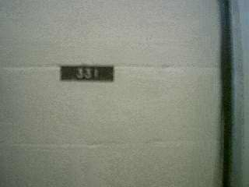
Fig.1 Sample Image of a Room Number

After examining the image, it was easy to distinguish multiple factors that had to be taking in consideration in order to design an algorithm which would effectively identify the room number. First, the presence of other objects with similar pixel color as the room number [1]. Second, the porosity and irregularities on the walk [2].Third, the presence of objects like door’s frame, displays, stands, etc [3].

1._ Same Pixel Color
2._ Irregular Surface
3._ Environment’s Object
Fig. 2 Factor to take in consideration in the development of the Program

Also, there is the issue of once the room number has being located in the image of how to know whether the room number is the one the algorithm is looking for or not.

Problem Solution

In this section a detail explanation of the way the algorithm process the image and find the correct room number will be describe. The program will start by creating the multiple variable and structures that will be use to store the images and the various mathematical data used it by the algorithm. The following structures were used:

- CvPoint = holds data in an X & Y format.
- CvSize = holds data in a Weight & Height format.
- IplImage = holds data of an image.
- CvMemStorage = holds data in the form of lists to store mathematical calculations.
- CvSeq = holds data of the contour of a blob.

Room Number Plate Identification Process

The room number plate identification process begin by loading the image to be process, as well as, the template of the room number the algorithm is looking to identify and turn them into gray scale. This will simplify the processing time of the images, Fig. 2.

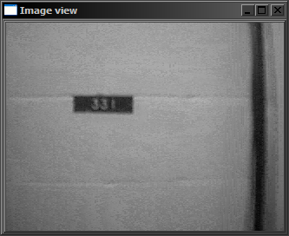

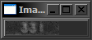

Fig. 3 Gray Scales Images of Image being process and Template Image

Now the program will execute a template matching process between the template and the sample image. The template matching process implements a normalize coefficients search which will generate an image make of the global maximum for every pixel location, (1).
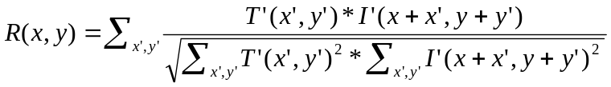 (1)
Where 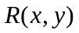 correspond to the output image, to the template, and to the sample image. The output image will be form by maximum probabilities values from 0 to 1 for every pixel form the original image, Fig. 4. Now, by thresholding the resulting image from the template matching process by a factor of .5, all those pixel locations with a probability value less than 50% will be set to 0 and those greater than 50% will be set to 1, Fig. 5, so the location of the room number plate within the image could be estimated, Fig. 6. The coefficient used to threshold the image can be adjusted in order to modify the efficiency of the algorithm or the purpose of the algorithm.

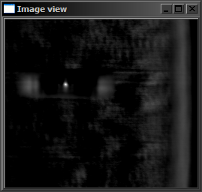
Fig. 4 Template Match Results

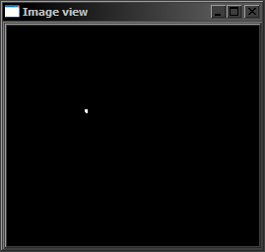
Fig. 5 Threshold Template match imag

As it can be observe in the figure above the result of the tresholding is a binary image with a single blob in it, if a match was found. By a using evaluation process the program would establish if there is blob in the image, therefore a match with the template. If a contour is found, a single blob which will be considered as a template match, the program will start a more complex process to check if the digits on the room number plate on the sample image match the numbers on the template. Given that the size of the resulting template match image is smaller than the sample image, the template match image has to be resized in order to acquire an accurate estimate of its location.

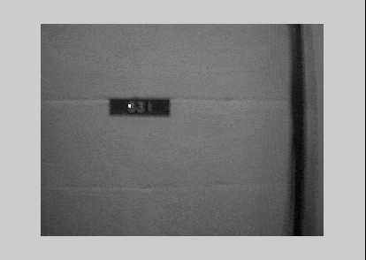
Estimates Center
Fig. 6 Superposition of Temple Match Results and Sample Image

Now that the approximate center of the black plate has been located, the limits of the plate have to establish. For this process the boundaries of the room number plate were determine by observing changes in the average of the intensity values of contiguous pixels. The way this process work is by calculating the average of an array of intensity values, using as reference 0 for Min and 255 for Max, if the average is within the acceptable limits, < 98, the array will shift to the left by one pixel and check the average again until the define limit is breach. Once the limit is breach, the boundary of the black plate can be set. Figure 7 shows how the program search troughs the left side of the black plate for the left limit of room number plate.

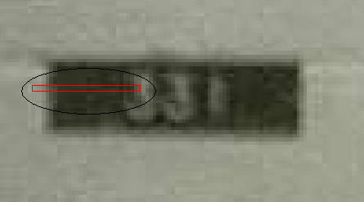

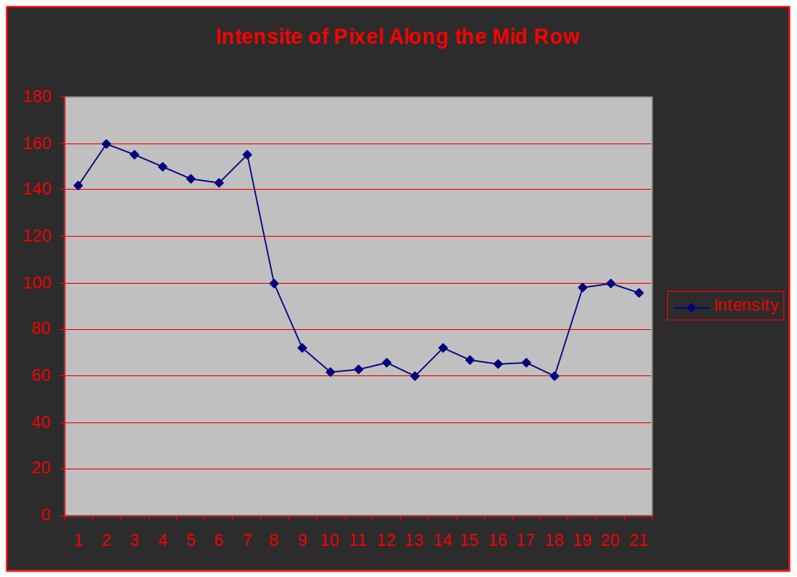
Within Limits
Within Limits
Within Limits
Out of Limits
Boundary
Found
Boundary
Found
Fig. 7 Sample of how the boundary finding process works on the left boundary of the black plate.
So, in order to find the four limits to crate a frame for the room numbers plate, the same procedure implemented above for the left boundary will be implemented for the other 3 boundaries. However, to take in consideration the possibility that the plate maybe in an angle, the top and bottom boundary will be separate on top-left, top-right, bottom-left and bottom-right. Figure 8 shows the orientation for the search pattern of the six boundaries.

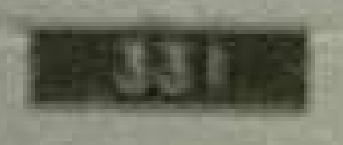
Fig. 8 Search pattern use to find the boundaries of the black plate.

Once the coordinates for the boundaries have been found, the frame shown in the figure below, Fig. 9, was drawn and used as reference to extract that section of the sample image so the digits imprinted on the black plate could be identify.

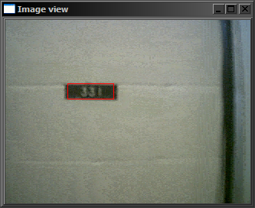

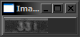

Fig. 9 Sample of the boundary found by the program for the black plate and the section of the image extracted.

The program will now proceed to isolate the digits within the black plate and compare them to the isolated digits on the template. The isolation process was achieved by taking the average of pixel intensity value of every column, Fig. 10. This will allow the program differentiate in which area of the black plate are digits imprinted and determine their coordinates within the sample image so they could be extracted one by one, Fig. 11.

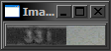
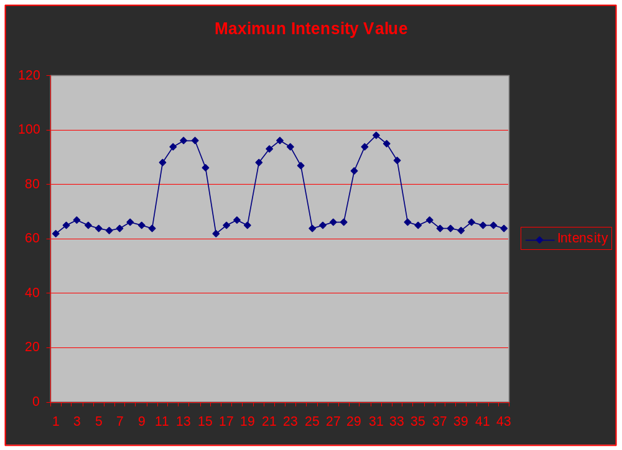
Fig. 10 Display of the averages of the maximum intensity values for every column of pixels along the horizontal axes of the room number’s image.

Once the location for every digit within the image has been established everything else will be set to zero in order to facilitate the extraction of the single digits.

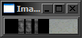
Fig. 11 Isolated digits within the black plate

Now, in order to compare every digit, the same process describe before will be applied to the template image and every single digit will be evaluate trough the same template match process initially use in the program. However, given that the image being search has to be bigger that the template, the program will copy the digit extracted from the sample image into a bigger white background image and then compare it to the digit from the template. If the digits match the template the final out put of the algorithm will be the original image being process with the room number being surrounded by a green frame, Fig. 12, otherwise it will be surrounded by a red frame, Fig. 13.

Template Being Search

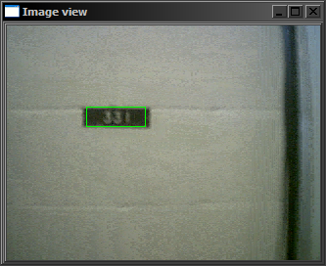
Fig. 12 Match Found

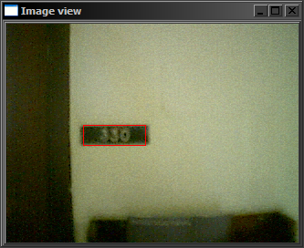
Fig. 13 Match no Found

Future Development

- Change the identification process from a template matching system to a training system.
- Modify the frame grabbing code so it would faster and work for other types of camera.
- Enhance the speed of the code so it will be able to process data at a real time rate.

Thanks To

- Dr. Antonio Arroyo
- Dr. Michael C. Nechyba
- Daniel Rodriguez
- Kevin Phillipson
- Brian Pietrodangelo

