Gnuman: An Interactive Omni-Directional Anthropomorphic

Robot

Jacob Collums
Student Researcher at MIL
00-352-392-6605
mechejdc@ufl.edu
Dr. Eric M. Schwartz
MIL Associate Director
00 (352) 392-2541
ems@mil.ufl.edu

Machine Intelligence Laboratory (MIL)
MAEB 325, Building 720
University of Florida
Gainesville, FL 32611-6300
00-352-392-6605

ABSTRACT
Gnuman is being developed as a platform for ongoing research on anthropomorphic interactive robots. Gnuman is to be capable of natural interaction with humans. Its primary objective will be to provide the public with tours by leading them throughout the tour area, and responding to questions with its own voice synthesis. The platform will consist of three independently controlled wheels, spaced 120° apart. Each of the three wheel housings will be able to change the direction each wheel is facing along with controlling its speed, providing smooth omni-directional motion control. This lends to no distinctive front or back, and thus it will never need to turn in order to “face” a tourist. A simple torso will extend from the base and lead to the upper midsection which will have three articulated arms. A head with three-faces will house much of the critical electronics including multiple cameras. The multi-faced head will also aid in giving Gnuman the ability to continually face towards its object of interaction. This paper discusses the history of the Gnuman project, the present state of the project, and visions for the future development of Gnuman.
- Introduction
The University of Florida’s Machine Intelligence Laboratary (MIL) continues to develop functional humanoid robots specifically geared towards natural human interaction. The Gnuman project is now in its fourth incarnation. It started with a Radio Shack toy, Omnibot 2000. During the summer of 1999 Scott Nortman created an autonomous robot using the OmniBot 2000 platform [1]. Shortly after this robot lost his enhanced head on the way to the UF’s 2000 Engineering & Science Fair, the Pneuman iteration was begun. Pneuman was conceived as a pneumatic man, utilizing the extra strength and durability that pneumatic actuation has over electric motors. Scott Nortman and Scott Kanowitz [2-5] developed the Pneuman idea ultimately designing an electronic controller board for pneumatic cylinders (as shown in Figures 3 and 4 of [1]). At this point they realized that the noise created by pneumatics would be a major problem for a tour guide robot and therefore reverted back to using electric motors for the robot (still named Pneuman). Scott Nortman graduated with the electric motor Pneuman not quite completed. Pneuman was retired for several years until a team was reformed in the summer of 2003 to begin the first Gnuman iteration of the project [6]. Gnuman was designed with only three wheel assemblies instead of the four used on Pneuman. This version of Gnuman died in the spring of 2004 when the students either graduated or moved on to other projects. Figure 1 shows the previous incarnations of the Gnuman project. The Gnuman project was restarted in the fall of 2005. Figure 2 shows the projected platform of the latest incarnation of Gnuman.
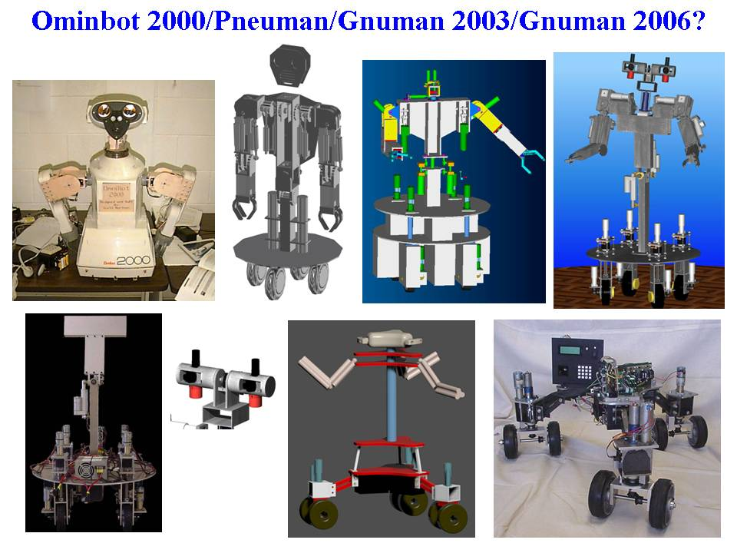
Figure 1. Gnuman project over the years. Starting at the top and moving to the right: (Top row) OmniBot 2000, CAD of original pneumatic Pneuman, alternate CAD of a pneumatic Pneuman, CAD of (electric) Pneuman, (Bottom row) completed portion of Pneuman (body), Pneuman head, original Gnuman CAD, completed portion of original Gnuman base.
The previous incarnation of Gnuman included a drive system that utilized hypotrochoid (spinning) motion [6]. This type of drive system proved to be very problematic, and has been redesigned into a more efficient means of motion in the latest design. The vision of Gnuman is to provide a platform for a wide range of advancing technologies including, but not limited to, obstacle mapping, voice recognition, speech synthesis, vision, artificial intelligence, and above all natural human interaction.
2. Physical Structure
2.1 Overall size
Parts of the platform for Gnuman came from the previous Gnuman. Though Gnuman is currently overly wide (over 35 inches), too wide to easily pass through a normal doorway, soon the extensions (shown in green in Figure 2) will be moved closer to the center of the platform. This modification should give Gnuman the ability to easily navigate through doorways.
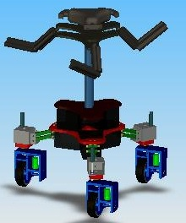
Figure 2. Gnuman’s projected platform.
In keeping with Gnuman’s humanlike appearance, the final structure will be about five feet tall. The weight of Gnuman is certainly an issue that needs to be carefully monitored as development continues, but the final weight should be no more than 160 lbs. Since Gnuman is projected to be such a large robot, we intend to incorporate the ability to easily partially disassemble him for transportation purposes.
2.2 Articulated Arms and Hands
Consistent with the overall structure, Gnuman will have three articulated arms again equally spaced 120° apart. Each of these arms will be equipped with a hand/gripper. One hand will be able to actuate a standard computer mouse, giving the ability to present PowerPoint presentations. Another hand will have the capability of operating a particular style of door handle. Finally, the third hand will be a multipurpose gripper for future research.
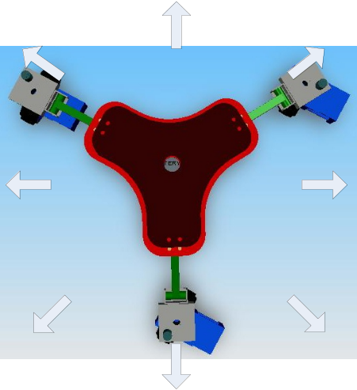
Figure 4. Gnuman’s redesigned omni-directional platform.
3. Mobility
One of the most important aspects of Gnuman is the manner which it moves across the floor. To give Gnuman motion that is compatible with its sensors is of primary concern. The omni directional means of motion chosen was made possible by the development of a completely new drive system. This system was designed with durability and versatility in mind. The wheel and drive-motor housing is constructed of 3” by 0.5” extruded aluminum, and could possibly accommodate a larger motor if necessary. The design of the previous Gnuman’s platform is shown in Figure 3. With two wheels at each vertex, we regularly had wheel alignment problems. Our new design (shown in Figure 4) has only a single wheel at each vertex. Imperfect alignment will still cause slipping, but will not be nearly the issue it was for the previous design.
4. Main Platform
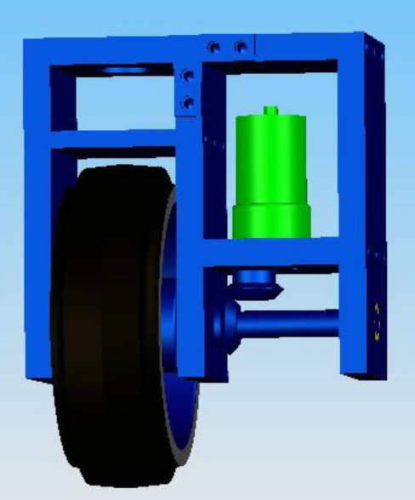 Figure 12. Pro Engineer solid model of wheel assembly

The main platform was originally designed with idea that even though the robot was too wide to fit straight through a doorway, with its unique platform shape (see Figure 5), it could “wiggle its way” through a doorway. Since the “Roulette and Hypotrochoidal” motion described in [6] has been abandoned for the latest Gnuman, the overly wide platform will be reduced as described in Section 2.1.
5. Drive System
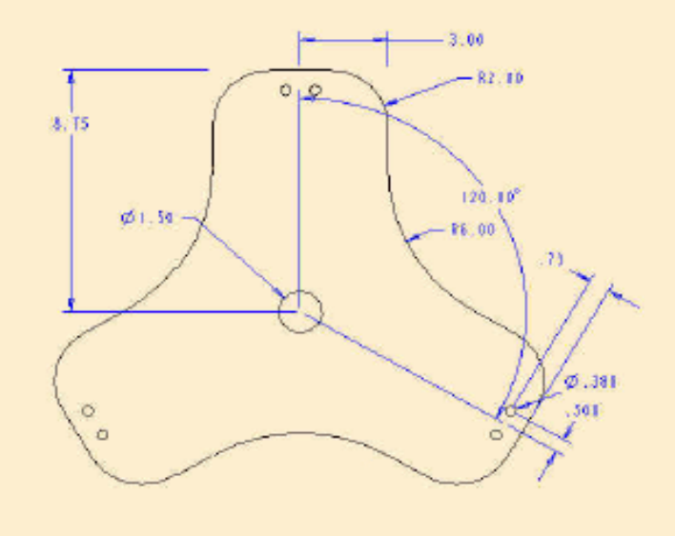
Figure 5. Main platform.
The drive system being used for Gnuman allows it to travel/strafe in any direction without the need to turn its body. This type of motion is accomplished by utilizing a total of six motors (2 at each vertex), each independently controlled. One motor at each vertex controls the rotation of the wheel along the floor (see the green motor in Figure 6), and the other motor control the direction of travel for the wheel housing. The second motor will rotate the entire assembly shown in Figure 6. Since the motor that rotates the wheel is attached to the motor housing there is a limit to how far the housing can spin before the wires to the motor become bound. The binding of the wire is greatly reduced by running the wire through the axis of rotation, which allows the wire to twist on it self rather than wrap around the entire assembly. This arrangement safely allows for as many as 4 complete revolutions before the rotation must stopped. Given that the wheels can rotate both forward and backwards, the wheel housing must only rotate 180º to obtain the full 360º strafing capabilities. The direction of the wheels is very important and must be monitored closely to provide accurate movement. The shaft that controls the motion of each wheel housing is outfitted with an optical encoder to provide feedback of each wheel position. In the future, there may also be optical encoders on the shafts that rotate the wheel to aid in obstacle mapping and path planning.
Figure 7 shows Gnuman at the MIL’s Media Demonstration Day on April 25, 2006. The CAD design of the wheel assembly is shown in Figure 8.
Figure 6. Solid model CAD of Gnuman’s wheel assembly.
6. Electronic Systems
Though Gnuman is still in its infancy, it will soon grow into a robust platform for continuing research on interactive humanoid robots. During development and implementation the hope is to unlock some of the mysteries that cause the segregation of man and machine.
7. Conclusion
Though Gnuman is still in its infancy, it will soon grow into a robust platform for continuing research on interactive humanoid robots. During development and implementation the hope is to unlock some of the mysteries that cause the segregation of man and machine.
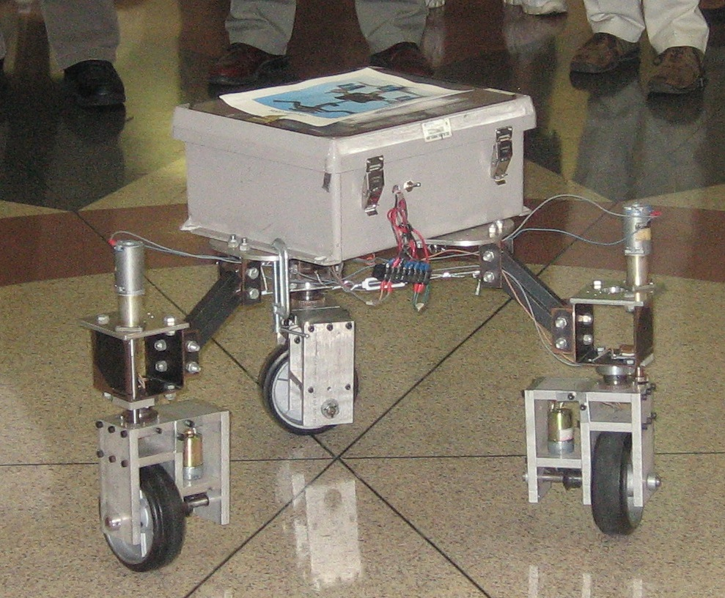
Figure 7, Gnuman at MIL’s Media Demonstration Day.
8. REFERENCES
- Scott Nortman, A. Antonio Arroyo, Eric M. Schwartz, “Omnibot 2000: Development of an Autonomous Mobile Agent for the Disabled and Elderly,” Proceedings of the 2000 Florida Conference on Recent Advances in Robotics, Volume 6, May 4-5, 2000, Florida Atlantic University, Boca Raton, Pages 51-58.
- Scott Nortman, Scott Kanowitz, A. Antonio Arroyo, Eric M. Schwartz, “Development Of An Autonomous Anthropomorphic Mobile Agent,” Proceedings of the 2000 Florida Conference on Recent Advances in Robotics, Volume 6, May 4-5, 2000, Florida Atlantic University, Boca Raton, Pages 51-58.
- Scott Nortman, Jack Peach, Michael Nechyba; L. Brown, A. Antonio Arroyo, “Construction and Kinematic Analysis of an Anthropomorphic Mobile Robot”, Proceedings of the 2001 Florida Conference on Recent Advances in Robotics, May 10-11, 2001, FAMU -FSU, Tallahassee, Florida, Volume 7, Pages 32-42.
- Scott Nortman, A. Antonio Arroyo, Michael Nechyba; Eric M. Schwartz, “PNEUMAN: A Humanoid Robot Implementation”, Proceedings of the 2002 Florida Conference on Recent Advances in Robotics, May 23-24, 2002, FIU, Miami, Florida.
- Scott Nortman. Design, Construction, And Control Of An Autonomous Humanoid Robot, UF Masters Thesis, Gainesville, Florida, 2002.
- Keith Stegath, Jim Greco, and Eric M. Schwartz. “Three-wheeled Autonomous Agent (Gnuman) With Roulette and Hypotrochoid,” Proceedings of the 2004 Florida Conference on Recent Advances in Robotics, May 6-7, 2004, UCF, Orlando, Florida..

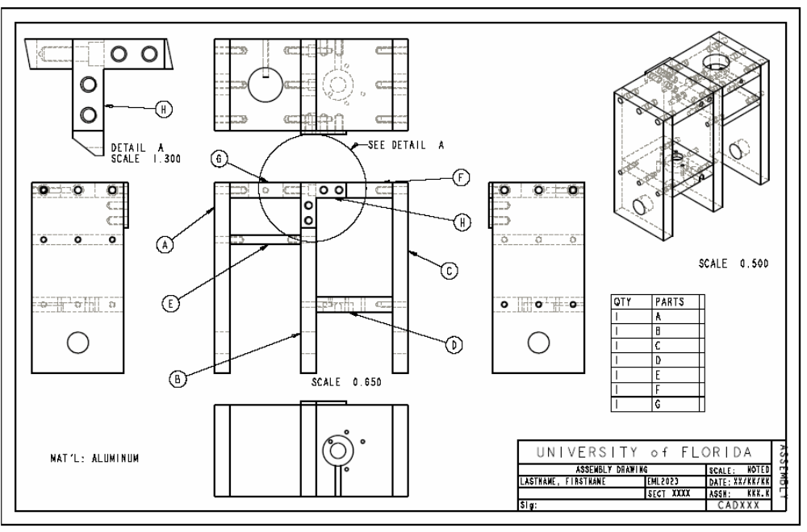
Figure 8. CAD of Gnuman’s wheel assembly.

