SubjuGator 2005

William Dubel, James Greco, Carlo Francis
gatorcar@ufl.edu,
Aaron Chinault, Adam Barnett,
Kevin Claycomb, Grzegorz Cieslewski,
Alan Melling, Sean Cohen
Eric M. Schwartz
00-352-392-2541
ems@umil.ufl.edu,
A. Antonio Arroyo

Machine Intelligence Laboratory (MIL)
MAEB 325, Building 720
University of Florida
Gainesville, FL 32611-6300
00-352-392-6605

http://subjugator.org/

ABSTRACT
Graduate and undergraduate students at the University of Florida are in the process of completing the fifth generation of their autonomous submarine, SubjuGator, to compete in the 2005 AUVSI/ONR 8th International Autonomous Underwater Vehicle Competition. SubjuGator is designed to operate underwater at depths in excess of 32 feet. The mission behavior of SubjuGator is controlled by a network of I²C modules. This system includes sensors, motor controllers, and other necessary peripherals. A single-board Pentium M based computer running the Windows XP Professional operating system provides processing power for the vision system and advanced signal processing. In this paper, we first describe the construction of the SubjuGator body and other mechanical systems. Next, we discuss the electronic and processing hardware as well as the motivation for our electronic design. Finally, we comment on vehicle control strategies and how we expect a typical competition run to proceed using the vehicle's subsystems.
Keywords
Submarine, autonomous, robot, AUVSI, SubjuGator.
1. Introduction
The Autonomous Unmanned Vehicle Systems International (AUVSI) and the Office of Naval Research (ONR) are sponsoring the eighth annual international autonomous underwater vehicle competition to be held in San Diego, California at the SPAWAR facility August 3rd through August 7th. A student team at the University of Florida is once again developing an autonomous underwater vehicle (AUV) for this year’s contest. SubjuGator has been completely redesigned to meet the challenges of the competition.

To successfully complete the competition objectives, submarines must be able to complete three tasks: pass under a gate to meet with a docking station, inspect a pipeline to find a target bin in which to drop markers into, and locate the surface zone.

In this paper, we first describe the mechanical construction of SubjuGator, including the mechanism used to deliver markers to the target. Next, we describe the electronic and processing hardware as well as the motivation for our electronic design. We then discuss the various on-board sensors and mechanisms, both mission-dependent as well as mission-independent. Finally, we comment on vehicle control strategies and how we expect a typical competition run to proceed using the subsystems on board SubjuGator.

2. Mechanical System
As a fifth-generation vehicle, SubjuGator embodies the lessons learned in eight years of AUV development. We considered several key design criteria, including survivability in a chlorinated or salt-water environment and its adaptability for different missions through a versatile thruster reconfiguration and future sensor additions. To assist in the mechanical design we developed a computer model of our submarine, as shown below in Figure 1.
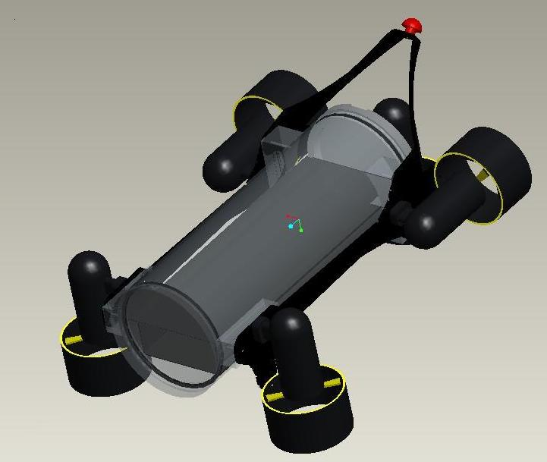
Figure 1: SubjuGator Design Concept.

The submarine was designed to be easy to work on and also easy for a diver to manage during the competition rounds. For the divers convenience the kill switch is located above and behind the submarine at a 45 degree angle. The electronics tray is easily removable from the SubjuGator body. Using a slot interface, we are able to simplify our wiring scheme and easily disconnect the electronics. The end caps are held in place by three clips placed 120° apart and two Velcro straps keep the clips from slipping. This clipping mechanism holds the end caps securely while allowing easy access to the internal electronics.

Blending composite materials with a pressure case design, SubjuGator is a compact submarine that fits in a 24" x 18" x 18" box and weighs less than 40 pounds.

2.1 Body
The central core of the body is a 6" by 17", polycarbonate tube. This gave us an inexpensive, waterproof, and lightweight housing that provides a clear front and bottom for downward and forward looking cameras. To complete the pressure case, a rear end cap is made from PVC and a front end cap is made of acrylic. Hard points and carbon fiber mounting plates support the thrusters and external peripherals.

Two thrusters positioned in line with the body provide the submarine with forward and rearward thrust. These two thrusters will also provide yaw control. The three downward thrusters provide the thrust to submerse the submarine and also provide the pitch and roll control. The five thruster configuration (see Figures 1 and 2) was chosen to provide control in all directions, as well as simplify the programming of the PID (Proportional Integral Derivative) controller. Each thruster can be individually controlled to thrust in either direction with a range of output power.

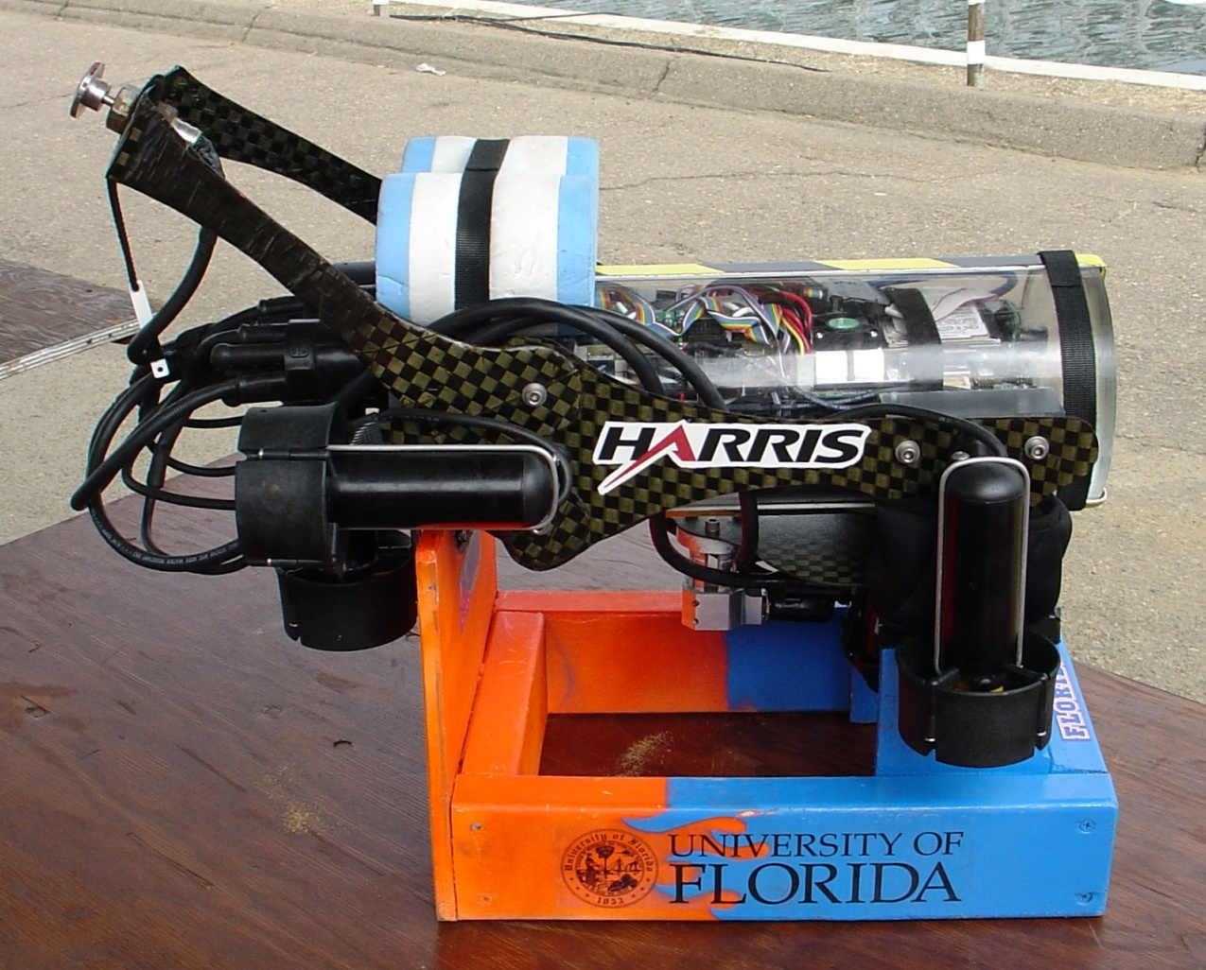
Figure 2: Platform body and thrusters

2.2 Motors
All five motors are Seabotix SBT150 sealed thrusters with 3" diameter propellers. At 24V these thrusters provide 6.4 lbs of thrust and require up to 80 watts. Each thruster weighs 1.5 lbs, adding 7.5 lbs to the total weight of the submarine. The thrusters are rated for a depth of 500 feet, and feature integrated leak detectors and current limiters. For safety, each thruster is shrouded to prevent accidental blade contact.

2.3 Through-hull connections
All of SubjuGator's through-hull connections use SeaCon ALL-WET split series wet mate-able connectors. A kill switch is implemented with a Gianni hermetically sealed push-pull switch that disconnects power from the thrusters and initiates a software motor kill routine. A serial line and connections for the hydrophones are also accessible.

To keep the analog signal lines short, the hydrophone amplifier and acquisition board is mounted externally.

2.4 Interior layout

A carbon fiber shelf fitted against the polycarbonate body provides support for all the internal electronics and power. The heavy batteries and are stowed under the shelf to provide a self-righting center of gravity for the submarine, making SubjuGator inherently stable. Electrical connections terminate at connectors on the back end cap of the submarine (see Figure 3) for efficient removal of the electronics shelf.
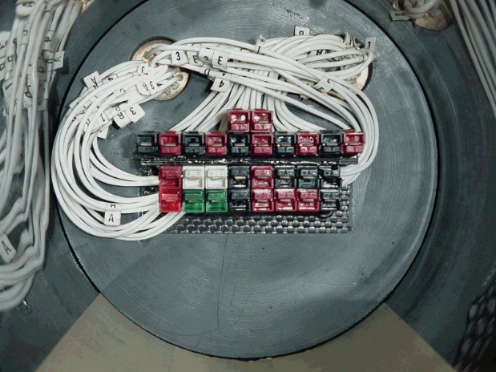
Figure 3: Through-hull electrical connections

2.5 Marker dropping mechanism
The dropping mechanism was designed to safely carry and deliver two markers to the active target and release them when the target is detected. The markers selected for use on SubjuGator are steel bearings with a diameter of 1.500 ± .0002 in. A spherical shape was chosen to simplify the dropper mechanism design and loading procedure.
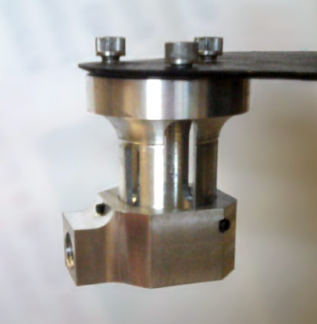
Figure 4: Ball dropper holding tube
The dropping mechanism is mounted externally on the bottom of the submarine. The mechanism is actuated by a solenoid that frees the steel bearings. Throughout the mission, the mechanism carries the markers within a machined aluminum holding tube (see Figure 4). When the target is detected, the solenoid is activated, pulling a pin that allows the markers to fall onto the target.

3. Electrical System
The electrical system of our submarine consists of batteries, computing resources (x86 microprocessor and microcontrollers), and various sensors that provide environmental feedback to the vehicle. In this section, we describe each of the robot's subsystems in further detail.

3.1 Power supply
SubjuGator uses four PolyQuest 14.8V, 4Ah lithium polymer battery packs to power the thrusters and electronics. Each pack is made from four 4Ah lithium polymer cells connected in series. Lithium polymer chemistry batteries are preferable over other battery chemistries because of their higher energy density and lower cell count. Each pack is rated to continuously source 48A; since the submarine will draw a maximum of only 20A, the batteries will produce a very linear voltage until the packs run out. This will allow the submarine to provide the same performance throughout the life of the battery.

For the drive system, SubjuGator uses three of the 14.8V, 4Ah lithium polymer batteries connected in parallel. This provides the submarine with a 14.8V, 12Ah battery for the thrusters. The worst case run time of the submarine is estimated to be 36 minutes; each of the five thrusters will draw 4 amps maximum, producing a 20A maximum current draw.

The submarine uses a single 14.8V, 4Ah lithium polymer battery to power the electronics system, including the networked sensors and single board computer.

3.2 Computing
The various tasks of the computing system on SubjuGator demand different approaches. The vision system requires a powerful processor to perform real-time scene analysis. Thus, an Advantech PCM-9380 Pentium M 3.5" embedded single-board computer is implemented for on board processing. We decided that the Windows XP operating system along with Matlab 7 would make the easiest and quickest development environment. The subsystems and sensors of the AUV are integrated using Atmel AVR microcontrollers. The microcontrollers make higher level decisions and control analog and timing related interfaces.

3.2.1 Microcontrollers

The core of the SubjuGator computing system is a network of about nine I²C interfaced ATmega8 modules. The ATmega8 eight-bit microcontrollers have a multitude of peripheral capabilities that lend themselves to easy implementation of sensor and control units. Each microcontroller has a specific task such as controlling a motor, reading a compass, or as an interface to the PC (The architecture for our system can be seen in Figure 5). This distributed system allows for circuit/software problems to be quickly isolated and thus debugging is much easier than in a conventional centralized system.

The only sensors not integrated directly to the microcontrollers are the cameras and the hydrophones (which require preprocessing to obtain the desired information).

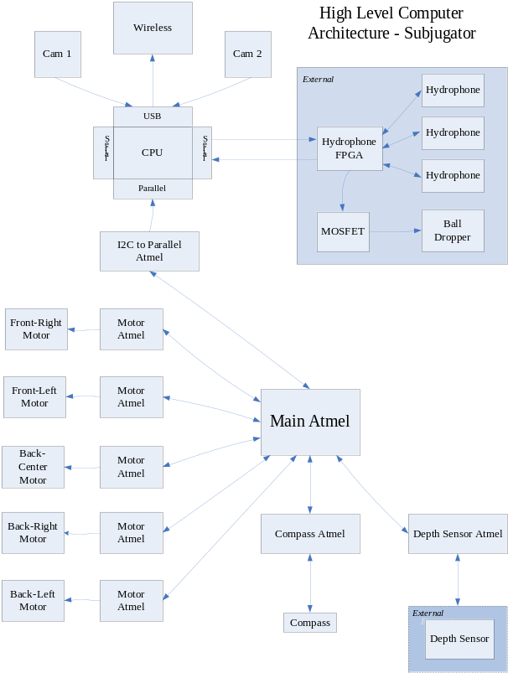
Figure 5: System Architecture

3.2.2 Altera FPGA
An Altera Cyclone EP1C3T144 FPGA serves as the hydrophone data acquisition device. For further information on the hydrophones, please refer to Section 3.4.2.

3.2.3 Image processor
Image processing is handled by an on-board SBC (Single Board Computer). The Pentium M based 1600MHz board has 1GB of RAM, 60GB hard drive, USB 2.0, and runs Windows XP Professional. The 5.75" inner diameter of the submarine and the computationally intensive computer vision algorithms influenced the decision to go with the Advantech PCM-9380.

3.2.4 Wireless system access
A communications interface between a base station and the vehicle utilizes a wireless Ethernet (802.11b/g) connection with up to a 54Mb/s data path. We are using a USB to 802.11b wireless solution. This allows remote access to SubjuGator's computer, FTP, and simultaneous programmer access for parallel code development and debugging. Wireless access is only reliable when the vehicle is surfaced.

Near surface testing of the submarine is performed by remote operation through software running across the wireless link. By viewing the real-time sensor data, we can tune most aspects of the submarine’s intelligence and control, including PID coefficients and arbiter modes.

3.3 Navigational sensors
For even the most basic operation, an AUV must be able to maintain a heading, depth and attitude. Regardless of mission specific operations these sensors provide basic AUV control.

3.3.1 Digital compass
SubjuGator uses a TCM5 compass (see Figure 6) from Precision Navigation. With a triaxial magnetometer and a microprocessor, this compass generates heading, tilt and roll information throughout its operational range. This sensor interfaces with a serial port on an Atmel microcontroller.

The compass provides a set of outputs that, when combined with a subset of the desired parameters, determine some of the error inputs to the PID controller.
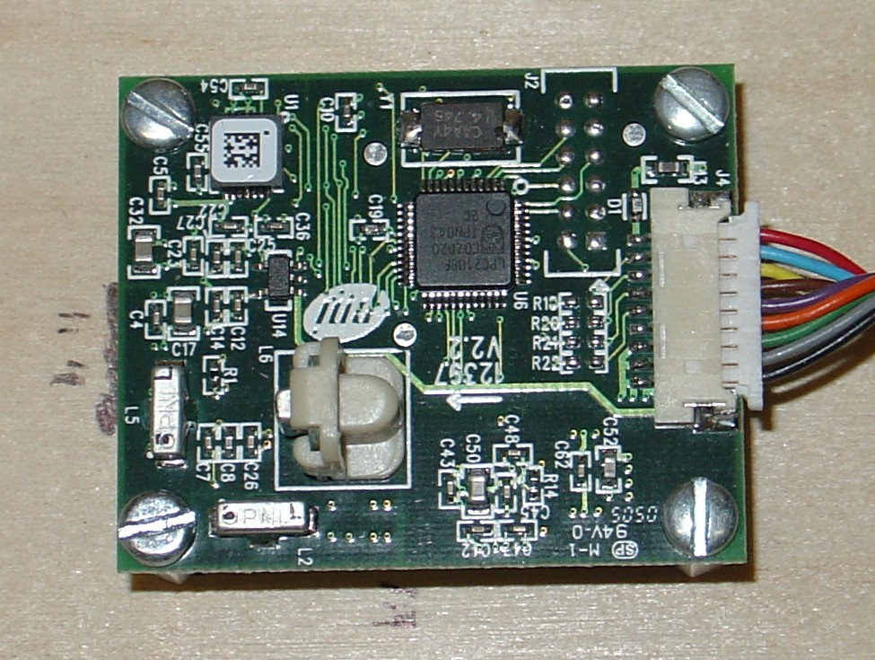
Figure 6: Precision Navigation TCM5 Compass

3.3.2 Depth sensor
Depth measurements are gathered with a Measurement Specialties MSP-300 series pressure sensor. This sensor is rated to 100 PSI, with a rated accuracy of +/- .25 PSI, and outputs an analog voltage between 1 and 5 volts. This translates to a depth resolution of +/- 2 inches. The depth sensor interfaces with an A/D converter on an Atmel microcontroller. This is used as an error input to the PID controller.

3.4 Mission-specific sensors
To complete the mission objectives, submarines will need sensors specific to each of the three tasks. SubjuGator will use a compass to pass under a gate and point in the general direction of the docking station. Computer vision is used to find the docking station. The first task is completed by pushing over the omni-directional light source that represents the docking station.

The vision system is again used to inspect a pipeline to find a target bin. To complete the second task, the submarine needs to drop its markers into the target bin. The pipeline is represented by orange PVC panels and the target bin will be found as a 12" square black box inside a white amorphous shaped area.

Finally, for the third task, SubjuGator will use its hydrophone system to locate the surface zone where the submarine will surface.

The surface zone is marked by an acoustic pinger resonating at a specific frequency every couple seconds.

3.4.1 Computer vision system
The on board SBC takes in video feeds from two USB cameras. Both cameras are mounted inside the transparent pressure case. One camera is mounted behind the clear acrylic end cap and the other is mounted in the back of the sub facing directly down.

We use simple thresholding algorithms to detect the flashing light on the docking station.

The light source normally flashes at three Hz; when docked, the frequency changes to seven Hz. The submarine steers toward the docking station until it detects a change in the frequency of the light source.

After docking with the light source, the submarine searches for the pipeline. Finding the pipeline requires a more robust vision algorithm. In testing we found image noise and scene complexity to be a problem with underwater image analysis. To address this, we begin by pre-filtering the image with Perona and Malik's nonlinear diffusion filter. [2] This simplifies the image by removing texture and noise while preserving strong edges. Figure 7 shows both an original test image and the diffusion filtered image.
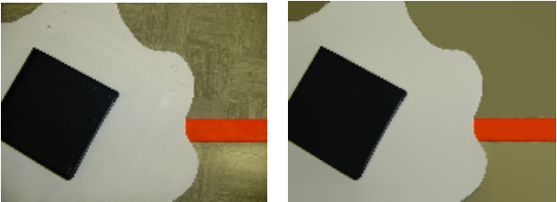
Figure 7: Original image (left) and nonlinear diffusion filtered image (right).

Linear diffusion is analogous to the physical process of diffusion. This is modeled in the heat equation,
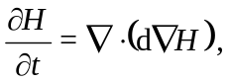 (1)
where H is the concentration (temperature) and d is the diffusivity (thermal conductance).

In nonlinear diffusion, the diffusivity becomes a function of the concentration gradient,
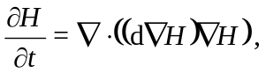 (2)
where the diffusivity equation, d, is defined as
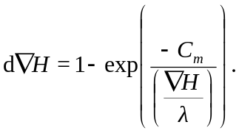 (3)
The constant Cm is automatically calculated for each value m to make the flux ascending for x < λ and descending for x ≥ λ. The only free variables are ∇H, λ and m. As ∇H is the image gradient, only two parameters need to be set: λ and m.

After pre-filtering, the image is characterized using a Gaussian Mixture Model (GMM),
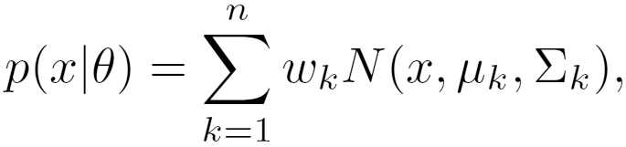
where n represents the number of Gaussians in the model, μ the mean, ∑ is the variance, and w is the weight of the kth Gaussian component.

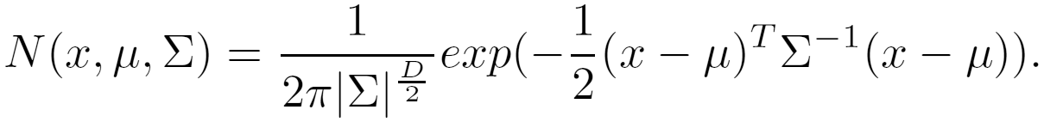
The multi-dimensional Normal function, N, is defined as,

A GMM is trained for each of the three major classes to be encountered in this stage of the competition: Water/pool floor, pipeline, and break in the pipeline. While the training of a single Gaussian can be done using Maximum-Likelihood Estimation, multiple Gaussians have no closed-form solution and require the EM (Expectation-Maximization) Algorithm to iterate to a solution. The EM algorithm guarantees the convergence of the models parameters, θ, to a local maximum.[1]

The GMMs generated in training are then continuously evaluated during the mission. Once the pipe object is found, it is followed until the break in the pipe is located using the same procedure. The sub then attempts to lower itself to an appropriate depth to drop the markers.

3.4.2 Hydrophone System
The hydrophone system consists of four basic stages that aid in obtaining and processing the signals transmitted by a target’s pingers. These stages are:

- Hydrophones
- Amplifier/Filter
- FPGA
- Processing in MATLAB

The hydrophones provide a means with which to detect acoustic vibrations in the water, such as the signals transmitted by the pingers corresponding to the surface zone. SubjuGator utilizes three hydrophones mounted in an isosceles-triangle configuration to create the geometry needed to identify the direction from which the received signals originated. When the hydrophones detect a transmission from a pinger, they are only capable of producing a signal ranging from 50 mVp-p to 200 mVp-p, depending on the strength of the pinger’s signal.

3.5 Solenoid
A solenoid is mounted with the ball dropping mechanism outside the submarine on a platform. The purpose of the solenoid is to retract a rectangular pin, actuating the marker dropping mechanism and releasing the markers onto the target. The dropping mechanism and markers are discussed in section 2.5.

The solenoid is triggered by a transistor circuit. When the circuit receives a logic high signal from the FPGA controller, the signal activates a transistor which grounds the solenoid and allows current to flow. The solenoid in turn actuates the dropping mechanism to drop the markers onto the target.

4. Vehicle control and strategy

4.1 PID controller
Control of the submarine is implemented using a proportional, integral, derivative (PID) based controller. This general control technique is used in four independent PID algorithms that calculate compensator values for four different degrees of freedom. These are pitch, roll, depth, and yaw for which feedback is attained through the depth sensor and compass unit. The controller a value for each thruster based upon the relevance that each compensator has towards the thruster's effect upon the submarine. This relevance is determined by internal gain settings defined during testing. Each motor is independently affected by each of the four degrees of freedom giving the submarine full autonomy to navigate into any direction or position.

The continuous equation is converted to its discrete-time equivalent and the errors are calculated from the difference between the current and desired heading, pitch, and depth, using the following equation:

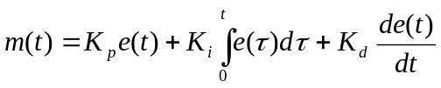

In the above equation, m(t) represents the motor value and e(t) represents the error at time step t. The individual gains (Kp, Ki, Kd) are tuned through repetitive testing at various depths and operating conditions. For each of our possible speed and depth range configurations, we maintain a separate set of control parameters. These parameters are determined through experimentation and simulation. (Figure 8 shows the submarine in the water during the tuning of these control parameters.) The PID controller was initially designed in MATLAB and ported to the ATmega series microcontroller for control in the submarine.

Depending on the mission task, the error inputs for the PID control are determined by the arbiter. For example, during the docking task, the computer vision algorithm will determine the error input for the PID control, along with the depth, pitch, and roll sensors. During the surface zone mission task, the hydrophone processing error would be input to the PID control in place of the vision processing error.
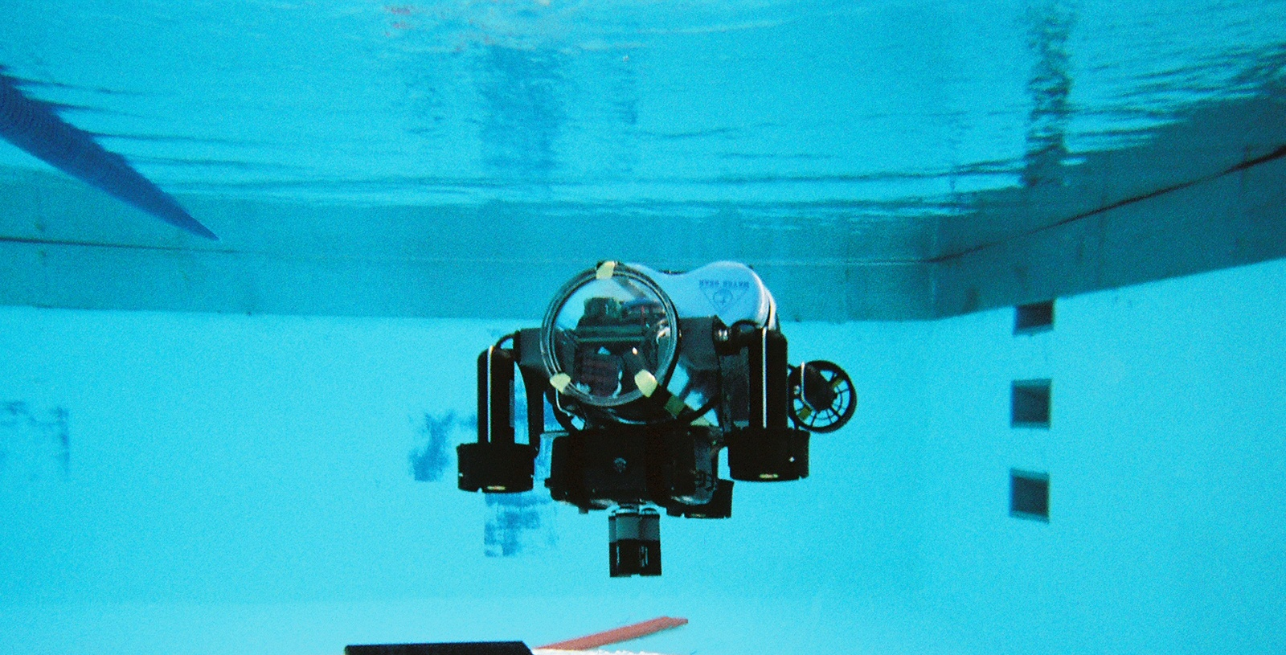
Figure 8: Testing the PID control of SubjuGator

4.2 Arbiter
Each of the sensor analysis processes makes heading, speed, and/or depth requests to improve the position of the submarine in relation to the targets. Due to the various strengths and weaknesses of particular sensors, and the occasional sensor anomaly, these requests may sometimes conflict. Therefore, we have implemented an arbiter, a rule-based algorithm specifically tuned for the competition environment, which is tasked with deciding on the next action for the submarine, given the various, possibly erroneous, sensor inputs.

Our solution to locating the correct target and delivering our markers to the target will logically proceed as follows: The submarine will dive to a predetermined depth and travel through the validation gate. It will continue on its course following the light using the camera system and vision code until the docking station is pushed over.

The vision system will then look for the pipeline, following the course of the pipeline until it finds the amorphous blob. The vision system will then center the submarine over the target bin and drop the markers. After dropping the markers, the hydrophone system will then tune itself to the frequency of the pinger and the submarine will travel towards the signal until the surface zone is reached. The surfacing of the submarine will signify the end of our run.

5. Updates for the 2006 SubjuGator
After working (and winning wining the 2005 AUVSI/ONR 8th International Autonomous Underwater Vehicle Competition) with the 2005 SubjuGator we decided that the basic design was good, but a few mechanical and electrical design improvements should be incorporated into our 2006 SubjuGator. In the 2005 SubjuGator, our thruster configuration allows us to control roll, but we found that we do not need stabilization in the roll axis. For the 2006 SubjuGator design we will instead use the thruster configuration seen in Figure 9. (Compare Figure 1 to Figure 9 to notice the changes.) Pitch and yaw axis will now be controlled using only 4 thrusters (instead of 5) and the 5th thruster will allow us to strafe. The locations of the thrusters in the new sub will also help with the weight distribution, allowing us to lighten the sub by about 20 percent. The 2006 SubjuGator will also isolate the signal lines of the microcontrollers from the motor driver chips in order to significantly reduce the noise on the I2C bus.
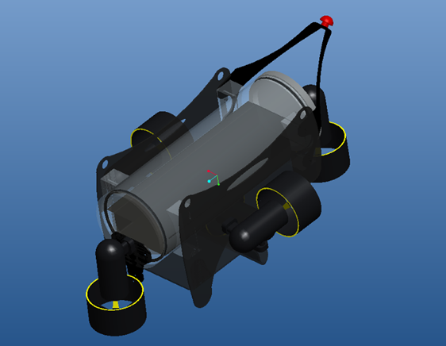
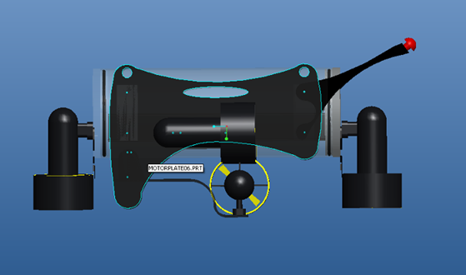
Figure 9: 2006 SubjuGator Mechanical Design

6. Acknowledgments
We would like to thank Harris Corporation, Lockheed Martin Corporation, UF’s College of Engineering and UF’s Department of Electrical and Computer Engineering for their continued and substantial support of Team SubjuGator. We would also like to thank Altera, the Gainesville section of IEEE, Microsoft, EFlightPacks.com, and Seacon. We would especially like to thank our faculty advisors for all their support, encouragement, and advice. Thanks also go out to the previous SubjuGator team members who have contributed to the legacy of SubjuGator. Finally, we are grateful to the many other members of the Machine Intelligence Laboratory (MIL) who have helped over the last year with our submarine.

7. References
[1] N. M. Laird A. P. Dempster and D. B. Rubin. Maximum likelihood from incomplete data via the em algorithm. JSSRB , 39:1–38, 1977.
[2] P. Perona and J. Malik. Scale-space and edge detection using anisotropic diffusion. IEEE Transactions on Pattern Analysis and Machine Intelligence, 12:629–639, 1990.
[3] US patent 4,622,657, "Acoustic Di-rection Finding Systems," Nov. 11, 1986.
[4] Rogers, R. M., Applied Mathematics in Integrated Navigation Systems, Reston, VA: American Institute of Aeronautics and Astronautics, 2000.
[5] Dorf, C. and Bishop, R. 2001. Modern Control Systems, 9th Edition, Prentice-Hall, Inc.
[6] SubjuGator 2004. R. Panez, K. Dockendorf, W. Dubel, E. Irigoyen, B. Pietrodangelo, A. Silverman, J. Godowski, E. M. Schwartz, M. C. Nechyba, A. A. Arroyo Association for Unmanned Vehicle Systems International, July 2004.

