Robotic Arm Manipulator Control for SG5-UT

Hussain Sultan
Machine Intelligence Lab
3800 SW 34th Street
Gainesville, FL 32608
407-453-3787, 1
hussainz@ufl.edu

Dr. Eric M. Schwartz
Machine Intelligence Lab
PO BOX 116300,
Gainesville, FL 32611
(352) 392-6605, 1
ems@mil.ufl.edu

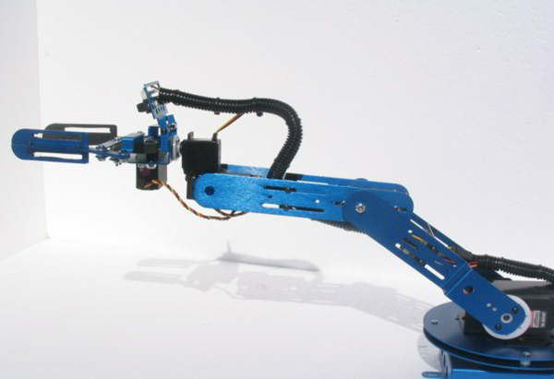
ABSTRACT
Figure 1: SG5-UT, 5DOF Robotic Manipulator
This paper presents a complete forward and inverse kinematics solution for SG5-UT, 5 DOF robotic arm. The solution is intended to be implemented on a microprocessor to control the arm in any environment. The control presented in the paper makes it possible to manipulate the arm to any reachable position. The algorithm derived in this paper has been successfully tested on the arm. This arm is analyzed for the purposes of being mounted on a humanoid robot, called Gnuman.
Keywords
Inverse Kinematics; Manipulator Control; Robotic Arm

INTRODUCTION
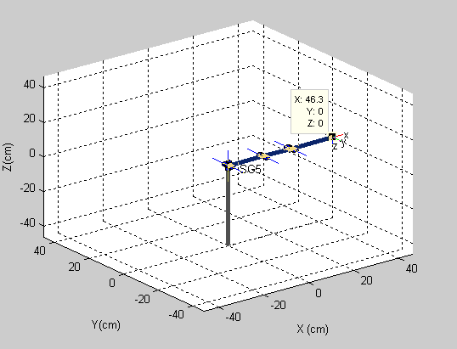
The forward and inverse kinematics for control of the SG5-UT robotic arm (Figure 1) is developed in this paper. This work can also be applied to any robotic manipulators of similar configuration.
Figure 2: Robot in fully stretched position
After a thorough review of preliminary research previously compiled in the field of robotics, a complete kinematics solution for this arm was determined. Another aim of this research is to develop the programming to implement the kinematic solutions on the arm.
Utilization of a microprocessor control board in order to manipulate the arm is one of the key aspects of this research. Software packages like MATLAB were used extensively in order to design the simulations and to perform the necessary kinematics analysis.
The SG5-UT is made by Crust Crawler (www.crustcrawler.com). It has five (5) degrees of freedom. In Robotics, degrees of freedom (DOF) are the set of independent rotations or displacements that specify completely the position and orientation of the body or the system. This is a fundamental concept relating to systems of moving bodies in robotic arms’ mechanics.
The SG5-UT is governed by two servos for the bicep joint. One servo provides the degree of freedom allocated to the elbow joint. The remaining two servos are utilized in the gripper. Figure 2 depicts the configuration of SG5-UT while fully stretched and initialized to zero degrees at each joint. This also defines the initial frame.

KINEMATICS
Inverse kinematics modeling has historically been one of the foremost tribulations in robotics research. When the inverse kinematics is not performed, a popular method for controlling robotic arms is still based on look-up tables that are usually designed in a manual manner. Alternative methods include neural networks and optimal search. The approach used in this paper is based on analytical inverse kinematics for the SG5-UT. There are no previous controllers for this arm which applies a closed loop inverse kinematics solution. The inverse kinematics is unique due to the reason that the position parameters and orientation parameters can be defined separately, hence providing the liberty to chose position precision at the expense of orientation and vice versa. Inverse kinematics solutions provide a more robust controller for trajectory generation and movement of the robot as compared to other methods. The iterative method to solve for the inverse kinematics is popular for the manipulators which do not have a closed form solution available. The iterative process is more taxing on resources and is less accurate than the process involving the closed form solutions.

Forward Kinematics
In order to represent the inverse kinematics of the robotic manipulator, the Denavit-Hartenberg (D-H) convention is used. The D-H parameters can be used to model robot joints and links for any serial link manipulator, regardless of its complexity[1]. The illustration in Figure 3 defines the end effector position which is the center of the arm gripper.
The D-H parameters can be found by assigning a local frame reference at every joint as shown in Figure 3. Physical measurements on the robot were made to extract the D-H parameters in Table 1. The a_{i} parameter is the distance along x_{i} from the origin to the intersection of the x_{i} and z_{i-1} axes. Similarly, d_{i} is the distance along z_{i-1} from the origin to the intersection of x_{i} and z_{i-1} axes. It is variable if the join (i) is prismatic. α_{i} is the angle between z_{i-1} and z_{i} measured about x_{i} and θ_{i} is the angle between x_{i-1} and x_{i} measured about z_{i-1}. θ_{i} is variable if joint (i) is revolute.
Table 1: D-H Parameters
The transformation matrix can be formed by using D-H parameters for forward and inverse kinematics of the manipulator[5].
Link | α_{i} | a_{i}(cm) | d_{i} | θ_{i}
1 | π/2 | 0 | 0 | θ₁
2 | 0 | a₂=15.5 | 0 | θ₂
3 | 0 | a₃=12.3 | 0 | θ₃
4 | π/2 | a₄=18.5 | 0 | θ₄
The following matrix represents the rotation about the z_{i-1} axis by θ_{i} , then about the x_{i} axis by α_{i}..
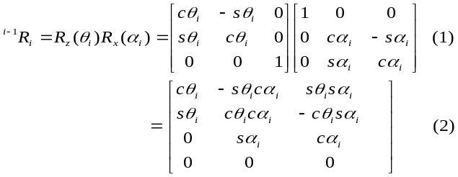
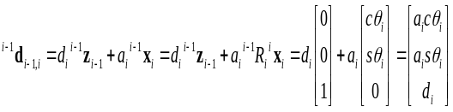Below, the equation represents the translation of z_{i} axis a distance of d_{i} followed by the translation along x_{i-1} axis a distance of a_{i}.

(3)

The overall translation and rotation transformation from one frame to another is given below. The SG5-UT robot has no d_{i} parameters since all of the joints are revolute and all displacements are orthogonal to joint rotations.
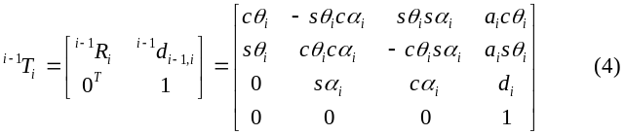The total transformation between the base of the robot and the end effector is given by:
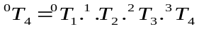
(5)
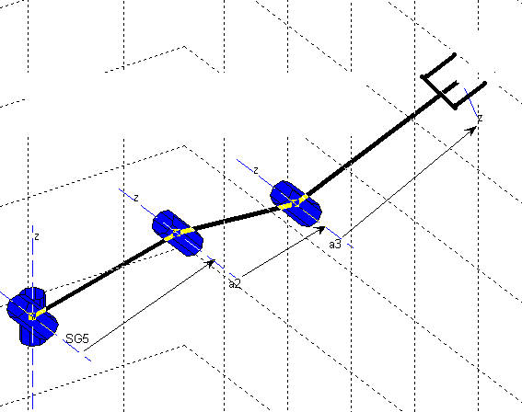
Figure 1: Frames for D-H Parameters
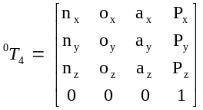

(6)

The forward kinematics solution of the SG5-UT is given by the product of the 4 transformation matrices, where p_{x,} p_{y}, and p_{y} are the global coordinates indicating the spatial position of the center of end effector in fully open position and n_{x}, n_{y ,} n_{z}, o_{x ,} o_{y} , o_{z} , a_{x}, a_{y} , and a_{z} represent the global orientation parameters that follow the D-H convention.
By equating the product of the four matrices with the total transformation, ⁰T₄, a set of 12 equations that define our forward kinematics are found.
_{1*}(C₂₃C₄- S₂₃S₄) (7)
_{1*}(C₂₃C₄- S₂₃S₄) (8)
Equations can be cleaned up some
₂₃C₄+C₂₃S₄ (9)
S₁ (10)
C₁ (11)
(12)
_{1*}(C₂₃S₄+S₂₃C₄) (13)
_{1*}(C₂₃S₄+S₂₃C₄) (14)
S₂₃S₄-C₂₃C ₄ (15)
p_{x} = C₁*(a₄(C₂₃C₄-S₂₃S₄)+a₃C₂₃+C₂a₂) (16)
p_{y} = S₁*(a₄(C₂₃C₄-S₂₃S₄)+a₃C₂₃+C₂a₂) (17)
p_{z} = a₄(S₂₃C₄+C₂₃S₄)+a₃S₂₃+a₂S₂ (18)
In the above equations S_{i} = sin(θ_{i}), S_{ij} = sin(θ_{i} + θ_{j}), C_{i} = cos(θ_{i}), and C_{ij} = cos(θ_{i} + θ_{j}).
It is important to note that o_{z} is zero because of the fact that the end effector lacks a degree of freedom in order to achieve the desired orientation. Under strict robotics terminology, SG5-UT is not really a 5 DOF arm. It is a 4 DOF manipulator and has a degree of freedom in the gripper, which doesn’t play any role in the orientation or the positioning of the arm in the kinematics terms.

Inverse Kinematics
Inverse kinematics is the process of determining the parameters of a jointed object with rigid links in order to achieve a desired orientation and position. This issue is vital in robotics, where manipulator arms are commanded in terms of joint angles (or displacements). The inverse kinematics solutions involve applying various symbolic manipulation techniques to determine a closed form (when possible) solution for the angles (or displacements) with respect to the orientation and position coordinates.
Dividing 17 and 18, we get
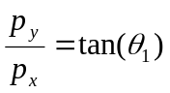 (19)
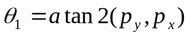 (20)
This is a simple solution of the base angle.
In order to calculate θ₂ and θ₃ , from (10), (11) and (12), we can derive the following set of equations:
(21)
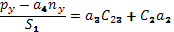
(22)

(23)
Setting,
(24)
(25)

Squaring the above equations and adding them yield:
(26)
Where (27)
Expanding 13 and 14,
(28)
(29)
The following pair of solutions is achieved.
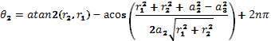 (30)
Where n can be -1,0,1 making θ₂ between –π to π.
And corresponding θ₃ becomes:
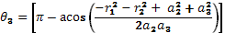 (31)

And another set of possible solutions is:

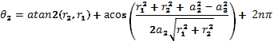
(32)

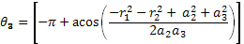
(33)

It should be noted that r ≠ 0, which means the above equations always provide certain solutions for θ₂ and θ₃.
The solution for θ₄ can be found by manipulating (9) and (15) as a function of the previously determined θ₁, θ₂, and θ₃.
We get,
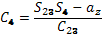 (34)
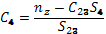 (35)
Equating both sides we get,
(36)
This implies,
(37)
Therefore, two sets of possible solutions to the inverse kinematics of the SG5-UT arm have been derived. Our strategy for choosing the correct solution is to calculate all the two sets of possible solutions (joint angles). Thus, two possible corresponding positions and orientations will be generated using forward kinematics. A comparison between the positions found by the forward kinematics and the desired position can be made. Hence, the solution with minimal error can be ultimately chosen.
Theoretically, the equations for calculating joint angles θ₁ to θ₄ are correct. However, in practice there could be problems in atan2 and acos calculation. For instance, the absolute value of the variable in acos could be slightly greater than 1 due to computing inaccuracy. Albeit, the possibility of such an inconsistency would be minimal due to the derivation process utilized. The two variables in the atan2 functions for calculating θ₂ and θ₃ cannot equal zero simultaneously. The inverse kinematics solution can closely approximate points which lie within 1 cm of the workspace boundaries. Other methods such as optimal search can be used for a better approximation to derive the arm as close as to the points which lie outside the workspace. The workspace of the robotic arm is depicted in Figure 4. It consists of a spherical surface, which accounts for the outer boundary of the reachable space, and a cylindrical surface, which depicts the inner boundary of reachable space. The points on the surface depict singularities of the arm.
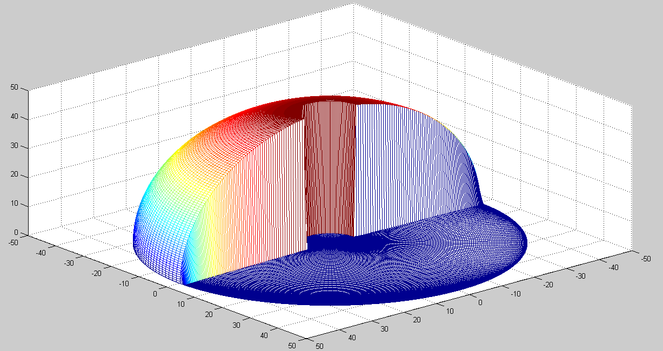
Figure 2: Workspace of the SG5-UT

APPLICATIONS
The inverse kinematics solution can be programmed with a microprocessor. This will generate real-time conditions in turn, manipulating the arm. Sensory data should be interpreted in a manner that provides the inverse kinematics function within a microprocessor. All of the orientation and position coordinates should remain consistent with the D-H convention. The microprocessor can interpret the angles into servo parameters that are sent to the servo controller module. Figure 5 depicts a block diagram that incorporates the control process. A sensor, such as a CMU camera, can send the position parameters to the microprocessor, which then computes the inverse kinematics and sends the joint parameters to a servo controller. The servo controller moves the arm at the right speed making a trajectory for the arm movement.
The derived algorithm can be used in a low cost 8-bit microprocessor using a lookup table for the sine and cosine. The tangent can be calculated using the sine and cosine terms. The accuracy of the calculated angles is compromised but is sufficient for the servos for the purposes of this robot. A Taylor series approximation can also be used to computer sine and cosine more accurately at the cost of resources, such as microprocessor clock speed. The algorithm based on the inverse kinematics method has been tested and proves sufficient for the arm.
The SG5-UT was selected because of its commercial availability and its ability to satisfy all the project goals. The control of this arm has been developed for the humanoid robot called Gnuman (see Figure 6). Gnuman's platform is being developed and is founded on a tripod which will allow the robot to travel in any direction with no explicit "front" or "back". Each wheel is independent of the others in both steering and drive which allows the robot to hypotrochoid (spin) as it moves. The design also showcases three arms, which makes the Gnuman a dynamic oriented robot.
When the Gnuman is equipped with three (3) robotic arms, it will be further able to complete one of its basic goals, i.e., making a presentation while being able to point at various other robots. The presentation will involve both speech and manipulation of a computer mouse. A set of three (3) SG5-UT arms can fulfill the needs of Gnuman, and as a consequence, make it a more powerful and dynamic robot.
The techniques applied to find the inverse kinematics solution for SG5-UT can be utilized to solve other serial link manipulators of similar configuration.
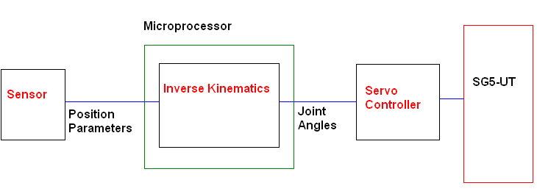
Figure 3: Block Diagram for arm control
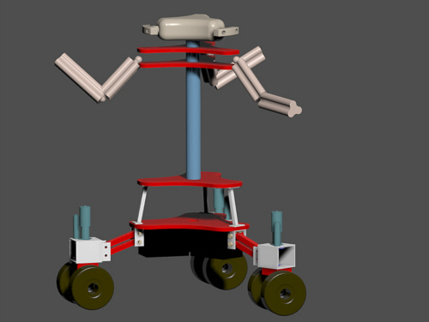
Figure 4: Design of a humanoid robot, Gnuman

CONCLUSION
A complete analytical solution to the inverse kinematics of SG5-UT is derived for the first time in this paper. The derived analytical inverse kinematics model always provides the correct joint angles for manipulation of the arm end-effector to any given reachable position and orientation. Even if the given position/orientation(s) cannot be reached to the exact level, the model is able to give a superior level of approximate solutions. We believe that the solution developed in this document will make the SG5-UT more useful in applications with unpredictable trajectory movements in unknown environments. Without this elucidation, the trajectory movements of the SG5-UT would have to be completed by manually manipulating the arm to follow the trajectory and recording a sequence of joint angles for the later use in the trajectory following task. The analytical solution is able to automatically provide joint angles for a given trajectory in an efficient, accurate, and effective manner.

ACKNOWLEDGMENTS
This work was supported by Machine Intelligence Lab (MIL) under the supervision of Dr. Eric M. Schwartz and through a scholarship was provided by the University Scholars Program at the University of Florida. Joshua Lewis has been a great help during the robot testing and building process.

REFERENCES
- Niku, S., Introduction to robotics. Analysis, System, and Applications. The Prentice Hall, 1991. 30-250.
- Paul, R.. Robot Manipulators: Mathematics, Programming and Control. The MIT Press, 1981.
- Sciavicco, Lorenzo, and Bruno Siciliano. Modelling and Control of Robot Manipulators. Springer, 2004.
- Koivo, A. Fundamentals of Control of Robotic Manipulators. John Wiley & Sons Inc., 1989.
- Crane, C. Kinematic Analysis of Robot Manipulators. The Press Syndicate of the University of Cambridge, 1998.

